AN ECOLOGICAL IMPACT ASSESSMENT FOR THE PROPOSED EXPANSION OF THE THABA CRONIMET CHROME MINE, NORTHAM AREA, LIMPOPO PROVINCE

Prepared for: Cronimet Chrome Mining SA (Pty) Ltd

Prepared by: Exigo Sustainability

AN ECOLOGICAL IMPACT ASSESSMENT FOR THE PROPOSED EXPANSION OF THE THABA CRONIMET CHROME MINE, NORTHAM AREA, LIMPOPO PROVINCE

EIA PHASE REPORT

January 2015

Conducted on behalf of:
Worley Parsons RSA
P.O. Box 61232,
Marshalltown,
South Africa
2107
39 Melrose Boulevard
Melrose Arch, South Africa

Compiled by:
Dr. BJ Henning (PhD plant Ecology; M.Sc Botany - Soil Science related Pr.Sci.Nat)

Although Exigo exercises due care and diligence in rendering services and preparing documents, Exigo accepts no liability, and the client, by receiving this document, indemnifies Exigo and its directors, managers, agents and employees against all actions, claims, demands, losses, liabilities, costs, damages and expenses arising from or in connection with services rendered, directly or indirectly by Exigo and by the use of the information contained in this document.

This document contains confidential and proprietary information of Exigo and is protected by copyright in favour of Exigo and may not be reproduced, or used without the written consent of Exigo, which has been obtained beforehand. This document is prepared exclusively for Cronimet Chrome Mining SA (Pty) Ltd and Worley Parsons RSA and is subject to all confidentiality, copyright and trade secrets, rules, intellectual property law and practices of South Africa.

REPORT DISTRIBUTION LIST

Name | Institution
Ms T. Jacquemin  Ms. N. Kinkaid-Smith | Worley Parsons RSA
Mr. B. Van Wyk | Cronimet Chrome Mining SA (Pty) Ltd
 | All registered I & Ap’s & stakeholders

DOCUMENT HISTORY

Date | Version | Status
March 2015 | 1.0 | Draft 1

Declaration

I, Barend Johannes Henning, declare that -
- I act as the independent specialist;
- I will perform the work relating to the project in an objective manner, even if this results in views and findings that are not favourable to the project proponent;
- I declare that there are no circumstances that may compromise my objectivity in performing such work;
- I have expertise in conducting the specialist report relevant to this project, including knowledge of the National Environmental Management Act, 1998 (Act No. 107 of 1998; the Act), regulations and any guidelines that have relevance to the proposed activity;
- I will comply with the Act, regulations and all other applicable legislation;
- I will take into account, to the extent possible, the matters listed in Regulation 8;
- I have no, and will not engage in, conflicting interests in the undertaking of the activity;
- I undertake to disclose to the project proponent and the competent authority all material information in my possession that reasonably has or may have the potential of influencing - any decision to be taken with respect to the project; and - the objectivity of any report, plan or document to be prepared by myself for submission to the competent authority or project proponent;
- All the particulars furnished by me in this document are true and correct; and
- I realise that a false declaration is an offence in terms of Regulation 71 and is punishable in terms of section 24F of the Act.
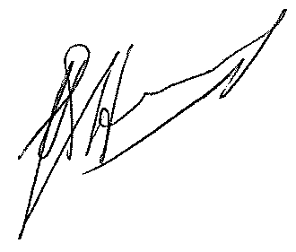
___________________________________
Signature of specialist
Company: Exigo Sustainability (Pty) Ltd.

Date: March 2015

Notations and terms

Alien vegetation Plants that do not occur naturally within the area but have been introduced either intentionally or unintentionally. Vegetation species that originate from outside of the borders of the biome -usually international in origin.

Anthropogenic: of human creation

Alluvium (from the Latin, alluvius, from alluere, "to wash against") is loose, unconsolidated (not cemented together into a solid rock) soil or sediments, which has been eroded, reshaped by water in some form, and redeposited in a non-marine setting. Alluvium is typically made up of a variety of materials, including fine particles of silt and clay and larger particles of sand and gravel. When this loose alluvial material is deposited or cemented into a lithological unit, or lithified, it would be called an alluvial deposit.

Biome A broad ecological unit representing major life zones of large natural areas – defined mainly by vegetation structure and climate.

Biota: living things; plants, animals, bacteria

Bottomland: the lowlands along streams and rivers, on alluvial (river deposited) soil.

Ecologically sensitive ecosystem: One where relatively even minor disturbances may result in substantial and significant changes.

Ecoregion An ecoregion is a "recurring pattern of ecosystems associated with characteristic combinations of soil and landform that characterise that region”.

Ecosystems: Include living (e.g. plants, animals) and non-living (e.g. minerals, soil, water) components, which can be defined in terms of distinguishing characteristics (e.g. a wetland ecosystem, a freshwater ecosystem, a terrestrial ecosystem, a forest ecosystem, etc.).

Endemic or range-restricted species or ecosystem: One whose distribution is confined to a particular and often very limited geographical region.

Environment: Broadly covers our surroundings and the characteristics of those surroundings that influence our health and wellbeing. That is, the environment includes all living organisms (plants, animals and other life), the physical environment (land, water and air), as well as social, economic and cultural conditions. Sometimes we speak of ‘the natural environment’ and ‘the built environment’, to differentiate between natural and man-made systems.

Floristic: of flora (plants).

Floodplain: Wetland inundated when a river overtops its banks during flood events resulting in the wetland soils being saturated for extended periods of time.

Habitat: The place or type of site where an organism or population naturally occurs.

Indigenous vegetation Vegetation occurring naturally within a defined area.

Protected species or ecosystem: One that is protected by law from particular activities and land uses.

Seasonally wet soil: soil which is flooded or waterlogged to the soil surface for extended periods (>1 month) during the wet season, but is predominantly dry during the dry season.

Soil horizons: layers of soil that have fairly uniform characteristics and have developed through pedogenic processes; they are bound by air, hard rock or other horizons (i.e. soil material that has different characteristics).

Soil profile: the vertically sectioned sample through the soil mantle, usually consisting of two or three horizons (Soil Classification Working Group, 1991).
Species: A group of plants, animals, micro-organisms or other living organisms that are morphologically similar; that share inheritance from common ancestry; or whose genes are so similar that they can breed together and produce fertile offspring.

Temporarily wet soil: The soil close to the soil surface (i.e. within 50 cm) is wet for periods > 2 weeks during the wet season in most years. However, it is seldom flooded or saturated at the surface for longer than a month.

Terrain unit classes: areas of the land surface with homogenous form and slope. Terrain may be seen as being made up of all or some of the following units: crest (1), scarp (2), midslope (3), footslope (4) and valley bottom (5).

Threatened species or ecosystem: Species/ Ecosystems that are at risk of going extinct in its natural range. It may be ‘critically endangered’ at extremely high risk, ‘endangered’ at very high risk, or ‘vulnerable’ at high risk. Species or ecosystems at low or no risk are not ‘threatened’, and fall into the ‘near threatened’ or ‘least concern’ categories.

Water regime: When and for how long the soil is flooded or saturated.

LIST OF ABBREVIATIONS
Abbreviation | Description
ARC | Agricultural Research Council
CR | Critically Endangered
C-Plan | Gauteng Conservation Plan
CARA | Conservation of Agricultural Resources Act
CSIR | Council for Scientific and Industrial Research
DAFF | Department of Agriculture, Forestry and Fisheries
DEA | Department of Environmental Affairs
DME | Department of Minerals and Energy Affairs
EN | Endangered
DD | Data Deficient
EAP | Environmental Assessment Practitioner
ECO | Environmental Control Officer
EIA | Environmental Impact Assessment
EIS | Ecological Importance and Sensitivity
EMPR | Environmental Management Programme Report
ENPAT | Environmental Potential Atlas
GDARD | Gauteng Department of Agriculture and Rural Development
GIS | Geographic Information Systems
GNCB | Gauteng Nature Conservation Bill
GPS | Geographical Positioning System
IDP | Integrated Development Plan
IUCN | World Conservation Union
LC | Least Concern
LR | Lower Risk
MAE | Mean Annual Evaporation
MAMSL | Meter Above Mean Sea Level
MAP | Mean Annual Precipitation
MAR | Mean Annual Runoff
NEMA | National Environmental Management Act
NFA | National Forest Act
NWA | National Water Act
OL | Orange Listed
PQ4 | Priority Quaternary Catchment
QDS | Quarter Degree Square
RDL | Red Data List
SADC | Southern African Development Community
SANBI | South African National Biodiversity Institute
Vu | Vulnerable
WHO | World Health Organisation

Table of contents
Declaration ii
1 EXECUTIVE SUMMARY 1
2 ASSIGNMENT 5
2.1 Information Sources 5
2.2 Regulations governing this report 5
2.2.1 National Environmental Management Act Regulation 543 Section 32 5
2.2.2 The National Environmental Management Act (NEMA) (Act No. 107 of 1998) 6
2.2.3 Conservation of Agricultural Resources Act (Act No. 43 of 1983) 7
2.2.4 National Environmental Management Biodiversity Act (NEMBA: Act 10 0f 2004) 7
2.2.5 The National Forest Act (Act 84 of 1998) 7
2.2.6 Limpopo Environmental Management Act (2004) 7
2.3 Terms of reference 7
2.3.1 Objectives 7
2.3.2 Scope 8
2.3.3 Limitations and assumptions 9
3 STUDY AREA 11
3.1 Location and description of activity 11
3.2 Climate 16
3.3 Vegetation types 16
3.4 Geology and soil types 16
3.5 Topography & Drainage 17
4 METHODS 18
4.1 Vegetation survey 18
4.1.1 Data recorded: 18
4.1.2 Red data species 18
4.1.3 Protected trees 18
4.1.4 Protected plants 19
4.1.5 Data processing 19
4.2 FAUNA SURVEY 19
4.2.1 Data recorded: 19
4.2.2 Red data species lists 20
4.2.3 Data processing 20
4.3 SENSITIVITY ASSESSMENT 20
4.3.1 Ecological function 20
4.3.2 Conservation importance 20
4.3.3 Sensitivity scale 21
4.4 Impact rating assessment 21
4.5 Qualititative impact assessment 23
4.6 Quantitative impact assessment 23
5 RESULTS: ecological assessment 24
5.1 FLORA 24
5.1.1 Acacia tortilis – Ziziphus mucronata – Peltophorum africanum Woodland 27
5.1.2 Acacia tortilis – Acacia nilotica Woodland 28
5.1.3 Dense Knobthorn thickets 29
5.1.4 Riparian woodland 31
5.1.5 Seepage wetlands 32
5.1.6 Valley bottom (VB) wetlands 33
5.1.7 Old Fields 35
5.1.8 Degraded bushveld (Old mining dumps) 36
5.1.9 Rocky outcrops and ridges 37
5.2 Recommendations & management strategies for flora 39
5.2.1 Red data Flora Species 39
5.2.2 Protected tree species 40
5.2.3 Invasive alien species 40
5.2.4 Encroacher species 42
5.2.5 General 43
5.3 FAUNAL ASSESSMENT 44
5.3.1 Overview 44
5.3.2 Birds 44
5.3.3 Mammals 48
5.3.4 Herpetofauna 50
6 DISCUSSION OF IMPACTS ON FLORA AND FAUNA FOR DIFFERENT MINING PHASES 52
6.1 PLANNING AND DESIGN PHASE 52
6.2 CONSTRUCTIONAL PHASE 52
6.2.1 Underground Mining 54
6.2.2 Opencast Mining 54
6.2.3 Processing Plant and tailings storage facility (TSF) 55
6.2.4 Support infrastructure 55
6.2.5 Cumulative Impact 56
6.3 OPERATIONAL PHASE 56
6.3.1 Underground Mining 58
6.3.2 Opencast Mining 58
6.3.3 Processing Plant and tailings storage facility (TSF) 59
6.3.4 Support infrastructure 59
6.3.5 Cumulative Impact 60
6.4 DECOMMISION PHASE 60
6.4.1 Underground Mining 60
6.4.2 Opencast Mining 60
6.4.3 Processing Plant and tailings storage facility (TSF) 61
6.4.4 Support infrastructure 61
6.4.5 Cumulative Impact 61
6.5 CLOSURE PHASE 61
6.5.1 Underground Mining 62
6.5.2 Opencast Mining 63
6.5.3 Processing Plant and tailings storage facility (TSF) 63
6.5.4 Support infrastructure 63
6.5.5 Cumulative Impact 63
7 qualitative impact assessment 64
8 quantitative impact assessment 64
9 ecological sensitivity and suitability of the project areA for the future mining projects according to biodiversity ASSESSMENT and potential alternatives 86
10 eCOLOGICAL MANAGEMENT PLAN FOR THE PROPOSED THABA CRONIMET MINE PHASE iii 88
11 MONITORING REQUIREMENTS 95
11.1 Objectives 96
11.2 Proposed monitoring programme 96
11.2.1 Extent and condition of wetlands and riparian areas 97
11.2.2 Habitat transformation 98
11.2.3 Distribution and abundance of selected alien plant species 99
11.2.4 Viability of populations of endangered endemic species 99
11.2.5 Occurrence of disturbances (fire) 100
11.3 Responsibility for monitoring and expertise needed 100
11.4 Data analysis and storage 100
11.5 Methods 100
11.5.1 Habitat characteristics and vegetation 101
11.5.2 Mammals 101
11.5.3 Birds 101
11.5.4 Reptiles 101
11.5.5 Amphibians 102
11.6 LIMITATIONS 102
12 impact statement and viability of mining project 105
13 conclusion 105
14 References 107
15 APPENDIX A – PLANT SPECIES LISTS 108
16 APPENDIX B – BIRD SPECIES LIST 114
17 APPENDIX C – MAMMAL SPECIES LIST (Friedmann & Daly, 2004) 124
18 appendix e. herpetofauna species list for project area 126
19 PHOTOGRAPHIC GUIDE 128

List of Figures
Figure 1. Regional Location Map 13
Figure 2. Layout plan of the Thaba Cronimet Mine 14
Figure 3. Satelite image showing the project area(Google Pro, 2010) 15
Figure 4. Vegetation Map of the project areas as surveyed during 2010 25
Figure 5. Vegetation Map of the 2015 survey indicating specific changes that occurred between 2009 and 2015 26
Figure 6. Sensitivity Map for the project area 87

List of Tables
Table 1. Land types, geology and dominant soil types of the proposed development site 17
Table 2. Impact assessment methodology for the qualitative and quantitative 22
Table 3. Vegetation units occurring in the study area 24
Table 4. Botanical analysis and characteristics of Acacia tortilis – Ziziphus mucronata woodland 27
Table 5. Botanical analysis and characteristics of Acacia tortilis – Acacia nilotica woodland 28
Table 6. Botanical analysis and characteristics of Acacia nigrescens thickets 30
Table 7. Botanical analysis and characteristics of Degraded Bushveld areas 37
Table 8. Botanical analysis and characteristics of rocky outcrop areas 38
Table 9. List of protected tree species found on the proposed development area according to habitat type 40
Table 10. Declared weeds and invader plants of the study area 41
Table 11. Listed encroacher species that occur on the proposed development site 43
Table 12. List of red data birds that could potentially occur in the study area 45
Table 13. List of red data mammals that could occur in the study area 48
Table 14. List of red data and protected reptile and amphibian species that could potentially occur in the study area 51
Table 15. Qualitative impact assessment for the various mining components and mining phases 65
Table 16. Quantitative impact assessment for the various mining components and mining phases 79
Table 17. Ecological Management Plan to be implemented as part of the Environmental Management Programme Report for the Thaba Cronimet Mine 89
Table 18. Fauna and Flora Monitoring requirements for the Thaba Cronimet Mine 103

EXECUTIVE SUMMARY
Following the investigation and ecological interpretation of the vegetation in the study area, some conclusions can be made.
Mining have a huge impact on the environment since most of the natural vegetation and general environment becomes modified. However, in recent times these mining operations have become sensitive towards the environment with specific mitigation and rehabilitation procedures ensuring that the environment will recover to its former state to a certain extent. The main aim of the mining operation is the development of an opencast and underground mine, process plant and associated infrastructure for the Thaba Cronimet Mine. The mining operation will impact on isolated, fragmented woodland areas of the site, although large areas have already been degraded through previous agricultural or mining activities.
The mining activities will completely modify the natural vegetation and faunal habitats, especially in the pristine areas. Specific aspects that were addressed in this EIA phase biodiversity specialist report are as follows:
- Detailed descriptions and analysis of the vegetation of the site on a plant community and species level;
- Detailed description of the fauna habitats and potential fauna that could occur on the proposed mining sites;
- Detailed ecological impacts assessment of the proposed mining footprint on the flora and fauna of the area for the construction, operational, decommissioning and closure phases of the mine;
- Input into the selection and evaluation of project alternatives;
- Mitigation measures and action plans to be implemented to reduce the impacts to a minimum and to optimise the mining development;
- Rehabilitation and monitoring programme.
The study area was surveyed to determine the sensitive nature of the vegetation, fauna populations and the ecological sensitivity. State of the vegetation communities; sense of place, potential red data species habitat (fauna and flora), geology and soils (erosion risk; dust pollution etc.), previous land-use and topography (rockiness, slopes) are the main determinants of the sensitivity of the area proposed for the mining development.
Nine vegetation units were identified for the proposed mining areas (underground, opencast & processing plant areas). The sensitivity of these vegetation units are indicated in the table below:

Vegetation units | Sensitivity
- Acacia tortilis – Ziziphus mucronata – Peltophorum africanum woodland | Medium Sensitivity
- Acacia tortilis – Acacia nilotica woodland | Medium Sensitivity
- Riparian woodland | High Sensitivity
- Valley bottom wetlands | High Sensitivity
- Seepage areas | Medium – High Sensitivity
- Rocky Outcrops and ridges | Medium – High Sensitivity
- Degraded bushveld (old mining dumps; tribal land) | Low Sensitivity
- Old fields | Low Sensitivity
- Dense Knobthorn thickets | Medium-low Sensitivity
If one considers the location of the study area in relation to the greater surrounding area, the site can be considered a moderate sensitivity area with some isolated and unique sensitive features (drainage channels, wetlands, rocky outcrops and slightly degraded woodlands) considering faunal and floral habitats. The mining activity will completely modify the natural vegetation and faunal habitats of the areas of the planned opencast mining operations, while large areas of the proposed mining area on the farms Schilpadnest, Middellaagte and Zwartkop have already been degraded through previous mining activities and anthropogenic influences. The only areas where potential red data species could occur was found on the outcrop areas. The probability that any red data plant species will occur in the remainder of the vegetation units and on the surrounding plains are low due to the state of the vegetation and physical environment of the larger area mostly not being suitable for any of the red data plant species that may be found in the area. Protected tree species such as leadwood, marula and shepherd’s trees occur scattered through the area and can only be eradicated after obtaining a permit from DAFF.
The site has an ecological sensitivity that varies from low on the old cultivated fields and degraded bushveld areas; moderate on natural woodland areas; and high on the outcrop areas and floodline zones (natural fauna corridors). The ecosystem as an entity can be considered unique to a certain extent, although only small pristine areas still exist in an area largely utilized for mining. It is recommended that the ecological sensitivity be considered for the Environmental Impact Assessment (EIA) process undertaken by the Environmental Assessment Practitioner (EAP).
A number of ecological potential impacts were identified and assessed. A few of these were assessed as having potentially medium or high significance, including the following:
- Destruction or disturbance to ecosystems leading to reduction in the overall extent of a particular habitat;
- Impairment of the movement and/or migration of animal species resulting in genetic and/or ecological impacts (habitat fragmentation);
- Increased soil erosion;
- Establishment and spread of declared weeds and alien invader plants;
- Habitat degradation as a result of dust;
- Fauna road mortalities;
- Spillages of harmful substances leading to soil and water pollution and ecosystem degradation.
Monitoring and rehabilitation plans have also been compiled should the proposed application be approved. Provided that all mitigation measures and recommendations in the report are strictly adhered to, the proposed development can be supported.
The most important considerations for the project area are as follows:
- The mining activities should take cognisance of the red data or endemic plants in the area, as well as other sensitive habitats such as drainage channels and outcrops. The riparian and wetland areas forming part of floodlines associated with the major water courses in the area have a high sensitivity and no activities can be allowed within these areas without the necessary authorization according to the National Environmental Management Act (NEMA) 107 of 1998 and Section 21 c and i of the National Water Act 36 of 1998.
The proposed mining activities that form part of the Thaba Cronimet Mine will definitely impact on the flora and fauna of the area. The following can be concluded with regards to the impacts:
- Vegetation clearing and topsoil stripping will have the most definite and permanent direct negative impact on the flora and fauna of the area during the construction phase of the mine. The clearance will eradicate all vegetation and displace fauna that will migrate to neighbouring areas;
- The laydown areas of WRDs and stockpiles during the operational phase of the mine will have a direct, significant negative impact on the vegetation and fauna habitats, even though most of the vegetation units are in a degraded state and fragmented;
- The indirect impacts such as soil erosion, fauna mortalities, spillages and establishment of alien invasive species are relevant for all mining phases, although with strict implemented of the mitigation measures and action plans for the various components, the impacts can be minimized;
- Considering the cumulative impacts of the mining phases on the fauna and flora of the area, it can be concluded that the current degraded state of the vegetation and fauna habitats caused by the surrounding and on site mining activities, will cause some negative impacts, although the implementation of a rehabilitation and revegetation plan will allow the vegetation to recover over time and the fauna to return to the area;
The mining development can be considered as viable as a result of the fragmented state of the vegetation and fauna habitats and the degraded state of the ecosystem caused by nearby villages and other local mining activities.

ASSIGNMENT
Exigo Sustainability (Pty) Ltd was appointed by Worley Parsons RSA on behalf of Cronimet Chrome Mining SA (Pty) Ltd to conduct an EIA phase study on the ecological components (fauna and flora) for the proposed establishment of the Thaba Cronimet Mine. The project involves the development of underground and opencast mining sections, a processing plant as well as associated infrastructure (e.g. access roads, tailings storage facility, waste rock dumps etc.).
The proposed activities/infrastructure will be located on portions of the farm Middellaagte 382 KQ, portions of Zwartkop 369 KQ, portions of Elandskuil 378 KQ and Roodedam 368 KQ. The farms are currently zoned as agriculture and special private resorts. The project area is located in the Amandelbult area, Thabazimbi Local Municipality, Waterberg District Municipality, Limpopo Province (see figure 1).
This report will include detailed impact assessment of the proposed development on the biodiversity of the site. This assessment is essential as it will contribute to meeting the requirements of the National Environmental Management Act (NEMA), 1998 (Act No. 107 of 1998).
The assignment is interpreted as follows: Compile an ecological study on the flora (vegetation units), fauna and general ecology of the site and determine the potential impacts of the proposed development on the fauna and flora of the area as well as proposed mitigation measures. The study will be done according to guidelines and criteria set by the Limpopo Department of Economic Development, Environment and Tourism (LEDET) for biodiversity studies. In order to compile this, the following had to be done:

Information Sources
- All relevant topographical maps, aerial photographs and information (previous studies and environmental databases) related to the ecological components in the study area;
- Requirements regarding the fauna and flora survey as requested by the LEDET;
- Legislation pertaining to the fauna and flora study as relevant;
- Red data species list from the South African National Biodiversity Institute (SANBI).

Regulations governing this report

National Environmental Management Act Regulation 543 Section 32
This report has been prepared in terms of Regulation 32 of the National Environmental Management Act (No. 107 of 1998) Regulations GN 33306 GNR 543 for environmental impact assessment. Regulation 32 states that:
- An applicant or the EAP managing an application may appoint a person to carry out a specialist study or specialized process.
- The person referred to in sub-regulation 1 must comply with the requirements of regulation 17 (General requirements for EAPs or a person compiling a specialist report or undertaking a specialized process).
- A specialist report or a report on a specialized process prepared in terms of these regulations must contain:
  - Details of
    - The person who prepared the report;
    - The expertise of that person to carry out the specialist study or specialized process.
  - A declaration that the person is independent in a form as may be specified by the competent authority;
  - An indication of the scope of, and purpose for which, the report was prepared;
  - A description of the methodology adopted in preparing the report or carrying out the specialized process;
  - A description of any assumptions made and any uncertainties or gaps in knowledge;
  - A description of the findings and potential implications of such findings on the impact of the proposed activity, including identified alternatives, on the environment;
  - Recommendations in respect of any mitigation measures that should be considered by the applicant and the competent authority;
  - A description of any consultation process that was undertaken during the course of carrying out the study;
  - A summary and copies of any comments that were received during any consultation process; and
  - Any other information requested by the competent authority.

The National Environmental Management Act (NEMA) (Act No. 107 of 1998)
This Act embraces all three fields of environmental concern namely: resource conservation and exploitation; pollution control and waste management; and land-use planning and development. The environmental management principles include the duty of care for wetlands and special attention is given to management and planning procedures.

Conservation of Agricultural Resources Act (Act No. 43 of 1983)
This Act regulates the utilization and protection of wetlands, soil conservation and all matters relating thereto; control and prevention of veld fires, control of weeds and invader plants, the prevention of water pollution resulting from farming practices and losses in biodiversity.

National Environmental Management Biodiversity Act (NEMBA: Act 10 0f 2004)
The following aspects of the NEMBA (2004) are important to consider in the compilation of an ecological report. It:
- Lists ecosystems and species that are threatened or in need of national protection;
- Links to Integrated Environmental Management processes;

The National Forest Act (Act 84 of 1998)
The National Forest Act:
- Promotes the sustainable management and development of forests for the benefit of all;
- Creates the conditions necessary to restructure forestry in State Forests;
- Provide special measures for the protection of certain forests and protected trees;
- Promotes the sustainable use of forests for environmental, economic, educational, recreational, cultural, health and spiritual purposes.
- Promotes community forestry.

Limpopo Environmental Management Act (2004)
The Limpopo Environmental Management Act (2004) deals with the conservation of wild animals, fresh water fish and the conservation and protection of flora in the Limpopo Province. Animals and plants are both listed in the schedules with different degrees of protection afforded to each.

Terms of reference

Objectives
- The primary aim of this project is to investigate options for enhancing and / or maintaining biodiversity to mitigate the impact of the proposed development and related infrastructure with the overall objective of preventing further loss of biodiversity. The end product would be a tool for promoting and lobbying for the recognition of the importance of species habitat and habitat conservation. Options available to maintain the current level of floral diversity include:
    - Protection of native vegetation restored elsewhere in return for unavoidable clearing;
    - Minimisation of habitat fragmentation;
    - Minimisation of any threats to the native flora and fauna and their habitats during the construction and operational phases of the developments and;
    - Rehabilitation to establish plant communities / landscaping that will provide future habitat values.
- To produce a clear and agreed species and habitat priorities for conservation actions. This includes the following:
    - Determine the potential ecological impacts and actions the developments will have on the biodiversity on a species and habitat level;
    - Conduct a risk analyses of the impacts identified to determine the significance of the impacts on the fauna and flora of the study area;
    - Protection and enhancement of vegetation / habitats of high conservation value;
    - The retention of a substantial amount of native vegetation / habitat of adequate size and configuration to promote the conservation of the existing flora communities;
    - The retention and / or creation of vegetation links, wildlife corridors and vegetation buffers wherever possible, subject to the appropriate bush fire risk management; and
    - The protection of water quality in the locality so as not to threaten native aquatic flora that rely on the watercourse for survival.
- Provide recommendations on the ecological mitigation measures to be implemented by the developer and the way forward.

Scope
- Detailed flora survey – in each vegetation type/plant community on site:
    - After studying the aerial photograph identify specific areas to be surveyed and confirm location by making use of a Geographical Positioning System (GPS).
    - Conduct a site visit and list the plant species (trees, shrubs, grasses, succulents and other herbaceous species of special interest) present for plant community and ecosystem delimitation.
    - Identify potential red data plant species, possible encroacher species, medicinal plants of value and exotic plant species.
    - Indicate suitable plant species that can be used for the landscaping around the proposed developments.
- Plant community delimitation and description
    - Process data (vegetation and habitat classification) to determine vegetation types on an ecological basis.
    - Describe the habitat and vegetation.
- Fauna scoping
    - List the potential fauna (mammal species, red data birds, reptiles, amphibians, invertebrates) present linked to the specific potential habitats that occur as identified in the vegetation survey.
    - Analyse the data and identify potential red data fauna species, as well as other endemic or protected species of importance.
    - Indicate species mitigation measures and management measures to be implemented to prevent any negative impacts on the fauna of the area.
- General
    - Identify and describe ecologically sensitive areas. Create a sensitivity map to indicate specific sensitive areas based on various environmental parameters such as natural vegetation in a good condition, rockiness, slopes, flood lines etc.
    - Identify problem areas in need of special treatment or management, e.g. bush encroachment, erosion, degraded areas, reclamation areas.
    - Make recommendations, impact ratings and risk assessments for each specific impact.

Limitations and assumptions
- In order to obtain a comprehensive understanding of the dynamics of the flora and fauna of the study area, surveys should ideally be replicated over several seasons and over a number of years. However, due to project time constraints such long-term studies are not feasible and this floral study was conducted over two seasons;
- The large study area did not allow for the finer level of assessment that can be obtained in smaller study areas. Therefore, data collection in this study relied heavily on data from representative, homogenous sections of vegetation units, as well as general observations, aerial photograph analysis, generic data and a desktop analysis;
- Visibility proved to be a constraint in encroached areas where plant species might have been missed beneath the densely overgrown and obstructed by surface vegetation;
Thus, even though it might be assumed that survey findings are representative of the ecosystem of the project area, it should be stated that the possibility exists that individual plants species might have been missed due to the nature of the terrain (dense vegetation). Therefore, maintaining due cognisance of the integrity and accuracy of the ecological survey, it should be stated that the ecological resources identified during the study do not necessarily represent all the ecological resources present on the property.

STUDY AREA

Location and description of activity
The Thaba Cronimet Chrome Mine is located in the North Western Bushveld Igneous Complex in the Limpopo Province of South Africa, approximately 18 km north of the town of Northam along the R510 provincial road to Thabazimbi and falls within the Waterberg Magisterial District (Figure 1). The site is located north west of the old Zwartkop Chrome Mine and south east of the Anglo Platinum’s Dishaba and Tumela Mines. The area is drained to the north by the Bierspruit River and a number of associated tributaries. The primary product of their mining is chromium ore, which is then processed in their processing plant to produce metallurgical concentrate, chemical concentrate and foundry sand. This product is then of export quality. Mining activities at the moment is restricted to opencast mining activities, which commenced in 2011.
The proposed activities/infrastructure will be located on portions of the farm Middellaagte 382 KQ, portions of Zwartkop 369 KQ, portions of Elandskuil 378 KQ and Roodedam 368 KQ. The farms are currently zoned as agriculture and special private resorts.
The following expansions are proposed, with the locality of the proposed mining and processing facilities indicated in Figure 2. The locality of the support infrastructure will be determined during the environmental impact assessment.
Opencast mining:
- Opencast pits with associated gravel access roads;
- Waste rock residue deposits and top soil and sub soil stockpiles;
- Settler dams with varying capacities (some exceeding 50 000 m3) for the storage of intercepted ground water and re-routing to the processing plant for re-use.
Underground mining:
- Additional areas for underground mining, estimated at 75kt/m for a life of 21 years;
- Two up-cast ventilation shafts consisting of concrete collars built up in selected opencast pits;
- Twin parallel decline cluster;
- Two parallel footwall declines;
- A conveyor decline will be developed as well as a vehicle decline for materials;
- Ore will be transported to a surface storage stockpile via the decline conveyor belt fed from a series of decline rock storage silos located at each production level;
- Waste rock residue deposits and top soil and sub soil stockpiles;
- Settler dams with varying capacities (some exceeding 50 000m3) for the storage of intercepted ground water and re-routing to the processing plant for re-use;
- Underground workshops, stores and battery bays.
Processing facilities:
- A proposed extension to the approved tailings storage facility and associated infrastructure (toe paddock, return water dam, storm water dam) with a total footprint area of approximately 54 ha. The proposed extension to the tailings storage facility is to be constructed to receive 60 000 t/m of tailings;
- Additional processing plant of a capacity of 60 000 m3 of concentrate per month.
- PGM plant (capacity currently unknown)
Surface support infrastructure:
- Erection of two low energy biological treatment plant with a maximum peak flow of 40 kl/day;
- New provincial road intersection and bridge in terms of the railway and mine access roads;
- Railway siding and loading pads;
- Gate house;
- Bulk water supply line as well as overhead power supply lines, transformer bay and substation;
- Surface workshops, including a vehicle wash bay and oil separator;
- Diesel bay;
- Change house, lamp room and medical facility;
- Stores;
- Mining offices;
- Designated solid waste management area
- An explosive off-loading facility of approximately 900m²;
- Storm water management containment facilities, berms and channels in accordance with the NWA, GN R704.
The aerial image of the project area is included in figure 3.
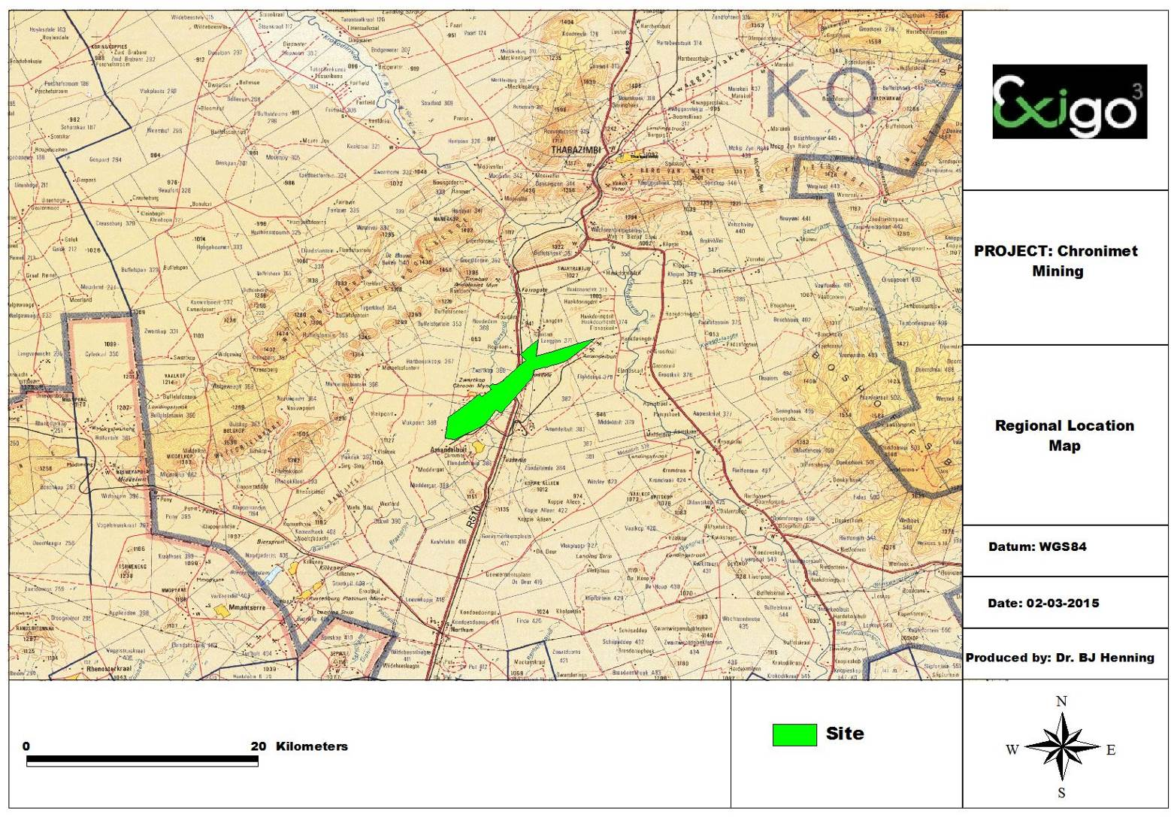

Figure 1. Regional Location Map
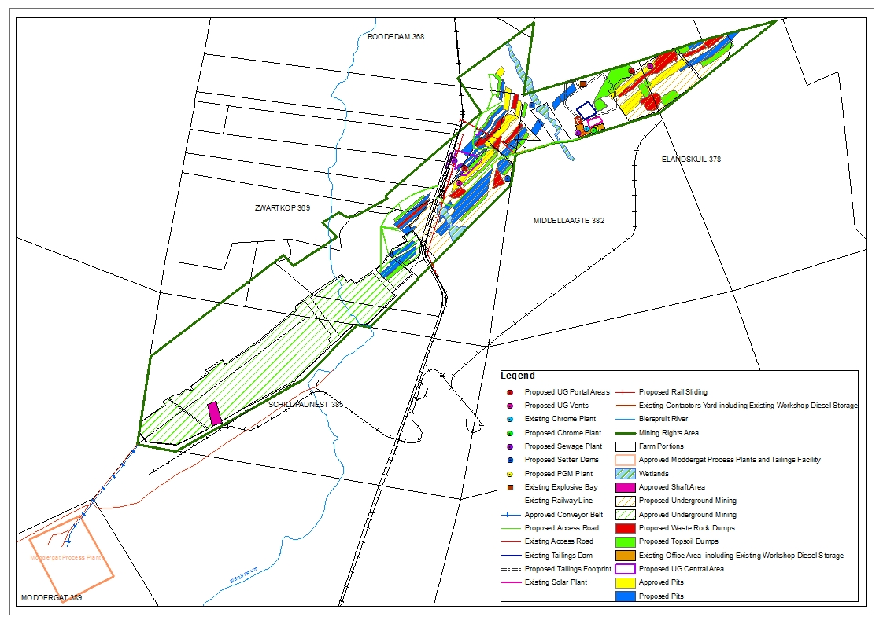

Figure 2. Layout plan of the Thaba Cronimet Mine
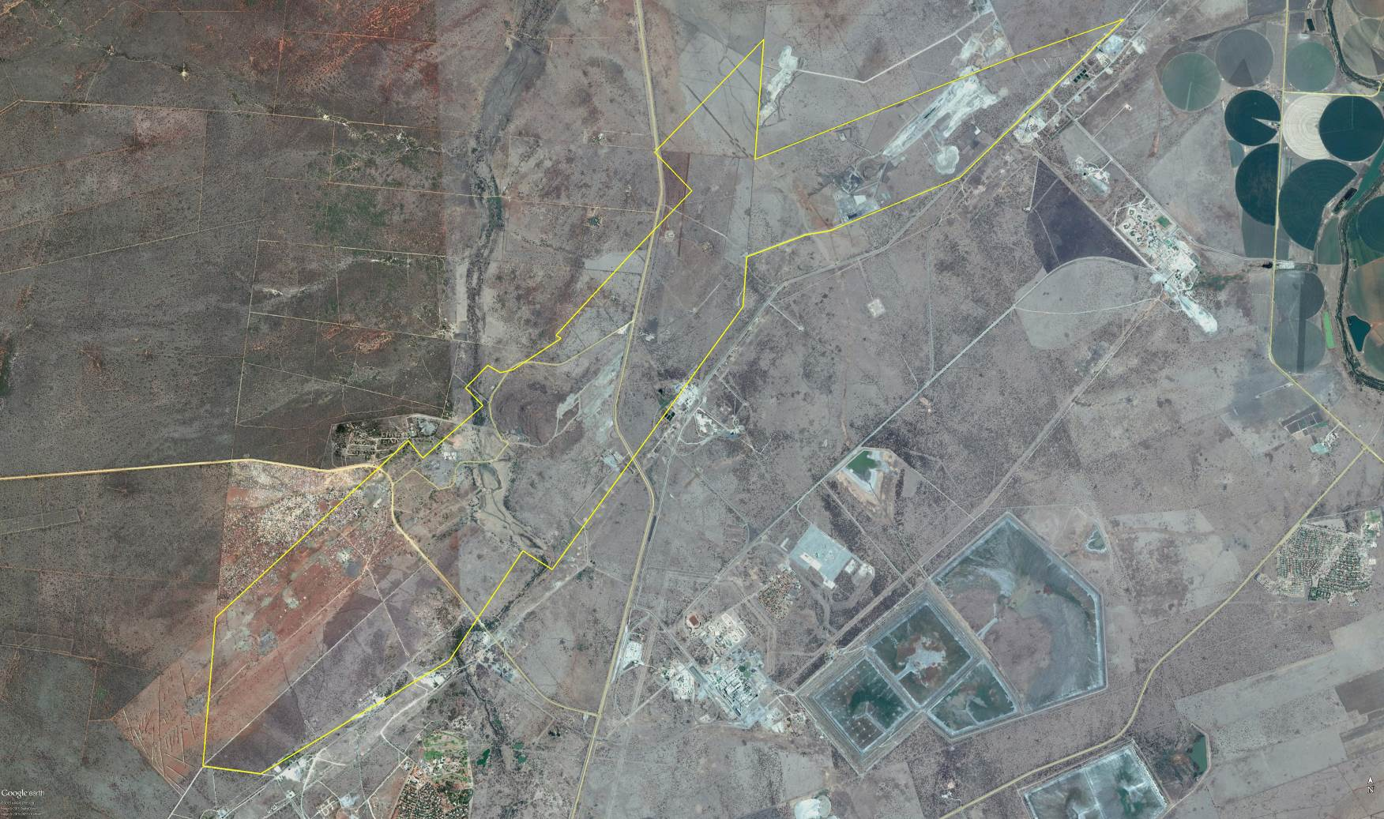

Figure 3. Satelite image showing the project area (Google Pro, 2010)

Climate
Climate in the broad sense is a major determinant of the geographical distribution of species and vegetation types. However, on a smaller scale, the microclimate, which is greatly influenced by local topography, is also important. Within areas, the local conditions of temperature, light, humidity and moisture vary greatly and it is these factors which play an important role in the production and survival of plants (Tainton, 1981). The climate for the region can be described as warm-temperate.
In terrestrial environments, limitations related to water availability are always important to plants and plant communities. The spatial and temporal distribution of rainfall is very complex and has great effects on the productivity, distribution and life forms of the major terrestrial biomes (Barbour et al. 1987).
Mean annual precipitation for the project area ranges from about 500-600mm. Aspects like topography, slope and altitude may result in differences in precipitation and water availability to plants within the study area. Frost is fairly infrequent in winter. The monthly maximum and minimum temperatures for the Thabazimbi area is 36.0˚C and -3.7˚C for February and June respectively.

Vegetation types
The development site lies within the Savanna biome which is the largest biome in Southern Africa. It is characterized by a grassy ground layer and a distinct upper layer of woody plants (trees and shrubs). The environmental factors delimiting the biome are complex and include altitude, rainfall, geology and soil types, with rainfall being the major delimiting factor. Fire and grazing also keep the grassy layer dominant. The most recent classification of the area by Mucina & Rutherford shows that the site is classified as Dwaalboom Thornveld.
The Dwaalboom Thornveld vegetation type has a least threatened conservation status, with 14% transformed and 6% statutorily conserved. This vegetation type in its pristine state is characterized by plains with layer of scattered, low to medium high deciduous microphyllous trees and shrubs with a few broadleaved tree species, and an almost continuous herbaceous layer dominated by grass species.

Geology and soil types
Geology is directly related to soil types and plant communities that may occur in a specific area (Van Rooyen & Theron, 1996). A Land type unit is a unique combination of soil pattern, terrain and macroclimate, the classification of which is used to determine the potential agricultural value of soils in an area. The land type unit represented within the study area include the Ea70 land type (Land Type Survey Staff, 1987) (ENPAT, 2001). The land type, geology and associated soil type is presented in Table 1 below as classified by the Environmental Potential Atlas, South Africa (ENPAT, 2000), while the location of the land types is presented in Figure 3.
Table 1. Land types, geology and dominant soil types of the proposed development site
Landtype | Soils | Geology
Ea70 | One or more of: vertic, melanic, red structured diagnostic horizons, undifferentiated | Predominantly norite and pyroxenite of the Bushveld Complex; red syenite of the Pilanesberg Complex in places.
The dominant soil types of the site are as follows:
- Soils associated with the outcrops and low ridges are of the Mispah or Glenrosah soil forms.
- Soils associated with the low-lying valleys and plains vary from being red, apedal soils of the Hutton soil or Shortlands soil forms to dark, clayey soils of the Arcadia soil form.
- Soil forms of the drainage channels and floodplains are dark and clayey (Valsrivier, Rensburg or Cartref soil forms).

Topography & Drainage
The project area is characterised by slightly undulating to flat plains with one major drainage channels bisecting the area, namely the Bier Spruit. The topography across the site is slightly undulating with the average elevation of 960 mamsl.
The site is located within the A24E quaternary catchment and is situated in the Limpopo Water Management Area. Drainage occurs as sheet-wash towards the major rivers.

METHODS

Vegetation survey
Two basic methods were used during the vegetation survey:
- Line transects were walked on the site surveyed to record the plant species present. Rare and threatened plant species and any botanically sensitive sites or habitats were searched for in the various vegetation units.
- The Braun-Blanquet survey technique to describe plant communities as ecological units was also used for this study. It allows for the mapping of vegetation and the comparison of the data with similar studies in the area.
The vegetation survey was conducted on site during early May and October 2009, while a follow-up survey was also conducted during February 2015. The vegetation was in a moderate to good condition and most species could be identified, although some species might have been missed as a result of the large site. No further surveys were necessary considering that the area received sufficient precipitation during the wet season to allow for the identification of most plants in the study area. Specific differences between the state of vegetation or specific impacts that occurred in the area will be addressed for the different surveying periods.

Data recorded:
Plant names used in this report are in accordance with Arnold & De Wet (1993), with the exception of a few newly revised species. A list of all plant species present, including trees, shrubs, grasses, forbs, geophytes and succulents were compiled. All identifiable plant species were listed. Notes were additionally made of any other features that might have an ecological influence as well as potential fauna habitat that might occur.

Red data species
A species list of the red data species previously recorded in the vicinity of the proposed development was obtained from the South African Biodiversity Institute (SANBI), South Africa as classified by the IUCN red data list categories.

Protected trees
A species list of the protected tree species was obtained from the Department of Forestry. These trees are listed by the NFA (Act 84 of 1998) as protected.

Protected plants
A list of protected and specially protected plants was obtained from the LEMA (2004).

Data processing
A classification of vegetation data was done to identify, describe and map vegetation types. The descriptions of the vegetation units include the tree, shrub and herbaceous layers.
Conservation priority of each vegetation unit was assessed by evaluating the plant species composition in terms of the present knowledge of the vegetation of the Limpopo Province, as well as the Dwaalboom Thornveld vegetation type and Savanna Biome of South Africa.
The following four conservation priority categories were used for each vegetation unit:
- High: Ecologically sensitive and valuable land with high species richness that should be conserved and no development allowed.
- Medium: Land that should be conserved but on which low impact development could be considered with the provision of mitigation measures.
- Medium-low: Land that has some conservation value but on which development could be considered with limited impact on the vegetation / ecosystem. It is recommended that certain sections of the vegetation be maintained.
- Low: Land that has little conservation value and that could be considered for developed with little to no impact on the vegetation / ecosystem.

FAUNA SURVEY
The fauna survey was conducted as follows:
- A site survey was done to identify potential habitats after identifying the vegetation units. Fauna observed on site or any specific indication of species was noted as confirmed in the species lists.
- A scoping survey was then conducted by comparing the habitat types identified with the preferred habitats of species occurring in the area.
The fauna survey was conducted on site during early May and October 2009, while a follow-up survey was also conducted during February 2015.

Data recorded:
A list of all species of fauna and their status as observed on the site or that could potentially occur on the site. Notes were made of any specific sensitive or specialized habitats that occur on the site.

Red data species lists
A species list of the red data species of the different faunal classes was obtained from the following references:
- Red Data Book of the Mammals of South Africa (Friedman & Daly, 2004)
- The Atlas of the Southern African Birds - digital data on quarter degree grid data (Avian Demography Unit, University of Cape Town)
- Atlas and red data book of the frogs of South Africa, Lesotho and Swaziland (Minter et al. 2004)
- South African Red Data Book – Reptiles and Amphibians. National Scientific Programmes Report no. 151;

Data processing
A comparison of the habitats (vegetation units) occurring on the property was made to the preferred habitats of the faunal species. In addition to species observed on the site, lists of the potential mammal, bird, reptile, amphibian and insect species were compiled and mitigating measures recommended if needed.

SENSITIVITY ASSESSMENT
The ecological sensitivity of any piece of land is based on its inherent ecosystem service and overall preservation of biodiversity.

Ecological function
The ecological function relates to the degree of ecological connectivity between systems within a landscape matrix. Therefore, systems with a high degree of landscape connectivity amongst one another are perceived to be more sensitive and will be those contributing to ecosystem service (e.g. wetlands) or overall preservation of biodiversity.

Conservation importance
Conservation importance relates to species diversity, endemism (unique species or unique processes) and the high occurrence of threatened and protected species or ecosystems protected by legislation.

Sensitivity scale
- High – sensitive ecosystem with either low inherent resistance or low resilience towards disturbance factors or highly dynamic systems considered being important for the maintenance of ecosystem integrity. Most of these systems represent ecosystems with high connectivity with other important ecological systems or with high species diversity and usually provide suitable habitat for a number of threatened or rare species. These areas should be protected;
- Medium – These are slightly modified systems which occur along gradients of disturbances of low-medium intensity with some degree of connectivity with other ecological systems or ecosystems with intermediate levels of species diversity but may include potential ephemeral habitat for threatened species;
- Low – Degraded and highly disturbed / transformed systems with little ecological function and which are generally very poor in species diversity.

Impact rating assessment
To ensure uniformity, the assessment of impacts is addressed in a standard manner so that a wide range of impacts can be compared with each other. For this reason a clearly defined significance rating scale was provided to specialist consultants to assess the significance (importance) of the associated impacts. The scale embraces the notion of extent and magnitude, but does not always clearly define these since their importance in the rating scale is very relative. For example, the magnitude (i.e. the size) of area affected by atmospheric pollution may be extremely large (1000 km2) but the significance of this effect is dependent on the concentration or level of pollution. If the concentration is great, the significance of the impact would be HIGH or VERY HIGH, but if it is dilute it would be LOW or VERY LOW. Similarly, if 60 ha of a grassland type are destroyed the impact would be VERY HIGH if only 100 ha of that grassland type was present. The impact would be VERY LOW if the grassland type was common.
As with all studies it is not possible to be 100% certain of all facts, and for this reason a standard “degree of certainty” scale is used. A timescale is included over which impact would operate: short term (1 year), medium term (life of mine) and long term (beyond the life of mine). The impacts are discussed in terms of affected parties or environmental components.
This section outlines the methodology for the impact assessment which is done both qualitatively and quantitatively for impacts in the EIR phase of the authorisation. Impacts are to be assessed both without and with mitigation measures. Potential impacts are to be reported on for the planning and design phase, construction phase, operational phase, decommissioning phase and closure and rehabilitation phase of the project. The impact assessment methodology is presented in table 2.

Table 2. Impact assessment methodology for the qualitative and quantitative
Criteria | Selection | Description | Rating
Status | Positive | A benefit to the holistic environment | -1
Status | Negative | A detriment to the holistic environment | 1
Certainty | Improbable | In all likelihood the impact will not occur. Less than 20 percent probability of a particular fact or of the likelihood of an impact occurring. | 1
Certainty | Low probability | Possibility of the impact to materialise is low. Between 20 and 50 percent probability of a particular fact or of the likelihood of an impact occurring. | 2
Certainty | Probable | A distinct possibility that the impact will occur. Between 50 and 80 percent probability of a particular fact or of the likelihood of an impact occurring. | 3
Certainty | Highly probable | Most likely that the impact will occur. More than 80 percent probability of a particular fact or of the likelihood of an impact occurring. | 4
Certainty | Definite | The impact will occur regardless of any prevention measures. 100 percent probability of a particular fact or of the likelihood of an impact occurring. | 5
Frequency | Continuous | Occurs on a daily basis | 4
Frequency | Frequent | Occurs on a weekly basis | 3
Frequency | Infrequent | Occurs on less than a monthly basis | 2
Frequency | Occasional | Occurs on a monthly basis | 1
Spatial | Site specific | Effects occur within the mining right boundary | 1
Spatial | Local | Effects extend beyond the mining right boundary, up to five kilometres from the mining right boundary | 2
Spatial | Regional | Widespread effect with impacts extending far beyond the mining right boundary, but within a 50 kilometre radius of the boundary | 3
Spatial | National | Within the boundaries of South Africa but further than the Limpopo Province | 4
Spatial | International | Beyond the boundaries of South Africa | 5
Intensity | Very INTENSE | Substantial deterioration  Irreversible or permanent change  Cannot be mitigated | 4
Intensity | INTENSE | Marked deterioration  Long term duration  Serious and INTENSE impacts  Mitigation is very expensive, difficult or time consuming | 3
Intensity | Moderately INTENSE | Moderate deterioration  Medium term to long term duration  Fairly easily mitigated | 2
Intensity | Slight | Minor deterioration  Short to medium term duration  Mitigation is easy, cheap or quick | 1
Duration | Short term | The environmental impact identified will be present for less than 10 years | 1
Duration | Medium term | The environmental impact identified will be present for life of mine (approximately 20 years) | 2
Duration | Long term | The environmental impact identified will be present beyond the life of mine | 3
Duration | Permanent | The environmental impact identified will be irreversible and will remain post closure | 4
Significance for negative impacts | High | Long term or permanent change to the natural and social environment. Of the highest order possible within the bounds of impacts which could occur. In the case of adverse impacts, there is no possible mitigation and/or remedial activity which could offset the impact. In the case of beneficial impacts, there is no real alternative to achieving this benefit. | 17 - 22
Significance for negative impacts | Medium | Impact is real but not substantial in relation to other impacts which might take effect within the bounds of those which could occur. In the case of adverse impacts, mitigation and/or remedial activity are both feasible and possible. In the case of beneficial impacts, other means of achieving this benefit are feasible but they are more difficult, expensive, time-consuming or some combination of these. | 11 - 16
Significance for negative impacts | Low | Impact is of a low order and therefore likely to have little real effect. In the case of adverse impacts, mitigation and/or remedial activity are not required, easily achieved, inexpensive or a combination of these. In the case of beneficial impacts, alternative means for achieving this benefit are likely to be easier, cheaper, more effective, less time consuming, or a combination of these. | 5 - 10
Significance for positive impacts | High | A large benefit to the holistic environment | 17 – 22
Significance for positive impacts | Medium | A benefit to the holistic environment | 11 – 16
Significance for positive impacts | Low | No real benefit to the holistic environment | 5 – 10

Qualititative impact assessment
Each impact will be qualitatively assessed as per Table 2 proving context and reasons for the description that has been chosen. Each impact is to be qualitatively assessed with and without mitigation. The qualitative and quantitative ratings of each impact are to be aligned. In order to make this report easier to read, the following notation format is used to highlight the various components of the assessment.
• Significance– colour coded (red for high, orange for medium and green for low and reversed colour coding for positive impacts)
- Duration – Underline
- Certainty – in bold
- Severity / Intensity – CAPITALS
- Frequency – italics
- Spatial – normal font

Quantitative impact assessment
The quantitative ratings are used to rate the impact as per the format in Table 2. The rankings of each of the different impacts relates to the maximum and minimum totals that can be achieved for each possible impact. The totals of the ratings are used to calculate the threshold “classes” to determine the significance of the impact.
For example: A negative impact (1) X (certainty + frequency + extent + intensity + duration) = Rating

RESULTS: ecological assessment

FLORA
The proposed mining site occurs on a slightly undulating to flat landscape with scattered outcrops. The area is bisected by the Bier Spruit and its tributaries. The farms surrounding this farm are primarily used for mining, crop cultivation, cattle farming and game farming.
Vegetation units were identified according to plant species composition, previous land-use, soil types and topography. The state of the vegetation of the proposed mining site varies from being natural to completely degraded. The farms are currently zoned as agriculture and special private resorts
The vegetation communities identified in the area are classified as physiographic physiognomic units, where physiognomic refers to the outer appearance of the vegetation, and physiographic refers to the position of the plant communities in the landscape. The physiographic-physiognomic units will be referred to as vegetation units in the following sections. These vegetation units are divided in terms of the topographical differences, previous land-use and soil differences that had the most definitive influence on the vegetation units. Each unit is described in terms of its characteristics. A species list for each of the units and photographs of the woody structure is included in the Photographic Guide at the end of the document. The analysis of the data resulted in the identification of 7 major vegetation / ecological units (Table 3) during the 2009 surveys, although impacts such as mining that occurred between the original surveys and 2015, caused some of these vegetation units to be partially fragmented with impacts on the surrounding vegetation units such as dust. A vegetation map was compiled as indicated in figure 4 for the 2009 surveys, while Figure 5 indicates the current vegetation units (e.g. changes to vegetation as a result of mining, agricultural activities etc.).
Table 3. Vegetation units occurring in the study area
- Acacia tortilis – Ziziphus mucronata – Peltophorum africanum woodland
- Acacia tortilis – Acacia nilotica woodland
- Valley bottom Wetlands
- Seepage wetlands
- Riparian woodland
- Rocky Outcrops and ridges
- Degraded bushveld (old mining dumps; tribal land)
- Old fields
- Dense Knobthorn thickets

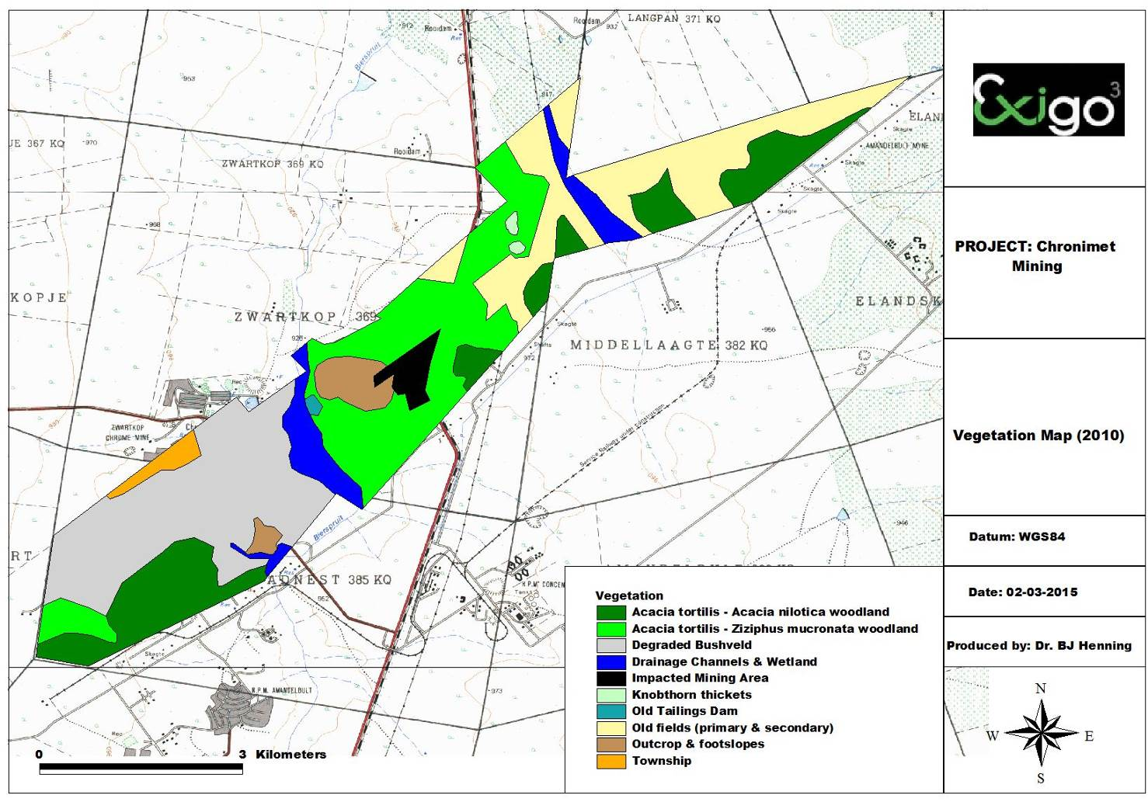

Figure 4. Vegetation Map of the project areas as surveyed during 2010
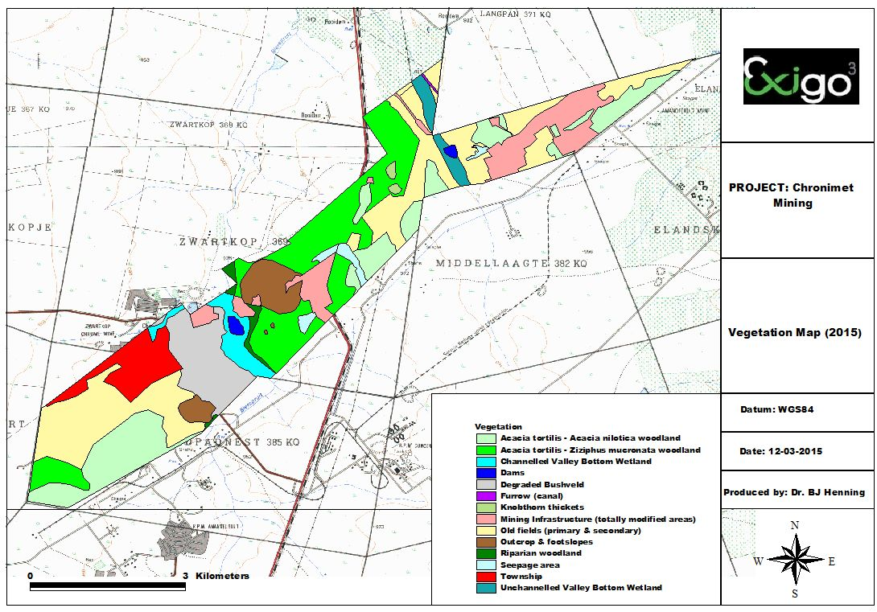

Figure 5. Vegetation Map of the 2015 survey indicating specific changes that occurred between 2009 and 2015

Acacia tortilis – Ziziphus mucronata – Peltophorum africanum Woodland
Status:
Microphyllous Woodland

Need for rehabilitation
Low

Conservation Priority:
Medium to medium - Low
Soil | Deep fertile Hutton soils | Rockiness | <1%
Dominant spp. | Acacia tortilis, Ziziphus mucronata, Grewia flava, Peltophorum africanum, Cymbopogon plurinoides

This vegetation unit occurs on slightly undulating to flat low plains and is characterized by microphyllous woodland varying in density. The soils are fertile, red Hutton soils derived from Gabbro. The characteristics of the vegetation unit are discussed below in table 4. The state of the herbaceous layer is in a climax state and the shrub layer is well developed. Typical woody species occurring in this vegetation unit include Acacia tortilis, Ziziphus mucronata and Peltophorum africanum.
Table 4. Botanical analysis and characteristics of Acacia tortilis – Ziziphus mucronata woodland
Location: | Eastern section of the study area on the farm Zwartkop and a small section of the farm Roodedam
State of the vegetation: | Pristine state
Characteristics | Open woodland with a dense grass layer and little or no forbs.
Density of woody layer | Trees: 15-20% (avg. height: 3-6m)  Shrubs: 5-10% (avg. height: 1-2m)
Density of herbaceous layer | Grasses: 70-80% (avg. height: 1.2m)  Forbs: <1 (avg. height: 0.5m)
Sensitivity | Medium – indigenous woodland with unique features; protected tree species
Red data species | None observed; no potential habitats
Protected tree species | Combretum imberbe
Recommendation: Considering that the area occurs in between degraded areas the proposed mining development can be supported in this vegetation unit provided that strict mitigation measures are implemented. Mitigation measures needed for the development will be discussed under Recommendations and Management Strategies for Flora.
Changes to vegetation between 2009 and 2015:

Acacia tortilis – Acacia nilotica Woodland
Status:
Varies between open to denser microphyllous Woodland

Need for rehabilitation
Medium to low

Conservation Priority:
Medium - Low
Soil | Vertic clay soils (black turf soils of the Arcadia soil form) derived from Gabbro | Rockiness | <1%
Dominant spp. | Acacia tortilis, Acacia nilotica, Cymbopogon plurinoides, Digitaria eriantha

This vegetation unit is one of the most common and dominant natural vegetation entities occurring throughout the study area. The vegetation structure is characterized by a woodland structure that varies from open to denser woodland dominated by microphyllous tree species such as Acacia tortilis and Acacia nilotica, while the shrub layer is poorly developed. The substrate is black, vertic clays derived from Gabbro and Norite. The herbaceous layer is well developed and mostly dominated by grass species with little or no forbs present.
The characteristics of both variations of this vegetation unit are presented in table 5:
Table 5. Botanical analysis and characteristics of Acacia tortilis – Acacia nilotica woodland
 | Open variation | Denser variation
Location: | Scattered throughout the northeastern and southwestern sections of the study area. | Scattered throughout the northeastern and southwestern sections of the study area.
State of the vegetation: | Pristine state | Pristine state
Characteristics | Open woodland with a dense grass layer and little or no forbs. | Denser woodland with some shrubs present. Some slight encroachment has occurred in isolated areas.
Density of woody layer | Trees: 10-15% (avg. height: 3-6m)  Shrubs: 1-2% (avg. height: 1-2m) | Trees: 20-25% (avg. height: 3-6m)  Shrubs: 2-5% (avg. height: 1-2m)
Density of herbaceous layer | Grasses: 70-80% (avg. height: 1.2m)  Forbs: <1 (avg. height: 0.5m) | Grasses: 60-70% (avg. height: 1.2m)  Forbs: <1 (avg. height: 0.5m)
Sensitivity | Medium – indigenous woodland with a widespread status | Medium – indigenous woodland with a widespread status
Red data species | None observed; no potential habitats | None observed; no potential habitats
Protected tree species | None | None

Recommendation: The mining development can be supported in this vegetation unit. Specific mitigation measures would be needed considering the pristine state of the vegetation in general. It is recommended that a section of this woodland area be conserved adjacent to the drainage channel (floodline zone)
Changes to vegetation between 2009 and 2015: Mining activities have completely cleared some sections of this woodland type in the north-eastern section of the project area.

Dense Knobthorn thickets
Status:
Dense Microphyllous Woodland

Need for rehabilitation
Medium to high

Conservation Priority:
Medium - Low

Soil | Deep fertile Hutton soils | Rockiness | <1%
Dominant spp. | Acacia nigrescens, Acacia tortilis

This vegetation unit is characterized by the dense stands of Acacia nigrescens trees occurring on red Hutton soils. The state of the woody layer can be considered as seriously encroached in some areas. The present legislation under the Conservation of Agricultural Resources Act, 1983 (Act No 43 of 1983) (CARA), regulation 16, states that bush encroachers, which are indigenous plants, require sound management practices to prevent them from becoming problematic. Bush encroachment is a term used for "stands of plants such as sickle bush and various Acacia species where individual plants are closer to each other than three times the mean crown diameter". Vegetation associated with encroached areas usually occurs in previously disturbed or overgrazed sites (Van der Meulen, 1979). Werger (1977) showed that when severely and prolonged overgrazing in the semi-arid savanna ecosystem occurs, the grass component is severely restricted in growth, or in moisture usage. More moisture remains thus available in the soil to be used by the woody plants, and the result is bush encroachment, a structural change towards more strongly woody vegetation Van der Meulen (1979) described it as one of the most seriously disturbed types of vegetation in the Central Bushveld, with overgrazing, trampling and erosion being common problems. Ecological management need therefore be implemented in these areas to address the problem.
Table 6 below indicates the botanical characteristics of this vegetation unit.
Table 6. Botanical analysis and characteristics of Acacia nigrescens thickets
Location: | Isolated sections of the farm Zwartkop
State of the vegetation: | Encroached state forming dense, often impenetrable thickets in some areas
Characteristics | Almost completely dominated by knobthorn trees. Encroached due to old cattle kraal that was located in these areas causing the soils to be enriched.
Density of woody layer | Trees: 40-50% (avg. height: 3-6m)  Shrubs: 10-15% (avg. height: 1-2m)
Density of herbaceous layer | Grasses: 40-50% (avg. height: 1.2m)  Forbs: <1 (avg. height: 0.5m)
Sensitivity | Medium-low – encroached woodland with indigenous elements still being present. Bush clearing should allow area to recover to its former state.
Red data species | None observed; no potential habitats
Protected tree species | None
Recommendation: Development of the opencast mining development and infrastructure can be supported in the area, especially considering the encroached state of the vegetation.
Changes to vegetation between 2009 and 2015: No specific changes occurred to this vegetation unit

Riparian woodland
Status:
Varies from degraded grassland (tribal land) to closed grassland (Middellaagte)

Need for rehabilitation
Low

Conservation Priority:
High
Soil | Fertile, alluvial soils (black clayey) | Rockiness | <1%
Dominant spp. | Acacia karroo, Combretum erythrophyllum, Ziziphus mucronata, Melia azedarach, Setaria incrassatae, Rhus lancea

This vegetation unit includes the riparian woodland associated with the water courses (Bier Spruit and tributaries) found on the property. The vegetation structure of the drainage channel varies from a sandy riverbed with alluvial sand and conglomerates to a closed woodland along the riverbanks. Most of the drainage channels are non-perennial, with some sections of the Bier Spruit forming earth dams. Typical woody species of the periphery of the drainage channels include species like Acacia karroo, Ziziphus mucronata, Combretum erythrophyllum, Searsia lancea and the exotic species Melia azedarach. Where the drainage channel cuts through rocky sections, several of the species associated with these rocky areas can be found. The herbaceous component is well developed along the riverbanks mostly dominated by species such as Sporobolus africanus and Panicum maximum. The importance to take the floodline into consideration during any mining development should receive high priority. Buffer zones should be adapted around drainage channels to ensure that peripheral impacts are avoided. Three different variations of the drainage channels occur in the study area:
- The areas in the floodline zone of the Bier Spruit forming part of the tribal land on the farm Zwartkop have been degraded to a large extent. Many exotic weeds and grasses occur on the floodplains and the area needs to be rehabilitated. Some earth dams also occur in the drainage channel and these dams play an important role as waterbird habitats. The mining development should aim at preserving the dams and rehabilitate the drainage channel. This will ensure that the drainage channel serve as an important corridor for birds and amphibians species, while further acting as a water source for small mammals and reptiles.
The following general recommendations are made for the drainage channels:
- The vegetation associated with all floodline zones is classified as a high sensitivity area with a high conservation priority. No alteration of these important drainage areas is recommended, especially considering it to be an important catchment.
- The drainage channels are also important corridors for fauna.
- Only existing roads should be used to cross drainage lines, and mitigating measures should be implemented to prevent erosion of roads across drainage lines.
- All alien species (prickly pear, Melia, Sesbania) should be eradicated, while larger tree species should be preserved to enhance the aesthetic state of the habitat.
- No development is planned in this area although the mining activities might indirectly impact on the natural drainage of the area as follows:
  - The development of the stockpiles, waste rock dumps, tailings storage facilities, processing plant and infrastructure often interrupts some of the natural drainage paths. Interference with drainage patterns may result in deprivation of water to drainage systems downstream of the mining developments or localised ‘shadowing’ effects on some vegetation which may be reliant on intermittent flows.
  - Another impact on the surface water during the operational phases would be the deterioration of surface water quality due to contamination of runoff by mining activities
  - Contamination events due to overtopping in the event of flooding and seepage from containment dams.
  - Impact on wetland systems by mining activities
- Changes to vegetation between 2009 and 2015: No specific visible changes occurred to this vegetation unit, although seepage from the tailings dam currently seeps into this wetland type.

Seepage wetlands
Seepage wetlands have been described by the wetland specialist for this project as artificial wetland created through leakage and overflow from the dams and tailings dams in the project area. The seepage wetlands are considered to potentially play an important role in trapping pollutants and contaminants that might be contained in the water from the mines. Mine water is typically expected to have elevated levels of chlorides, sulphates and nitrates. The more westerly of these dams and associated seepage wetland has no direct link to the valley bottom wetlands or riparian areas on site, while the eastern seepage wetland feeds into a narrow riparian zone via a culvert under the R510 road. The most current seepage leaks from the tailings dam of the new Thaba Cronimet Mine into the Unchannelled Valley Bottom at present. This needs to be contained to prevent polluted water having a negative impact on the wetlands.
The seepage wetlands downstream of the dams assumed to be associated with mining activities are dominated by Phragmites australis and Typha capensis in the permanently wet areas, while the edges represent a mix between terrestrial and wetland species. The artificial wetands are still classified as having a Medium-High Sensitivity and rehabilitation of these areas are recommended.

Valley bottom (VB) wetlands
DWAF (2003) states that in order to classify an area as a wetland it must have one or more of the following attributes:
- Hydromorphic soils that exhibit features characteristic of prolonged saturation;
- The presence of hydrophytes (even if only infrequently);
- A shallow water table that results in saturation at or near the surface, leading to the development of anaerobic conditions in the top 50cm of the soil.
The wetlands on site can be classified as valley bottom wetlands (channelled and unchannelled). The wetland areas have a high sensitivity and any changes or flow interruptions should be avoided if possible. Alternatively an application should be launched to the DWA to obtain an Integrated Water Use Licence.

Unchannelled VB wetlands
The closed grassland areas associated with the valley bottom wetland on the farm Middellaagte form a very open flat wetland area that can be considered as an unchannelled VB wetland. Indicator species of the seasonally wet conditions include Setaria incrassatae and Acacia tenuispina. This area can be considered sensitive although some opencast mining activities are planned in the area.
An unchannelled valley-bottom wetland is a mostly flat valley-bottom wetland area without a major channel running through it, characterised by an absence of distinct channel banks and the prevalence of diffuse flows, even during and after high rainfall events. Water inputs are typically from an upstream channel, as the flow becomes dispersed, and from adjacent slopes (if present) or groundwater. Water generally moves through the wetland in the form of diffuse surface flow and/or interflow (with some temporary containment of water in depressional areas), but the outflow can be in the form of diffuse or concentrated surface flow. Infiltration and evaporation from unchannelled valley-bottom wetlands can be significant, particularly if there are a number of small depressions within the wetland area. Horizontal, unidirectional diffuse surface-flow tends to dominate in terms of the hydrodynamics.
A small farm dam has been constructed across the unchannelled valley bottom wetland, while two excavations located adjacent to the valley bottom wetland are also likely to collect water during the rainy season. The presence of the small dam, presumably built by farmers to retain surface water on site for livestock, provides evidence that surface run-off does however occur within this system, despite the flat terrain (Wetland consulting services, 2009).
Changes to vegetation between 2009 and 2015: No specific changes occurred to this vegetation unit.

Channelled VB wetlands
This wetland type can be classified as a ‘Channelled Valley bottom Wetland’ and represent the section of the Bier Spruit in the project area. The large dam constructed across the river roughly in the centre of the study area is believed to have contributed towards the formation of the wetland conditions along this portion of the river due to the extended retention time and increased flow of water. Further upstream and downstream of the large dam and the Amandelbult Mine the Bierspruit is associated with a riparian zone (Wetland Consulting Services, 2009). Typical wetland species observed within this portion of the Bierspruit include Phragmites australis, Typha capensis, Schoenoplectus sp., Setaria sp., Sorghum bicolour, Imperata cylindrical and various Cyperaceae. The retention of water and the large expanse of open water and muddy
shoreline provided by the large dam has created an ideal water bird habitat and numerous species of water birds were recorded on.
A channelled valley-bottom wetland is classified as a mostly flat valley-bottom wetland dissected by and typically elevated above a channel. Dominant water inputs to these areas are typically from the man-made channels in the area, either as surface flow resulting from overtopping of the channel bank/s or as interflow, or from adjacent valley-side slopes (as overland flow or interflow). Water generally moves through the wetland as diffuse surface flow, although occasional, short-lived concentrated flows are possible during flooding events. Small depressional areas within the channelled valley-bottom wetland can result in the temporary containment and storage of water within the wetland. Water generally exits in the form of diffuse surface flow and interflow, with the infiltration and evaporation of water from these wetlands also being potentially significant (particularly from depressional areas). The hydrodynamic nature of channelled valley-bottom wetlands is characterised by bidirectional horizontal flow, with limited vertical fluctuations in depressional areas (SANBI, 2009).
Changes to vegetation between 2009 and 2015: No specific changes occurred to this vegetation unit

Old Fields
Status:
Primary Old Fields:
Degraded grassland

Secondary Old Fields:
Open, degraded woodland

Need for rehabilitation
Medium to high

Conservation Priority:
Low

Soil | Fertile Hutton soils, black vertic clays | Rockiness | <1%
Dominant spp. | Primary Old Fields: Aristida spp., Melinis repens, Cynodon dactylon  Secondary Old Fields: Acacia tortilis

The old fields occur on all of the farms in the study area. When cultivated fields are left fallow, it results in a landscape mosaic of patches of secondary vegetation varying in age and dominated by various grass species (Moll, 1965). Different stages of succession occur in the old fields, and Wildi (2002) described how dynamic these systems are over time and space. The most common old fields in the Savanna Biome and surroundings are the young old fields of 1-5 years old (Smits et al. 1999) dominated by the pioneer grass species of disturbed areas, Cynodon dactylon (Van Oudtshoorn, 1999). Secondary grassland communities may develop from this old field variation as shown by Smits et al. (1999) in the old fields of the Transkei, dominated by the secondary grassland species directly related to man-made disturbances, Hyparrhenia hirta. These fields are still in an early successional state, although somewhat older (older than 5 years) with several grass species like Hyperthelia dissoluta, Aristida junciformis, Aristida congesta s. congesta and Eragrostis rigidior. The landscape and vegetation features of the primary old fields on the proposed mining development site include slightly undulating plains with a low tree cover (< 1%) and dense (60%) grass layer. The dominant species include Cynodon dactylon and Aristida spp. indicating previous agricultural/utilizing activities within these areas, while typical herbs/weeds include Tagetes minuta and Bidens bipinnata. The shrub layer (1 - 1,5m.) on the primary old fields covers 1 – 2%, while the forb layer covers 30% of the area. The soil in the area is red Hutton soils or black clayey soils.
The outer successional stage of old fields only starts after several years of abandonment when woody species start to invade. These secondary old fields are usually dominated by species such as Dichrostachys cinerea, Acacia tortilis and Ziziphus mucronata. Where overgrazing occurs the encroacher Dichrostachys cinerea becomes dominant as is evident on certain areas of the site. The landscape and vegetation features of this unit include slightly undulating plains with Hutton or Arcadia soils. The tree layer (> 3m.) covers 5 -10%, while the shrub layer covers 10-15% (different variants) of the area. The grass layer is well developed with a 60 -70% cover, while the forb layer (0.2m.) covers 1 – 2 % of the area. The dominant tree species in the area include Acacia tortilis and Dichrostachys cinerea. This vegetation unit is defined as a secondary old field variant/modified land which is evident from the higher tree cover/diversity as well as the higher shrub cover/diversity.
No red data species were found on the old fields as a result of the degraded state of the vegetation. The following general ecological observations and recommendations were made for the area:
- The old fields have a low sensitivity due to the degraded, modified state of the vegetation.
- Old fields contribute to grazing for livestock and game species and therefore have a high value in terms of grazing potential.
- The local extent of the mining impact on the area would be low.
General recommendations:
- The proposed activities can be supported in both areas, although mitigation measures are needed in some areas. The mitigation measures and recommendations for both major areas are discussed later in the report.
- Changes to vegetation between 2009 and 2015: Mining activities have completely cleared some sections of this woodland type in the north-eastern section of the project area
Status:
Degraded open woodland

Need for rehabilitation
High

Conservation Priority:
Low

Degraded bushveld (Old mining dumps)

Soil | Deep fertile Hutton soils | Rockiness | <1%
Dominant spp. | Acacia tortilis, Dichrostachys cinerea, Aristida spp., Exotic weeds

The degraded areas occur on the tribal land areas of the farms Zwartkop and Schilpadnest. The vegetation of the site is characterized by exotic weeds and woody species such as Acacia tortilis and Dichrostachys cinerea. The area has become degraded through previous and current mining activities in the area, as well as anthropogenic influences of the local communities. Several mine dumps was observed in the area. The area needs to be rehabilitated. Table 7 indicates specific characteristics of this vegetation unit:
Table 7. Botanical analysis and characteristics of Degraded Bushveld areas
Location: | Areas around current mining activities and around local township on the farms Schilpadnest and Zwartkop
State of the vegetation: | Degraded
Characteristics | Open woodland with degraded herbaceous layer – high percentage exotic weeds and pioneer grasses.
Density of woody layer | Trees: 10-15% (avg. height: 3-6m)  Shrubs: 2-5% (avg. height: 1-2m)
Density of herbaceous layer | Grasses: 40-50% (avg. height: 1.2m)  Forbs: <1 (avg. height: 0.5m)
Sensitivity | Low – modified, degraded land
Red data species | None observed; no potential habitats
Protected tree species | None
General recommendations: The proposed activities can be supported in the degraded areas.

Changes to vegetation between 2009 and 2015: No specific changes occurred to this vegetation unit

Rocky outcrops and ridges
Status:
Open woodland

Need for rehabilitation
Low

Conservation Priority:
High

Soil | Shallow Glenrosah / Mispah soils derived from gabbro / norite | Rockiness | 50-60%
Dominant spp. | Natural outcrops: Croton gratissimus, Acacia caffra, Combretum molle  Archaeological sites: Acacia mellifera, Olea europaea, Aloe marlothii
Rocky outcrops and ridges in the savanna biome of South Africa are often habitats for red data and endemic species of an area, while also supporting a unique floral and faunal species composition. The vegetation unit representing this entity on the study area form part of the farm Zwartkop. Although no unique or red data species was encountered on the site, the rockiness, slope and state of the vegetation played an important role in determining the area to have a high sensitivity.
The outcrop adjacent to the secondary road on the farm Schilpadsnest is old archaeological sites and can be identified by the wall structures and specific plant species composition of the area. Species such as Agave sesillana and Aloe marlothii indicate the archaeological sites.
The landscape geomorphology of the natural rocky areas can be described as moderately steep sloping outcrops on the farm Zwartkop. The terrain is rocky with the rockiness varying between 50 and 60%, which occur throughout the area. The soil pattern is mostly the Mispah and Glenrosah soil forms. Gertenbach (1987) describes rainfall as the single most important component of climate determining vegetation patterns, while Bothma (1996) stated that northern slopes are warmer than south facing slopes in South Africa, and subsequently drier, causing plants to have a higher rate of evapotranspiration. Therefore, plants that are adapted to drier conditions will grow on these slopes. Furthermore, aspects like the degree of slope will also determine the amount of surface runoff after precipitation and direct sunlight having direct effects on water availability and sunlight for plants.
Table 8 below indicates specific characteristics of the rocky areas in the study area:
Table 8. Botanical analysis and characteristics of rocky outcrop areas
 | Archaeological sites  (Schilpadsnest) | Natural outcrops (Zwartkop)
Location: | Central section of the farm Schilpadsnest adjacent to the secondary road | Central section of the farm Zwartkop
State of the vegetation: | Slightly degraded state | Pristine state
Characteristics | Mixed broadleaf woodland with high percentage exotic weeds and other exotic trees and microphyllous elements. Species such as sessile trees and black thorn dominant. | Broadleaf woodland.  Steep rocky slopes
Density of woody layer | Trees: 15-25% (avg. height: 3-6m)  Shrubs: 2-5% (avg. height: 1-2m) | Trees: 5-20% (avg. height: 3-6m)  Shrubs: 2-5% (avg. height: 1-2m)
Density of herbaceous layer | Grasses: 40% (avg. height: 1.2m)  Forbs: <1 (avg. height: 0.5m) | Grasses: 50% (avg. height: 1.2m)  Forbs: 5-10 (avg. height: 0.5m)
Sensitivity | High sensitivity – high percentage rockiness with unique species composition | High sensitivity – high percentage rockiness with steep slopes and unique species composition
Red data species | None observed; no potential habitats | None observed; although potential habitats occur in the rocky areas
Protected tree species | None | Sclerocarya birrea

Recommendations: Preferably no development should occur on this high sensitivity rocky areas. The impact on these areas will be low considering that none of the proposed activities are planned in the rocky areas and subsequently no impact rating was considered necessary.
Changes to vegetation between 2009 and 2015: Vegetation remainded unchanged considering that no activities occurred within these areas.

Recommendations & management strategies for flora
South Africa has been recognized as having remarkable plant diversity with high levels of endemism. The major threats to plants in the study area are urban expansion, non-sustainable harvesting, collecting, overgrazing/browsing, mining and agriculture. The objective of this section was to compile a list of plant species for which there is conservation concern. This included threatened, rare, declining, protected and endemic species.

Red data Flora Species
A list of red data plant species previously recorded in the study area in which the proposed development is planned was obtained from the Plants of Southern Africa (POSA) database of SANBI. There are various categories for Red Data Book species, such as ‘Endangered’, ‘Vulnerable’, ‘Rare’ and ‘Near threatened’ as listed in the Red Data List of Southern African Plants (Hilton-Taylor 1996). No red data species exist according to the SANBI data base for the grid squares and no other potential red data species was observed during the surveys.

Protected tree species
The National Forest Act (no.84 of 1998: National Forest Act, 1998) provides a list of tree species that are considered important in a South African perspective as a result of scarcity, high utilization, common value, etc. In terms of the National Forest Act of 1998, these tree species may not be cut, disturbed, damaged, destroyed and their products may not be possessed, collected, removed, transported, exported, donated, purchased or sold – except under license granted by DAFF (or a delegated authority). Four protected tree species was observed and documented during the surveys. Obtaining relevant permits are therefore required prior to any impact on these individuals even though many young individuals occur on the property.
Table 9 indicate the protected tree species occurring in the area.
Table 9. List of protected tree species found on the proposed development area according to habitat type
Protected Tree species (NFA) | Habitat in area
Sclerocarya birrea | Sandy soils
Boscia albitrunca | Sandy & limestone areas
Combretum imberbe | Clayey and calcareous soils associated with woodland and riparian zones

Invasive alien species
Invasive alien plants pose a direct threat not only to South Africa’s biological diversity, but also to water security, the ecological functioning of natural systems and the productive use of land. They intensify the impact of fires and floods and increase soil erosion. Of the estimated 9000 plants introduced to this country, 198 are currently classified as being invasive. It is estimated that these plants cover about 10% of the country and the problem is growing at an exponential rate.
The Alien and Invasive Species Regulations (GNR 599 of 2014) are stipulated as part of the National Environmental Management: Biodiversity Act (10/2004). The regulation listed a total of 559 alien species as invasive and further 560 species are listed as prohibited and may not be introduced into South Africa. Below is a brief explanation of the four categories of Invasive Alien Plants as per the regulation.
Category 1a: Invasive species requiring compulsory control. Remove and destroy. Any specimens of Category 1a listed species need, by law, to be eradicated from the environment. No permits will be issued.
Category 1b: Invasive species requiring compulsory control as part of an invasive species control programme. Remove and destroy. These plants are deemed to have such a high invasive potential that infestations can qualify to be placed under a government sponsored invasive species management programme. No permits will be issued.
Category 2: Invasive species regulated by area. A demarcation permit is required to import, possess, grow, breed, move, sell, buy or accept as a gift any plants listed as Category 2 plants. No permits will be issued for Category 2 plants to exist in riparian zones.
Category 3: Invasive species regulated by activity. An individual plant permit is required to undertake any of the following restricted activities (import, possess, grow, breed, move, sell, buy or accept as a gift) involving a Category 3 species. No permits will be issued for Cat 3 plants to exist in riparian zones.
The fight against invasive alien plants is spearheaded by the Working for Water (WfW) programme, launched in 1995 and administered through the DWA. This programme works in partnership with local communities, to whom it provides jobs, and also with Government departments including the Departments of Environmental Affairs and Tourism, Agriculture, and Trade and Industry, provincial departments of agriculture, conservation and environment, research foundations and private companies.
WfW currently runs over 300 projects in all nine of South Africa’s provinces. Scientists and field workers use a range of methods to control invasive alien plants. These include:
- Mechanical methods - felling, removing or burning invading alien plants.
- Chemical methods - using environmentally safe herbicides.
- Biological control - using species-specific insects and diseases from the alien plant’s country of origin. To date 76 bio-control agents have been released in South Africa against 40 weed species.
- Integrated control - combinations of the above three approaches. Often an integrated approach is required in order to prevent enormous impacts.
Vehicles often transport many seeds and some may be of invader species, which may become established along the roads through the area, especially where the area is disturbed. The construction phase of the development will almost certainly carry the greatest risk of alien invasive species being imported to the site, and the high levels of habitat disturbance also provide the greatest opportunities for such species to establish themselves, since most indigenous species are less tolerant of disturbance. The biggest risk is that invasive alien species such as the seeds of noxious plants may be carried onto the site along with materials that have been stockpiled elsewhere at already invaded sites.
Continued movement of personnel and vehicles on and off the site, as well as occasional delivery of materials required for maintenance, will result in a risk of importation of alien species throughout the life of the project. The following alien invasives and exotic plant species were recorded on site during the surveys as stipulated in the Alien and Invasive Species Regulations (GNR 599 of 2014) (Table 10):
Table 10. Declared weeds and invader plants of the study area
Species |  | Category | Occurrence in study area
Argemone ochroleuca | White Flowered Mexican Poppy | 1b | Definite
Datura stramonium | Large Thorn Apple | 1b | Probable
Eucalyptus cf. camuldulensis | Red River Gum | 1b | Probable
Melia azedarach | Seringa | 1b | Probable
Nicotiana glauca | Wild Tobacco | 1b | Definite
Opuntia cf. ficus indica | Prickly Pear | 1b | Probable
Ricinus communis | Castor Oil Plant | 2 | Probable
Senna didymobotyra | Peanut Butter Cassia | 1b | Definite
Xanthium spinosum | Spiny Cocklebur | 1b | Probable

According to the amended regulations (No. R280) of March 2001 of the Conservation of Agricultural Resources Act 1983 (Act no. 43 of 1983), it is the legal duty of the land user/landowner to control invasive alien plants occurring on the land under their control. The State has the right to clear invasive plants at the landowner’s expense if the landowner refuses to remove invasive plants.

Encroacher species
The present legislation under the Conservation of Agricultural Resources Act, 1983 (Act No 43 of 1983) (CARA), regulation 16, states that bush encroachers, which are indigenous plants, require sound management practices to prevent them from becoming problematic. Bush encroachment is a term used for "stands of plants such as sickle bush and various Acacia species where individual plants are closer to each other than three times the mean crown diameter". Therefore CARA does not outlaw these plants, but instead prescribes management practices aimed at preventing bush encroachment, and at combating it where it already occurs. If communities of plants from the list of indicators occur in the natural vegetation of an area, the land users have to take the necessary precautions to prevent the deterioration of their land to such an extent that bush encroachment takes place. In cases where bush encroachment has already taken place, the land users have to remove the cause of deterioration and combat the encroachment of indicator species. Among the prescribed measures are the uprooting, felling or cutting of plants, the judicious application of registered herbicides, livestock reduction and the correct utilization and protection of veld. Typical bush encroacher species that occur in the area of the proposed development listed under CARA (Act No 43 of 1983) is included in Table 11 below:
Table 11. Listed encroacher species that occur on the proposed development site
Species | Status
Acacia mellifera | Isolated or widespread on property
Acacia erubescens | Isolated or widespread on property
Acacia nigrescens | Isolated or widespread on property
Acacia tortilis | Isolated or widespread on property
Commiphora pyracanthoides | Encroached in isolated areas
Dichrostachys cinerea | Encroached in isolated areas
Grewia flava | Encroached in isolated areas
Grewia bicolor | Isolated or widespread on property
Considering that the site will be cleared no specific further recommendations are made regarding these species.

General
An important aspect relating to the proposed development should be to protect and manage the biodiversity (structure and species composition) of the Dwaalboom Thornveld vegetation type which are represented on the proposed development site. Vegetation removal should be kept to a minimum during the construction phase of the mining development and only vegetation on the footprint areas should be removed. Mitigation measures and monitoring should however be implemented should the development be approved.

FAUNAL ASSESSMENT

Overview
A healthy environment is inhabited by animals that vary from micro-organisms to the birds and mammals. The species composition and diversity are often parameters taken into consideration when determining the state of the environment. A comprehensive survey of all animals is a time consuming task that will take a long time and several specialists to conduct. The alternative approach to such a study is to do a desktop study from existing databases and conduct a site visit to verify the habitat requirements and condition of the habitat. If any rare or endangered species are discovered in the desktop study with a high probability of occurring on site or actually being observed on site, specialist surveys will be conducted.
The mitigation and management measures under each fauna group are described separately.

Birds
A survey was conducted on the study site during October 2009 and February 2015 to identify specific bird habitats, and to compare these habitats with habitat preferences of birds occurring in the quarter degree grid according to Harrison et al. (1997).
Five major bird habitat systems were identified within the borders of the study site, including riparian vegetation, open water habitat, microphyllous woodland, broadleaf woodland and degraded grassland (old fields).
The riparian vegetation consists of two non-perennial river system with riparian vegetation and grassland floodplains. The river system is non-perennial though and therefore waterbirds will only periodically utilize this area for foraging. Due to the nature of the river, fish are not likely to occur in it and birds that feed on fish thus won’t be attracted to the site. Frogs might occur during the summer months in the pools and small dams will attract bird species such as Hadeda, herons and hamerkops. The dominant vegetation within the riparian zone includes/consists of large Acacia and broadleaved trees, which grow taller due to the availability of water when compared to trees further away from the river. The largest surface area on site consists of woodland. Acacia trees generally attract many insects and in turn attract a good diversity of typical Acacia savanna bird species. The ground cover between the trees consists of mainly short grasses interspersed with shrubs. This riparian vegetation will favour bird species typically associated with a bushveld habitat.
Microphyllous woodland usually supports much higher bird numbers compared to the broadleaved woodlands. The area represents microphyllous woodland and supports many smaller bird species such as Ashy Tit, Pied Babbler, Kalahari Robin, Burntnecked Eremomela, Desert Barred Warbler, Marico Flycatcher, PriritBatis, Crimsonbreasted Shrike, Longtailed Shrike, Threestreaked Tchagra, Great Sparrow, Whitebrowed Sparrowweaver, Scalyfeathered Finch, Violeteared Waxbill and Blackcheeked Waxbill.
The broadleaved woodland occurring in the study area (footslopes) has quite a higher diversity of birds as a result of the crossover of habitats. Typical examples of broad-leaved-woodland birds are Pallid Flycatcher, Greencapped Eremomela, White-bellied Korhaan and Meyer's Parrot.
Agricultural habitats (including old fields) sometimes cover extensive areas, and have become an artificial habitat that attracts a wide range of generalist species. Herons, storks, ibises, francolins, cranes, korhaans, plovers, pigeons and doves, larks, chats, pipits and starlings are attracted to the more open cultivated areas, while smaller species such as cuckoos, robins, sparrows, widows, finches, canaries and buntings are attracted to secondary growth around cultivation. Old fields represents a significant feeding area for many bird species in any landscape for the following reasons: through opening up the soil surface, land preparation makes many insects, seeds, bulbs and other food sources suddenly accessible to birds and other predators; the grasses are often eaten themselves by birds, or attract insects which are in turn eaten by birds.
The following list of red data species (Table 14) can potentially occur in the area as listed in the table below. The complete list of the birds potentially occurring in the area is included in Appendix B:
Table 12. List of red data birds that could potentially occur in the study area
English Name | Afrikaans Name | Status | Probability of occurrence on site
White Pelican | Witpelikaan | Vulnerable | Low
Pinkbacked Pelican | Kleinpelikaan | Vulnerable | Low
Whitebacked Night Heron | Witrugnagreier | Vulnerable | Medium to low
Black Stork | Grootswartooievaar | Near threatened | High
Marabou Stork | Maraboe | Near threatened | High
Yellowbilled Stork | Nimmersat | Near threatened | High
Greater Flamingo | Grootflamink | Near threatened | Low
Lesser Flamingo | Kleinflamink | Near threatened | Low
Secretarybird | Sekretarisvoël | Near threatened | Medium
Cape Vulture | Kransaasvoël | Vulnerable | Medium
Whitebacked Vulture | Witrugaasvoël | Vulnerable | Medium
Lappetfaced Vulture | Swartaasvoël | Vulnerable | Medium
Tawny Eagle | Roofarend | Vulnerable | Medium to high
Ayres' Eagle | Kleinjagarend | Near threatened | Medium
Martial Eagle | Breëkoparend | Vulnerable | Medium
African Marsh Harrier | Afrikaanse Vleivalk | Vulnerable | Medium to low
Pallid Harrier | Witborsvleivalk | Near threatened | Low
Peregrine Falcon | Swerfvalk | Near threatened | Low
Lanner Falcon | Edelvalk | Near threatened | Low
Lesser Kestrel | Kleinrooivalk | Vulnerable | Medium to low
Blue Crane | Bloukraanvoël | Vulnerable | Low to zero
African Finfoot | Watertrapper | Vulnerable | Low
Kori Bustard | Gompou | Vulnerable | Medium
Stanley's Bustard | Veldpou | Vulnerable | Medium
Whitebellied Korhaan | Witpenskorhaan | Vulnerable | Medium
Old World Painted Snipe | Goudsnip | Near threatened | Low
Blackwinged Pratincole | Swartvlerksprinkaanvoël | Near threatened | Medium
Yellowthroated Sandgrouse | Geelkeelsandpatrys | Near threatened | Medium
Grass Owl | Grasuil | Vulnerable | Low
Halfcollared Kingfisher | Blouvisvanger | Near threatened | Low
Redbilled Oxpecker | Rooibekrenostervoël | Near threatened | Medium to high

A total of 31 bird species are listed according to the red data book of South African Birds and can potentially occur on the property.
Opencast area:
- The vegetation of the proposed opencast mining site and associated infrastructure varies between natural to completely modified. Limited bird habitats occur in the natural microphyllous woodland area. The opencast mining activities will cause birds to rather move away from the area as a result of the disturbances. The most important bird habitat occurs in the man-made dam in the drainage channel bisecting the area. Red data bird species such as yellowbilled storks, flamingos and old world painted snipes will utilize this area. This area should be preserved and kept as a bird conservation area.
- The outcrops in the area represent potential habitats for species such as peregrine falcon and lanner falcon, although these areas occur outside the proposed mining area.
- The degraded state of a large section of the vegetation and current mining activities make the probability of finding any red data bird species (other than waterbirds) in the area low.
Process plant area:
- The bird habitats are diverse on the property and represent natural microphyllous woodland, outcrops and drainage channels. Although the development of the process plant and infrastructure will impact on bird habitats of the property the area impacted on will be relatively small, while the remainder of the area will still be managed as a game reserve. This will ensure that bird species can still utilize the area.
- Peripheral impacts relating to bird habitats should be avoided during the constructional and operational phases of the process plant. The area should be fenced. The following management measures should be applied:
  - The protection of valuable roosting and nesting sites on the property should considered a high priority during the planning phase. Large trees could provide roosting, hunting and nesting sites for a large variety of raptor species which include the vulture species, Martial eagle and Tawny eagle. Large specimens of Acacia erioloba (Camel thorn) and Combretum imberbe could provide nesting sites for the White-backed Vultures while larger specimens of Boscia albitrunca (Shepherd’s tree) are also commonly used by the Lappet-faced Vultures. The occurrence of these vulture species will however be influenced by the availability of carcasses and adequate roosting and nesting sites on the property. Poisons for the control of problem animals should rather be avoided since the wrong use thereof can have disastrous consequences for the vulture species as well as other birds of prey occurring in the area. The use of poisons for the control of rats, mice or other vermin should only be used after approval from an ecologist.
  - Awareness programmes should be initiated to emphasize the importance of protecting these red data birds as well as the other bird species which might occur in the area. The property has the potential to accommodate a large variety of bird species through the availability of different habitats (vegetation structure and composition) on site.
  - The natural areas such as outcrops, drainage channels and certain sections of the microphyllous woodland should be preserved as corridors for bird species utilizing the area. The importance of the area for avifauna should therefore be addressed in a conservation management plan.
- The probability that any of the red data bird species occur on the site varies between moderate to high. Provided that the impact of the process plant will be confined to the footprint area the impact on bird habitat will not be significant over the larger area.
Underground Mining area:
- The vegetation of the proposed underground mine and associated infrastructure varies between slightly degraded to completely modified. As a result limited bird habitats occur in the area and birds will rather move away from the area as a result of the disturbances. The most important bird habitat occurs in the man-made dams in the drainage channel bisecting the area. Red data bird species such as yellowbilled storks, flamingos and old world painted snipes will utilize this area. This area should be preserved and kept as a bird conservation area.
- The outcrops in the area represent potential habitats for species such as peregrine falcon and lanner falcon, although much of this area was previously degraded by mining activities. The area will not be mined though and no impact will occur on the outcrop area.
- The degraded state of the vegetation and current mining activities make the probability of finding any red data bird species (other than waterbirds) in the area low.

Mammals
Large mammals such as elephant, lion, buffalo and rhinoceros species that occurred historically at the site, are absent from the area, owing to anthropogenic impacts in recent centuries. This loss of large species means that the mammal diversity at the site is far from its original natural state not only in terms of species richness but also with regards to functional roles in the ecosystem.
Large predators that still roam freely in the area include leopard and brown hyena (red data). Antelope species such as kudu, bushbuck and duiker might potentially migrate through the area and are not restricted by game fences. Smaller mammal species such as honey badgers and serval can become habituated to anthropogenic influences, while other species such as brown hyena will rather move away from the construction activities and will seldom use the area. The dominant species composition therefore comprises of widespread taxa with some species having specialised life history traits.
Most mammal species are highly mobile and will move away during construction. The impact will also be low if one compares the footprint of the development and the overall range of individual species. It is therefore considered highly unlikely that the species will be affected negatively by the development of the proposed solar plant, specially considering that the herbaceous layer will be preserved below the solar panel structures.
The connectivity of the project site is poor considering the degraded state caused by the mining activities in the area. Of significance is the role of the river and riparian zone as zoogeographical dispersal corridors.
The following list of red data mammal species can occur according to Friedman & Daly (2004), in the study area. Where animals were seen or signs of them were seen their occurrence is indicated as confirmed. The complete list of potential mammal species occurring on site is included as Appendix C.
Table 13. List of red data mammals that could occur in the study area
Scientific name | Vernacular name | Probability of occurrence | Status
Acinonyx jubatus | Cheetah | Low | Vulnerable
Atelerix frontalis | South African Hedgehog | Marginal | Near threatened
Hyaena brunnea | Brown hyena | Medium | Near threatened
Laecon pictus | African wild dog | Low | Endangered
Manis temminckii | Pangolin | Medium | Vulnerable
Mellivora capensis | Honey badger | Medium | Near threatened
Miniopterus schreibersii | Schreibers’ long fingered bat | High | Near threatened
Although species might occur in the area according to their distribution range as indicated in the Red Data Book of the Mammals of South Africa (Friedman & Daly, 2004), species were only included if observed; or if the habitat was considered suitable according to the species’ habitat preference. Species documented as least concern are considered to be abundant, and no specific management strategies are proposed. Mammal species were included in the list if the habitat types were considered suitable according to the species’ habitat preference; and their distribution range as indicated in the Red Data Book of the Mammals of South Africa (Friedman & Daly, 2004). Any signs of specific mammal species by means of physical observations, tracks, dung or feeding patterns on vegetation were noted as “confirmed” under the probability a species might occur on the site.
Opencast mine:
- Red data and other mammal species have a low probability of occurring in the area as a result of the following:
  - The mining and anthropogenic influences in the area will cause mammal species to migrate from the area to more natural areas with less disturbance
  - The degraded state of the vegetation is not suitable habitat for red data mammal species, and will only support small antelopes and rodent species. The outcrops outside the mining area represent suitable habitat although this is an isolated areas (island effect) on already degraded land.
- Bat species like Geoffroy’s Horseshoe Bat, Darling’s Horseshoe Bat and Temminck’s Hairy Bat primarily roost in crevices or caves created by previous mining activities, although these areas occur outside the proposed opencast mining area.
Process Plant area:
- The protection of different habitat types on the property will be important to ensure the survival of the different mammals on the property due to each species’ individual needs and requirements. Sufficient natural corridor sections should be protected around the proposed Process plant area and infrastructure footprints to allow mammals to freely move between the different vegetation units in the area. Considering that the remainder of the site will still be managed as a game farm the impact of the development on the mammal species will not be significant.
- Large trees provide important habitat for smaller mammals like the large spotted genets. These larger trees should be protected as far as possible. The removal of large dead trees is also not advised as these trees also provide smaller habitats for the mentioned bat species as well as rodents.
- No mammals may be captured on hunted before or during the construction phase. Employees should be made aware through educational programmes on the possible occurrence of these species in the area and the importance to protect them and other mammal species in the area. Sightings should be reported of these protected mammals to the management which will assist in compiling a database for appropriate conservation measures.
- Although the development will impact only on small isolated areas (plant & infrastructure), specific mitigating measures need to be implemented to ensure that species classified as “endangered”, “vulnerable” or “near threatened” won’t be excluded from the area:
  - Corridors should be secured in each of the vegetation unit to ensure that mammals can still move between habitat types surrounding the proposed development. The corridors should be kept in its natural state as far as possible and degraded areas should be rehabilitated. The mining activities should allow more than enough space for mammal species to move freely between houses, especially considering the remainder of the farm to be managed as a game reserve.
  - Roads should be designed without pavements to allow for the movement of small mammals.
Underground Mining area:
- Red data and other mammal species have a low probability of occurring in the area as a result of the following:
  - The mining and anthropogenic influences in the area will cause mammal species to migrate from the area to more natural areas with less disturbance
  - The degraded state of the vegetation is not suitable habitat for red data mammal species, and will only support small antelopes and rodent species. The outcrop represent suitable habitat although this is an isolated areas (island effect) on already degraded land.
- Bat species like Geoffroy’s Horseshoe Bat, Darling’s Horseshoe Bat and Temminck’s Hairy Bat primarily roost in crevices or caves created by previous mining activities, although these areas will not be impacted on.

Herpetofauna
Species such as the southern rock python, the black mamba, puff adder, boomslang, vine snake, spotted bush snake and several members of the green snakes (Philothamnus spp.) is expected to occur in the study area., although the presence of these snakes is dependant on the presence of their prey species (rodents, frogs etc.). The general habitat type for reptiles consists of open to dense bushveld, with limited available habitat for diurnally active and sit-and-wait predators, such as terrestrial skinks and other reptiles. Arboreal species are the more prominent components of the local herpetofauna.
The amphibians appear to be poorly represented on site. The most probable habitat to find frogs is in the seasonal pools associated with the drainage channels although this do not represent optimal habitats due to a lack of breeding habitat and water plants which will attract insect for foraging. The riparian zone of the drainage channesl probably harbours a number of amphibian species but no particular hotspot for amphibian diversity is known from the site.
The list of species potentially occurring in the area is included in Appendix D, as classified by Branch (1998) & Minter et al. (2004), in the study area. Where species were seen or signs of them were seen their occurrence is indicated as confirmed.
Table 14. List of red data and protected reptile and amphibian species that could potentially occur in the study area
Scientific name | Vernacular name | Probability of occurrence | Conservation status
Python natalensis | Southern African Python | Moderate - High | Vulnerable
The only reptile species listed in the IUCN red data categories is the South African python, while the black file snake is listed as a protected species under the Limpopo Environmental Act.
Opencast area:
- Most of the area do not represent suitable habitat for herpetofauna, although the following areas should preferably by avoided during the mining activities:
  - The riverine and wetlands sections as well as other smaller drainage channels on the property should be seen as valuable habitats for the South African Python as well as a variety of amphibian species.
Process Plant area:
- Wilderness areas and corridors should be preserved on the property to allow the rare pythons and other reptile species to utilize their habitats optimally.
- The protection of large trees as part of the proposed development will be important to ensure sufficient habitat for arboreal reptile species occurring on the property.
- No reptiles should be captured or intentionally killed during the construction phase. Employees should refrain from killing or capturing reptiles (especially snakes) within residences and should report there occurrence to the management of the proposed reserve.
Underground mining area:
- Most of the area do not represent suitable habitat for herpetofauna, although the following areas should preferably by avoided during the mining activities:
  - The riverine and floodplain sections as well as other smaller drainage channels on the property should be seen as valuable habitats for the South African Python as well as a variety of amphibian species.
- Tall trees as well as exposed rocky areas (large boulders and exposed rock sheets) provide habitat for arboreal and other reptile species and should be protected.

Changes to fauna habitat between 2009 and 2015
All vegetation units described in section 4 of the report that have been changed by mining activities, epresent fauna habitats that have been modified. Disturbance of remnant terrestrial wild mammal, avian, amphibian and insect fauna probably occurred through physical habitat destruction, noise, traffic and movement of people.The changes in fauna habitat caused the following changes to fauna populations of these specific areas:
- The impact of the construction caused animals to move away from the area, while some ground-burrowing species such as moles and reptiles might have been killed in the process. Most mammal species are also highly mobile and will move away during construction.
- An increase in feral animals which impact on indigenous fauna e.g. cats, rats.
- Illegal hunting or disturbance probably caused a decrease in population size of smaller antelope species or mammals (e.g scrub hares);
- Changes in the community structure: It is expected that the faunal species composition shifted, due to the loss in habitat surface area. Therefore, more generalist species dominate the study area compared to 2009. Future rehabilitation will in all probability attract taxa with unspecialised and generalist life-histories. It is predicted that such taxa will persist for many years before conditions become suitable for succession to progress.

DISCUSSION OF IMPACTS ON FLORA AND FAUNA FOR DIFFERENT MINING PHASES
The objective of this section was to identify impacts and provide a list of actions and potential impacts associated with the various mining phases namely the planning and design phase, construction phase, operational phase, decommission phase and closure phase for the various mining components:
- Underground Mining;
- Opencast Mining;
- Processing Plant and TSF;
- Support infrastructure including roads, workshops (but excluding portal areas and surface area).

PLANNING AND DESIGN PHASE
Planning and design is necessary to ensure that mitigation and impact management can be effectively implemented and minimise impacts in future
Implemented and minimize in future stages of the project cycle.
The planning and design phase of the mine will involve the following actions:
- Obtaining of flora species permits (if relevant);
- Avoidance of sensitive habitats through identification of alternatives;
No specific impacts will occur on the fauna and flora of the area.

CONSTRUCTIONAL PHASE
The development and start-up of the mining operation covers the period of time when considerable changes take place as the mine infrastructure, plant and facilities are constructed, and when the ore body is first exposed. The most immediate impacts are seen as disruptions and disturbances to flora communities due to site clearance for construction of the plant, tailings facility, access and haul roads and other mining related infrastructure. This is usually a significant change to the visual appeal of the area.
Exposure of rocks, ore and soils to rainfall and wind may lead to atmospheric contamination by dusts and increased erosion of the site and sedimentation of local water courses. An increase in the movement of construction vehicles will result in an increase in the dust levels in the area.
The following impacts will occur during the Construction Phase of the proposed Thaba Cronimet Mine:
- The construction phase of the mining development will result in loss of and damage to natural habitats if the vegetation is cleared for the development of infrastructure (plant site), pit footprints, access and haul roads, and laydown areas for the stockpiles and waste rock dumps. Rehabilitation of some areas would be possible but there is likely to be long-term damage in large areas. Most habitat destruction will be caused during the construction phase. Vegetation communities are likely to be impacted on a very small spatial scale in comparison to the extent of the vegetation communities’ total area in the region;
- The construction of buildings, fences and roads will inevitably result in natural movement patterns being disrupted and, to a varying degree depending on how different species react to these barriers will result in the fragmentation of natural populations. The fencing of the mining area and construction of mining infrastructure will have a large, significant impact in fragmenting the habitats on and around the site.
- The construction activities associated with the developments may result in widespread soil disturbance and is usually associated with accelerated soil erosion. Soil erosion promotes a variety of terrestrial ecological changes associated with disturbed areas, including the establishment of alien invasive plant species, altered plant community species composition and loss of habitat for indigenous flora;
- Construction work of the magnitude contemplated for the proposed development will always carry a substantial risk of soil and water pollution, with large construction vehicles contributing substantially due to oil and fuel spillages. If not promptly dealt with, spillages or accumulation of waste matter can contaminate the soil and surface or ground water, leading to potential medium/long-term impacts on the flora of the site;
- The environmental impacts of wind-borne dust, gases and particulates from the construction activities associated with the proposed development will have an impact on the vegetation of the area when dust settles on plant material reducing the amount of light reaching the chlorophyll in the leaves, thereby reducing photosynthesis, which in turn reduces plant productivity, growth and recruitment;
- Continued movement of personnel and vehicles on and off the site during the construction phase, as well as occasional delivery of materials required for maintenance, will result in a risk of importation of alien species. Vehicles often transport many seeds and some may be of invader species, which may become established along the road, especially where the area is disturbed. The construction almost certainly carries by far the greatest risk of alien invasive species being imported to the site, and the high levels of habitat disturbance also provide the greatest opportunities for such species to establish themselves, since most indigenous species are less tolerant of disturbance. The biggest risk is that seeds of noxious plants may be carried onto the site along with materials that have been stockpiled elsewhere at already invaded sites.
- Disturbance of remnant terrestrial wild mammal, avian, amphibian and insect fauna would probably occur through physical habitat destruction, noise, traffic and movement of people. The impact of the construction would be MODERATE considering that animals would move away from the area, while some ground-burrowing species such as moles and reptiles might be killed in the process. There are however no specific red data species that would be critically impacted on by the opencast constructional phase.
- Potential increase in feral animals and impact on indigenous fauna e.g. cats, rats.
- Illegal hunting or disturbance.
- Operation or disturbance during breeding season can precipitate long-term cumulative effect on populations.
The following impacts for the on the flora and fauna apply to both the Thaba Cronimet Mine for the various components during the construction phase:

Underground Mining
  - Activity 1: Vegetation clearing
  - Related impacts
    - Habitat destruction or disturbance to ecosystems leading to reduction in the overall extent of a particular habitat;
    - Fragmentation of fauna habitats;
    - Potential establishment and spread of declared weeds and alien invader plants
  - Activity 2: Topsoil and subsoil stripping
    - Increased Soil erosion and sedimentation;
    - Habitat degradation due to dust;
  - Activity 3: Vehicle movement on site
    - Spillages of harmfull substances to the ecosystem;
    - Habitat degradation due to dust;
    - Road mortalities of fauna

Opencast Mining
  - Activity 1: Vegetation clearing
  - Related impacts
    - Habitat destruction or disturbance to ecosystems leading to reduction in the overall extent of a particular habitat;
    - Fragmentation of fauna habitats;
    - Potential establishment and spread of declared weeds and alien invader plants
  - Activity 2: Topsoil and subsoil stripping
  - Related impacts
    - Increased Soil erosion and sedimentation;
    - Habitat degradation due to dust;
  - Activity 3: Vehicle movement
    - Spillages of harmful substances to the ecosystem;
    - Habitat degradation due to dust;
    - Road mortalities of fauna

Processing Plant and tailings storage facility (TSF)
  - Activity 1: Vegetation clearing
  - Related impacts
    - Habitat destruction or disturbance to ecosystems leading to reduction in the overall extent of a particular habitat;
    - Fragmentation of fauna habitats;
    - Potential establishment and spread of declared weeds and alien invader plants
  - Activity 2: Topsoil and subsoil stripping
    - Increased Soil erosion and sedimentation;
    - Habitat degradation due to dust;
  - Activity 3: Vehicle movement
    - Spillages of harmful substances to the ecosystem;
    - Habitat degradation due to dust;
    - Road mortalities of fauna

Support infrastructure
  - Activity 1: Vegetation clearing
  - Related impacts
    - Habitat destruction or disturbance to ecosystems leading to reduction in the overall extent of a particular habitat;
    - Fragmentation of fauna habitats;
    - Potential establishment and spread of declared weeds and alien invader plants
  - Activity 2: Topsoil and subsoil stripping
    - Increased Soil erosion and sedimentation;
    - Habitat degradation due to dust;
  - Activity 3: Vehicle movement during construction of surface infrastructure, access road and bridges
    - Spillages of harmful substances to the ecosystem;
    - Habitat degradation due to dust;
    - Road mortalities of fauna

Cumulative Impact
The cumulative impacts associated with the construction phase are the same as discussed above for the different mining components. The rating will be higher compared to the individual component ratings as the landscape scarring of are permanent features affecting the species diversity and composition of the general vegetation patterns of the study area.

OPERATIONAL PHASE
The routine operational phases account for most of the environmental impacts associated with mining and are considered to have the greatest potential to drive environmental change. The extent to which mining operational activities act as drivers of environmental change depends in part on the type, scale, duration and magnitude of the activities, and the sensitivity of the receiving environment.
The removal and storage (stockpiling) of ore in the operational phase is usually the most intensive activity on any mine operation. The process involves exposure of ore bodies, followed by loading and transportation of the ore to the stockpile sites. These activities are characterized by large-scale disturbance due to noise and generation of dust from the movement of vehicles and possible wind-blown dust from stockpiles at the recovery plant.
Typical activities of the operational phase will include:
- Opencast and underground mining of ore body;
- Processing of ore in the processing plant;
- Storage of tailings (revised TSF height is approx. 40 m.)
- Disposal of waste rock on WRD;
- Transporting of people and equipment;
- Transportation of product off-site;
- Transportation of supplies to the site;
- Handling and storage of hazardous materials and substances;
- Domestic waste generation, storage and disposal;
- Water storage facilities;
- Hazardous waste storage and disposal;
A short description of the impacts associated with the operational phase is included below:
- The operational phase of the mine will have a very low impact on the vegetation of the proposed mining development site. Considering that most infrastructure (plant etc.) have already been constructed during this mining phase, the only impacts that might create habitat disturbance or loss of plant communities might be loss of plant communities and flora species of significance on the laydown areas of the waste rock and stockpiles that used to represent natural vegetation communities.
- The spread of alien invasive plants on site is more INTENSE during the operational phase of the mine due to the movement of vehicles over an extended area on and from the site, causing a higher risk of potentially spreading the seeds or vegetative material from invasive species. Although construction creates the suitable conditions for establishment of invasive species, the operational phase certainly carries by far the greatest risk of alien invasive species being spread through the area and even through the wetland systems to the greater region. This risk is further influenced by increased run-off as a result of exposed areas and hardened surfaces created during the construction phase of the mine.
- The increased hardened surfaces around infrastructure and exposed areas created alongside the open pit, as well as the roads and additional surface areas created on the slopes of the stockpiles and waste rock dumps will have a definite impact on the potential erosion of exposed areas that will eventually cause sedimentation in the wetlands and streams of the area. Soil erosion promotes a variety of terrestrial ecological changes associated with disturbed areas, including the establishment of alien invasive plant species, altered plant community species composition and loss of habitat for indigenous flora.
- During the operational phase heavy machinery and vehicles as well as sewage and domestic waste would be the main contributors to potential pollution problems.
- The impact of the operational phase of the mine relates more to the habitat loss of fauna as a result of specific mining activities. Furthermore, opencast developments can threaten migration routes or flight paths as a result of noise and dust pollution. Cumulative impact of illegal collecting, road kills or power line related deaths reduce population viability in the long-term. Some mining related habitats also favour species leading to un-natural competition with endemic fauna. Much of the impacts of the fauna related to the construction phase of the mining development also apply to the operational phase of the mine.
The following impacts for the on the flora and fauna apply to both the Thaba Cronimet Mine for the various components during the operational phase:

Underground Mining
  - Activity 1: Laydown areas of stockpiles and WRDs
  - Related impacts
    - Habitat destruction or disturbance to ecosystems leading to reduction in the overall extent of a particular habitat;
    - Fragmentation of fauna habitats;
    - Potential establishment and spread of declared weeds and alien invader plants;
    - Spillages of harmful substances to the ecosystem;
    - Habitat degradation due to dust;
  - Activity: Materials handling, storage and transportation
    - Increased Soil erosion and sedimentation;
    - Habitat degradation due to dust;
  - Activity: Crushing and stockpiling
    - Spillages of harmful substances to the ecosystem;
    - Habitat degradation due to dust;
    - Road mortalities of fauna

Opencast Mining
  - Activity 1: Laydown areas of stockpiles and WRDs
  - Related impacts
    - Habitat destruction or disturbance to ecosystems leading to reduction in the overall extent of a particular habitat;
    - Fragmentation of fauna habitats;
    - Potential establishment and spread of declared weeds and alien invader plants;
    - Spillages of harmful substances to the ecosystem;
    - Increased Soil erosion and sedimentation (increased runoff from laydown areas);
    - Habitat degradation due to dust;
  - Activity 2: Materials handling, storage and transportation
    - Habitat degradation due to dust;
    - Road mortalities of fauna
  - Activity 3: Crushing and stockpiling
    - Habitat degradation due to dust;
    - Increased Soil erosion and sedimentation (increased runoff from hardened surfaces and slopes of stockpiles);

Processing Plant and tailings storage facility (TSF)
  - Activity 1: Stockpiling of ore
  - Related impacts
    - Habitat destruction or disturbance to ecosystems leading to reduction in the overall extent of a particular habitat;
    - Fragmentation of fauna habitats;
    - Potential establishment and spread of declared weeds and alien invader plants;
    - Spillages of harmful substances to the ecosystem;
    - Increased Soil erosion and sedimentation (increased runoff from laydown areas);
    - Habitat degradation due to dust;
  - Activity 2: Materials handling and storage
    - Spillages of harmful substances to the ecosystem;
    - Habitat degradation due to dust;
    - Road mortalities of fauna
  - Activity 3: Disposal of tailings:
    - Spillages of harmful substances to the ecosystem;

Support infrastructure
  - Activity 1: Materials handling and storage
    - Spillages of harmful substances to the ecosystem;
    - Habitat degradation due to dust;
    - Road mortalities of fauna
  - Activity 2: Storm water management:
    - Increased Soil erosion and sedimentation;
  - Activity 3: Vehicle movement during construction of surface infrastructure, access road and bridges
    - Spillages of harmful substances to the ecosystem;
    - Habitat degradation due to dust;
    - Road mortalities of fauna

Cumulative Impact
The cumulative impacts associated with the operational phase are the same as discussed above for the different mining components. The rating will be higher compared to the individual component ratings, especially if one considers that water extraction and dust pollution will be increased through the operation of the mines. This will contribute to a loss of diversity and species composition over the larger area of the Dwaalboom Thornveld Vegetation Type. Cumulative effects only become critical if there are no other suitable habitats in the adjacent areas.

DECOMMISION PHASE
This phase starts when all the economically exploitable mineral reserves in an area have been extracted. The actions which mark this phase include:
- Cessation of mining;
- Removal of mine infrastructure
- Backfilling of the mined out areas
The only major impacts on the vegetation during this phase would be the potential increased invasion of alien species and weeds on the cleared areas, while the risks of spreading fires will also still exist. Otherwise, there should be no further negative impact on surrounding vegetation during decommissioning.

Underground Mining
  - Activity 1: Demolition of mining infrastructure
  - Related impacts
    - Potential establishment and spread of declared weeds and alien invader plants;
    - Spillages of harmful substances to the ecosystem;
    - Habitat degradation due to dust;
    - Road mortalities of fauna

Opencast Mining
  - Activity 1: Cessation of mining
  - Related impacts
    - Potential establishment and spread of declared weeds and alien invader plants;

Processing Plant and tailings storage facility (TSF)
  - Activity 1: Demolition of mining infrastructure
  - Related impacts
    - Potential establishment and spread of declared weeds and alien invader plants;
    - Spillages of harmful substances to the ecosystem;
    - Habitat degradation due to dust;
    - Road mortalities of fauna

Support infrastructure
  - Activity 1: Demolition of mining infrastructure
  - Related impacts
    - Potential establishment and spread of declared weeds and alien invader plants;
    - Spillages of harmful substances to the ecosystem;
    - Habitat degradation due to dust;
    - Road mortalities of fauna

Cumulative Impact
The cumulative impacts associated with the decommissioning phase are the same as discussed above for the different mining components. The rating will be slightly higher compared to the individual component ratings.

CLOSURE PHASE
The closure phases of the mine involve rehabilitation actions to mitigate impacts caused during the construction and operational phase of the mine. Some of the rehabilitation actions include the following:
- Rehabilitation of the areas surrounding the shafts and the decline;
- Ripping and rehabilitation of all haul roads;
- Rehabilitation of the opencast areas and TSF;
- Seeding of ripped and rehabilitated surfaces;
Amongst the more pronounced post-closure impacts on flora are landscape scarring in the form of unrehabilitated mine facilities, discard dumps and open pits, as well as continuing environmental damage from wind-blown dusts and the dispersal of contaminated solid waste. If mitigation measures are correctly implemented there should be not be any further significant impact on the surrounding natural vegetation after closure though.
The following impacts are associated with the closure phase of the mine:
- Soil compaction is likely to occur over much of the rehabilitated area as a consequence of the storage and placement of soil and the change in structure following replacement. The poor soil cover associated with the cleared areas, stockpiles and WRD also renders the site more susceptible to erosion and soil loss. It is probable that these soils will be transferred through the rehabilitated landscape into the draining water courses and receiving water bodies as described earlier. The rehabilitation of the site and decreased surfaces will however still reduce the risk of erosion and sedimentation carried into the wetlands and rivers during the closure phase, compared to the other phases;
- During the closure phase of the mine the risk of spillages are still pertinent, although the impact will mainly be limited to potential spillages from vehicles. The impact will therefore be greatly reduced as a result of concurrent rehabilitation;
- Dust generation can temporarily increase during closure phases of the mine. This is due to rehabilitation activities. During this phase, the impacts should last for a short period. The impact of dust on the vegetation will however be at a reduced intensity during the closure phase compared to the construction and operational phases of the mine as a result of the rehabilitation measures. The revegetation of exposed areas will play a major role in this regard.
- The control of alien invasive species will be more pertinent during the closure phase of the mine and the risk of spreading is therefore reduced. Although the movement of vehicles on site during rehabilitation will still have a potential impact on the spreading of alien invasive species, the intensity of spread of alien invasive plants on site is more INTENSE during the operational phase of the mine due to the movement of vehicles over an extended area on and from the site, causing a higher risk of potentially spreading the seeds or vegetative material from invasive species;
- The impact on fauna mortality will continue during the closure phase as a result of rehabilitation activities on site.

Underground Mining
  - Activity 1: Rehabilitation
  - Related impacts
    - Positive impact through habitat improvement in rehabilitated areas;
    - Potential establishment and spread of declared weeds and alien invader plants;
    - Spillages of harmful substances to the ecosystem;
    - Habitat degradation due to dust;
    - Road mortalities of fauna

Opencast Mining
  - Activity 1: Rehabilitation
  - Related impacts
    - Positive impact through habitat improvement in rehabilitated areas;
    - Potential establishment and spread of declared weeds and alien invader plants;
    - Spillages of harmful substances to the ecosystem;
    - Habitat degradation due to dust;
    - Road mortalities of fauna

Processing Plant and tailings storage facility (TSF)
  - Activity 1: Rehabilitation
  - Related impacts
    - Positive impact through habitat improvement in rehabilitated areas;
    - Potential establishment and spread of declared weeds and alien invader plants;
    - Spillages of harmful substances to the ecosystem;
    - Habitat degradation due to dust;
    - Road mortalities of fauna

Support infrastructure
  - Related impacts
    - Positive impact through habitat improvement in rehabilitated areas;
    - Potential establishment and spread of declared weeds and alien invader plants;
    - Spillages of harmful substances to the ecosystem;
    - Habitat degradation due to dust;
    - Road mortalities of fauna

Cumulative Impact
The cumulative impacts associated with the closure phase are the same as discussed above for the different mining components. The rating will be slightly higher compared to the individual component ratings, although much lower compared to the other phases of the development. The impacts associated with the rehabilitation of the mining sites are positive considering that the rehabilitated land will improve habitats in the area, even though it still represent degraded land.

qualitative impact assessment
Table 15 indicate the qualitiative impact assessment for the mining phases and for each specific mining components. Each impact was qualitatively assessed as per Table 15 proving context and reasons for the description that has been chosen. Each impact was qualitatively assessed with and without mitigation. The qualitative and quantitative ratings of each impact are to be aligned.

quantitative impact assessment
Table 16 indicate the quantitative impact assessment for the mining phases and for each specific mining components. The rankings of each of the different impacts relates to the maximum and minimum totals that can be achieved for each possible impact. The totals of the ratings were used to calculate the threshold “classes” to determine the significance of the impact. The sign of the impact determines whether it is positive (-1) or negative (1)
For example: A negative impact (1) X (certainty + frequency + extent + intensity + duration) = RATING

Table 15. Qualitative impact assessment for the various mining components and mining phases
Components | Activity |  | Aspect |  |  | Impact | Rating before mitigation | Summary of mitigation measures / action plans |  |  | Rating after mitigation
Flora and Fauna - Planning and design
UG Mining, including portal areas and central surface area | Protected flora permits | Flora |  |  | Risk of delay of mining project |  | Significance: Medium Negative  Duration: Short term  Certainty: Probable  Intensity: MODERATELY INTENSE  Frequency: Continuous  Spatial: Site specific | - Consultation with relevant authorities to obtain permits  - Site visit with officials |  |  |  | Significance: low negative  Duration: Short term Certainty: Improbable  Intensity: SLIGHT  Frequency: Continuous  Spatial: Site specific
OC Mining
Process Plant and Tailings storage facility
Support infrastructure
Cumulative
Flora and Fauna - Construction Phase

UG Mining, including portal areas and central surface area | Vegetation Clearing | Flora |  |  | Habitat destruction or disturbance to ecosystems leading to reduction in the overall extent of a particular habitat; |  | Significance: Medium negative  Duration: Permanent  Certainty: Definite  Intensity: MODERATELY INTENSE  Frequency: Continuous  Spatial: Site specific | - The removal of the isolated indigenous trees and shrubs should only occur on the construction footprint area of the development and not over the larger area. Where possible, vegetation should be retained in between infrastructural elements associated with the project;  - Conduct flora species search and rescue efforts before ground clearing begins in order to reduce negative impacts on species of concern;  - Remove and relocate any plants of botanical or ecological significance as indicated by the ecologist or Environmental Control Officer (ECO);  - Vegetation to be removed as it becomes necessary;  - Construction should preferably take place in winter to reduce disturbance to breeding fauna and flowering flora;  - Remove and relocate any plants of botanical or ecological significance as indicated by the ecologist or Environmental Control Officer (ECO);  - Vegetation to be removed as it becomes necessary – do not clear the entire footprint simultaneously;  - Clearly demarcate the entire development footprint prior to initial site clearance and prevent construction personnel from leaving the demarcated area;  - Monitoring should be implemented during the construction activities to ensure that minimal impact is caused to the flora of the area;  - The ECO should advise the construction team in all relevant matters to ensure minimum destruction and damage to the environment. The ECO should enforce any measures that he/she deem necessary. Regular environmental training should be provided to construction workers to ensure the protection of the habitat, fauna and flora and their sensitivity to conservation;  - Where trenches pose a risk to animal safety, they should be adequately cordoned off to prevent animals falling in and getting trapped and/or injured. This could be prevented by the constant excavating and backfilling of trenches during construction.  - Poisons for the control of problem animals should rather be avoided since the wrong use thereof can have disastrous consequences for the raptors occurring in the area. Poisons for the control of rats, mice or other vermin should only be used after approval from an ecologist. |  | Significance: Medium Negative  Duration: Long term  Certainty: Definite  Intensity: SLIGHT  Frequency: Continuous  Spatial: Site specific
UG Mining, including portal areas and central surface area | Vegetation Clearing | Fauna |  |  | Fragmentation of fauna habitats; |  | Significance: Medium negative  Duration: Permanent  Certainty: Definite  Intensity: MODERATELY INTENSE  Frequency: Continuous  Spatial: Site specific | - Use existing facilities (e.g., access roads, parking lots, graded areas) to the extent possible to minimize the amount of new disturbance.  - Ensure protection of important resources by establishing protective buffers to exclude unintentional disturbance. All possible efforts must be made to ensure as little disturbance as possible to the sensitive habitats such as ravines and moist grassland pockets during construction.  - During construction, sensitive habitats must be avoided by construction vehicles and equipment, wherever possible, in order to reduce potential impacts. Only necessary damage must be caused and, for example, unnecessary driving around in the veld or bulldozing natural habitat must not take place.  - Construction activities must remain within defined construction areas and the road servitudes. No construction / disturbance will occur outside these areas |  | Significance: Medium Negative  Duration: Long term  Certainty: Definite  Intensity: SLIGHT  Frequency: Continuous  Spatial: Site specific
UG Mining, including portal areas and central surface area | Vegetation Clearing, vehicle movement on site | Flora |  |  | Potential establishment and spread of declared weeds and alien invader plants |  | Significance: MEDIUM Negative  Duration: Permanent  Certainty: Highly probable  Intensity: MODERATELY INTENSE  Frequency: Continuous  Spatial: Local | - Control involves killing the alien invasive plants present, killing the seedlings which emerge, and establishing and managing an alternative plant cover to limit re-growth and re-invasion. The control of these species should even begin prior to the construction phase considering that small populations of the AIS occur around the sites;  - Institute strict control over materials brought onto site, which should be inspected for seeds of noxious plants and steps taken to eradicate these before transport to the site. Routinely fumigate or spray all materials with appropriate low-residual herbicides prior to transport to site or in a quarantine area on site. The contractor is responsible for the control of weeds and invader plants within the construction site for the duration of the construction phase;  - Rehabilitate disturbed areas as quickly as possible to reduce the area where invasive species would be at a strong advantage and most easily able to establish;  - Institute a monitoring programme to detect alien invasive species early, before they become established and, in the case of weeds, before the release of seeds;  - Institute an eradication/control programme for early intervention if invasive species are detected, so that their spread to surrounding natural ecosystems can be prevented;  - A detailed plan should be developed for control of noxious weeds and invasive plants that could colonize the area as a result of new surface disturbance activities at the site. The plan should address monitoring, weed identification, the manner in which weeds spread, and methods for treating infestations. |  | Significance: Medium Negative  Duration: Medium term  Certainty: Probable  Intensity: Slight  Frequency: Continuous  Spatial: Site specific
UG Mining, including portal areas and central surface area | Topsoil & subsoil stripping | Flora |  |  | Increased Soil erosion and sedimentation; |  | Significance: MEDIUM Negative  Duration: Permanent  Certainty: Highly probable  Intensity: MODERATELY INTENSE  Frequency: Continuous  Spatial: Local | - Cover disturbed soils as completely as possible, using vegetation or other materials;  - Minimize the amount of land disturbance and develop and implement stringent erosion and dust control practices.  - Sediment trapping, erosion and storm water control should be addressed by a hydrological engineer in a detailed storm water management plan;  - All aspects related to dust and air quality should be addressed by an air quality specialist in a specialist report;  - Protect sloping areas and drainage channel banks that are susceptible to erosion and ensure that there is no undue soil erosion resultant from activities within and adjacent to the construction camp and Work Areas;  - Repair all erosion damage as soon as possible to allow for sufficient rehabilitation growth;  - Gravel roads must be well drained in order to limit soil erosion; |  | Significance: Medium-Negative  Duration: Medium term  Certainty: Probable  Intensity: Slight  Frequency: Continuous  Spatial: Site specific
UG Mining, including portal areas and central surface area | Vegetation Clearing, Vehicle movement on site | Flora & Fauna |  |  | Habitat degradation due to dust; |  | Significance: High negative  Duration: Long-term  Certainty: Definite  Intensity: INTENSE  Frequency: Continuous  Spatial: Local | - All aspects related to dust and air quality should be addressed by an air quality specialist in a specialist report. Please refer to this report as part of the EIA process;  - A speed limit should be enforced on dirt roads (preferably 40km/h). |  | Significance: Medium negative  Duration: Medium term  Certainty: Probable  Intensity: MODERATELY INTENSE  Frequency: Continuous  Spatial: Site specific
UG Mining, including portal areas and central surface area | Heavy machinery & vehicle movement on site | Flora |  |  | Spillages of harmful substances to the ecosystem; |  | Significance: Medium negative  Duration: Permanent  Certainty: Probable  Intensity: INTENSE  Frequency: Continuous  Spatial: Local | - Pollution control and prevention measures should be addressed by a geohydrological specialist ;  - Any excess or waste material or chemicals should be removed from the site and discarded in an environmental friendly way. The ECO should enforce this rule rigorously;  - Hazardous chemicals to be stored on an impervious surface protected from rainfall and storm water run-off;  - Ensure that refuelling stations on site are constructed so as to prevent spillage of fuel or oil onto the soil, and put in place measures to ensure that any accidental spillages can be contained and cleaned up promptly;  - Spill kits should be on-hand to deal with spills immediately;  - All vehicles should be inspected for oil and fuel leaks on a regular basis. Vehicle maintenance yards on site should make provision for drip trays that will be used to capture any spills. Drip trays should be emptied into a holding tank and returned to the supplier. |  | Significance: low negative  Duration: Medium-term  Certainty: Low probability  Intensity: SLIGHT  Frequency: Continuous  Spatial: Site specific
UG Mining, including portal areas and central surface area | Heavy machinery & vehicle movement on site | Fauna |  |  | Road mortalities of fauna |  | Significance: Medium negative  Duration: Permanent  Certainty: Probable  Intensity: INTENSE  Frequency: Continuous  Spatial: Local | - More fauna are normally killed the faster vehicles travel. A speed limit should be enforced (speed on site max 40 km/hour; Outside of the site 80 km/h. In Rain max 40 km/h). It can be considered to install speed bumps in sections where the speed limit tends to be disobeyed. (Speed limits will also lessen the probability of road accidents and their negative consequences).  - Travelling at night should be avoided or limited as much as possible. No travelling at night should be allowed without approval by site manager;  - Lights should be positioned 5m from the roads or paved areas. |  | Significance: low negative  Duration: Medium-term  Certainty: Low probability  Intensity: SLIGHT  Frequency: Continuous  Spatial: Site specific
OC Mining | Vegetation Clearing | Flora |  |  | Habitat destruction or disturbance to ecosystems leading to reduction in the overall extent of a particular habitat; |  | Significance: High negative  Duration: Permanent  Certainty: Definite  Intensity: VERY INTENSE  Frequency: Continuous  Spatial: Site specific | Please refer to mitigation for Underground Mining for the construction phase |  | Significance: Medium negative  Duration: Medium term  Certainty: Highly Probable  Intensity: MODERATELY INTENSE  Frequency: Continuous  Spatial: Local
OC Mining | Vegetation Clearing | Fauna |  |  | Fragmentation of fauna habitats; |  | Significance: High negative  Duration: Permanent  Certainty: Definite  Intensity: VERY INTENSE  Frequency: Continuous  Spatial: Site specific | Please refer to mitigation for Underground Mining for the construction phase |  | Significance: Medium negative  Duration: Medium term  Certainty: Highly Probable  Intensity: MODERATELY INTENSE  Frequency: Continuous  Spatial: Local
OC Mining | Vegetation clearing, topsoil & subsoil stripping, vehicle movement on site | Flora |  |  | Potential establishment and spread of declared weeds and alien invader plants |  | Significance: High negative  Duration: Permanent  Certainty: Highly probable  Intensity: INTENSE  Frequency: Continuous  Spatial: Local | Please refer to mitigation for Underground Mining for the construction phase |  | Significance: Medium negative  Duration: Medium term  Certainty: Probable  Intensity: MODERATELY INTENSE  Frequency: Continuous  Spatial: Site specific
OC Mining | Topsoil & subsoil stripping | Flora |  |  | Increased Soil erosion and sedimentation; |  | Significance: High Negative  Duration: Permanent  Certainty: Highly probable  Intensity: INTENSE  Frequency: Continuous  Spatial: Local | Please refer to mitigation for Underground Mining for the construction phase |  | Significance: Medium negative  Duration: Medium term  Certainty: Probable  Intensity: MODERATELY INTENSE  Frequency: Continuous  Spatial: Site specific
OC Mining | Topsoil & subsoil stripping , Heavy machinery & vehicle movement on site | Flora & Fauna |  |  | Habitat degradation due to dust; |  | Significance: High negative  Duration: Permanent  Certainty: Definite  Intensity: VERY INTENSE  Frequency: Continuous  Spatial: Regional | Please refer to mitigation for Underground Mining for the construction phase |  | Significance: Medium negative  Duration: Medium term  Certainty: Highly Probable  Intensity: MODERATELY INTENSE  Frequency: Continuous  Spatial: Local
OC Mining | Heavy machinery & vehicle movement on site | Flora |  |  | Spillages of harmful substances to the ecosystem; |  | Significance: Medium negative  Duration: Permanent  Certainty: Probable  Intensity: INTENSE  Frequency: Continuous  Spatial: Local | Please refer to mitigation for Underground Mining for the construction phase |  | Significance: low negative  Duration: Medium-term  Certainty: Low probability  Intensity: SLIGHT  Frequency: Continuous  Spatial: Site specific
OC Mining | Heavy machinery & vehicle movement on site | Fauna |  |  | Road mortalities of fauna |  | Significance: Medium negative  Duration: Permanent  Certainty: Probable  Intensity: INTENSE  Frequency: Continuous  Spatial: Local | Please refer to mitigation for Underground Mining for the construction phase |  | Significance: low negative  Duration: Medium-term  Certainty: Low probability  Intensity: SLIGHT  Frequency: Continuous  Spatial: Site specific
Process Plant and Tailings storage facility | Vegetation Clearing | Flora |  |  | Habitat destruction or disturbance to ecosystems leading to reduction in the overall extent of a particular habitat; |  | Significance: Medium negative  Duration: Permanent  Certainty: Definite  Intensity: MODERATELY INTENSE  Frequency: Continuous  Spatial: Site specific | Please refer to mitigation for Underground Mining for the construction phase |  | Significance: Medium Negative  Duration: Long term  Certainty: Definite  Intensity: SLIGHT  Frequency: Continuous  Spatial: Site specific
Process Plant and Tailings storage facility | Vegetation Clearing | Fauna |  |  | Fragmentation of fauna habitats; |  | Significance: Medium negative  Duration: Permanent  Certainty: Definite  Intensity: MODERATELY INTENSE  Frequency: Continuous  Spatial: Site specific | Please refer to mitigation for Underground Mining for the construction phase |  | Significance: Medium Negative  Duration: Long term  Certainty: Definite  Intensity: SLIGHT  Frequency: Continuous  Spatial: Site specific
Process Plant and Tailings storage facility | Vegetation clearing, topsoil & subsoil stripping, vehicle movement on site | Flora |  |  | Potential establishment and spread of declared weeds and alien invader plants |  | Significance: MEDIUM Negative  Duration: Permanent  Certainty: Highly probable  Intensity: MODERATELY INTENSE  Frequency: Continuous  Spatial: Local | Please refer to mitigation for Underground Mining for the construction phase |  | Significance: Medium Negative  Duration: Medium term  Certainty: Probable  Intensity: Slight  Frequency: Continuous  Spatial: Site specific
Process Plant and Tailings storage facility | Topsoil & subsoil stripping | Flora |  |  | Increased Soil erosion and sedimentation; |  | Significance: High Negative  Duration: Permanent  Certainty: Highly probable  Intensity: INTENSE  Frequency: Continuous  Spatial: Local | Please refer to mitigation for Underground Mining for the construction phase |  | Significance: Medium-Negative  Duration: Medium term  Certainty: Probable  Intensity: Slight  Frequency: Continuous  Spatial: Site specific
Process Plant and Tailings storage facility | Topsoil & subsoil stripping , Heavy machinery & vehicle movement on site | Flora & Fauna |  |  | Habitat degradation due to dust; |  | Significance: High negative  Duration: Long-term  Certainty: Definite  Intensity: INTENSE  Frequency: Continuous  Spatial: Local | Please refer to mitigation for Underground Mining for the construction phase |  | Significance: Medium negative  Duration: Medium term  Certainty: Probable  Intensity: MODERATELY INTENSE  Frequency: Continuous  Spatial: Site specific
Process Plant and Tailings storage facility | Heavy machinery & vehicle movement on site | Flora |  |  | Spillages of harmful substances to the ecosystem; |  | Significance: Medium negative  Duration: Permanent  Certainty: Probable  Intensity: INTENSE  Frequency: Continuous  Spatial: Local | Please refer to mitigation for Underground Mining for the construction phase |  | Significance: low negative  Duration: Medium-term  Certainty: Low probability  Intensity: SLIGHT  Frequency: Continuous  Spatial: Site specific
Process Plant and Tailings storage facility | Heavy machinery & vehicle movement on site | Fauna |  |  | Road mortalities of fauna |  | Significance: Medium negative  Duration: Permanent  Certainty: Probable  Intensity: INTENSE  Frequency: Continuous  Spatial: Local | Please refer to mitigation for Underground Mining for the construction phase |  | Significance: low negative  Duration: Medium-term  Certainty: Low probability  Intensity: SLIGHT  Frequency: Continuous  Spatial: Local
Support infrastructure | Vegetation Clearing | Flora |  |  | Habitat destruction or disturbance to ecosystems leading to reduction in the overall extent of a particular habitat; |  | Significance: Medium negative  Duration: Permanent  Certainty: Definite  Intensity: MODERATELY INTENSE  Frequency: Continuous  Spatial: Site specific | Please refer to mitigation for Underground Mining for the construction phase |  | Significance: Medium Negative  Duration: Long term  Certainty: Definite  Intensity: SLIGHT  Frequency: Continuous  Spatial: Site specific
Support infrastructure | Vegetation Clearing | Fauna |  |  | Fragmentation of fauna habitats; |  | Significance: Medium negative  Duration: Permanent  Certainty: Definite  Intensity: MODERATELY INTENSE  Frequency: Continuous  Spatial: Site specific | Please refer to mitigation for Underground Mining for the construction phase |  | Significance: Medium Negative  Duration: Long term  Certainty: Definite  Intensity: SLIGHT  Frequency: Continuous  Spatial: Site specific
Support infrastructure | Vegetation clearing, topsoil & subsoil stripping, vehicle movement on site | Flora |  |  | Potential establishment and spread of declared weeds and alien invader plants |  | Significance: MEDIUM Negative  Duration: Permanent  Certainty: Highly probable  Intensity: MODERATELY INTENSE  Frequency: Continuous  Spatial: Local | Please refer to mitigation for Underground Mining for the construction phase |  | Significance: Medium Negative  Duration: Medium term  Certainty: Probable  Intensity: Slight  Frequency: Continuous  Spatial: Site specific
Support infrastructure | Topsoil & subsoil stripping | Flora |  |  | Increased Soil erosion and sedimentation; |  | Significance: High Negative  Duration: Permanent  Certainty: Highly probable  Intensity: INTENSE  Frequency: Continuous  Spatial: Local | Please refer to mitigation for Underground Mining for the construction phase |  | Significance: Medium-Negative  Duration: Medium term  Certainty: Probable  Intensity: Slight  Frequency: Continuous  Spatial: Site specific
Support infrastructure | Topsoil & subsoil stripping , Heavy machinery & vehicle movement on site | Flora & Fauna |  |  | Habitat degradation due to dust; |  | Significance: High negative  Duration: Long-term  Certainty: Definite  Intensity: INTENSE  Frequency: Continuous  Spatial: Local | Please refer to mitigation for Underground Mining for the construction phase |  | Significance: Medium negative  Duration: Medium term  Certainty: Probable  Intensity: MODERATELY INTENSE  Frequency: Continuous  Spatial: Site specific
Support infrastructure | Heavy machinery & vehicle movement on site | Flora |  |  | Spillages of harmful substances to the ecosystem; |  | Significance: Medium negative  Duration: Permanent  Certainty: Probable  Intensity: INTENSE  Frequency: Continuous  Spatial: Local | Please refer to mitigation for Underground Mining for the construction phase |  | Significance: low negative  Duration: Medium-term  Certainty: Low probability  Intensity: SLIGHT  Frequency: Continuous  Spatial: Site specific
Support infrastructure | Heavy machinery & vehicle movement on site | Fauna |  |  | Road mortalities of fauna |  | Significance: Medium negative  Duration: Permanent  Certainty: Probable  Intensity: INTENSE  Frequency: Continuous  Spatial: local | Please refer to mitigation for Underground Mining for the construction phase |  | Significance: low negative  Duration: Medium-term  Certainty: Low probability  Intensity: SLIGHT  Frequency: Continuous  Spatial: Local
Cumulative | Vegetation clearing, topsoil & subsoil stripping, vehicle movement on site | Fauna & Flora |  |  | As described above for each impact |  | Significance: High negative  Duration: Permanent  Certainty: Definite  Intensity: VERY INTENSE  Frequency: Continuous  Spatial: Local | Please refer to mitigation for Underground Mining for the construction phase |  | Significance: Medium negative  Duration: Medium term  Certainty: Highly Probable  Intensity: MODERATELY INTENSE  Frequency: Continuous  Spatial: Local
Flora and Fauna - Operational Phase
UG Mining, including portal areas and central surface area | Laydown areas of stockpiles and WRDs |  | Flora |  | Habitat destruction |  | Significance: High negative  Duration: Permanent  Certainty: Definite  Intensity: VERY INTENSE  Frequency: Continuous  Spatial: Site specific | - Concurrent rehabilitation should occur during the operational phase on all exposed areas created by construction as well as roads, stockpiles and WRD. Only indigenous species should be used for rehabilitation. The following programmes should be implemented as part of the operational phase of the mine:  - Concurrent rehabilitation programme  - Alien invasive programme  - Fire management programme  - Educational and training programme on the conservation and ecological systems  - Refer to mitigation measures needed during the operational phase that are similar to the mitigation measures for impacts during the construction phase. |  | Significance: Medium negative  Duration: Medium term  Certainty: Highly Probable  Intensity: MODERATELY INTENSE  Frequency: Continuous  Spatial: Site specific
UG Mining, including portal areas and central surface area | Laydown areas of stockpiles and WRDs |  | Fauna |  | Fragmentation of fauna habitats |  | Significance: High negative  Duration: Permanent  Certainty: Definite  Intensity: VERY INTENSE  Frequency: Continuous  Spatial: Site specific | Refer to mitigation measures needed during the operational phase that are similar to the mitigation measures for impacts during the construction phase. |  | Significance: Medium negative  Duration: Medium term  Certainty: Highly Probable  Intensity: MODERATELY INTENSE  Frequency: Continuous  Spatial: Site specific
UG Mining, including portal areas and central surface area | Laydown areas of WRDs and stockpiles, crushing and stockpiling |  | Flora |  | Increased Soil erosion and sedimentation; |  | Significance: High negative  Duration: Long-term  Certainty: Definite  Intensity: VERY INTENSE  Frequency: Continuous  Spatial: Local | - Rehabilitation: revegetate or stabilise all disturbed areas as soon as possible. Indigenous trees can be planted in the buffer zone of the proposed development to enhance the aesthetic value of the site and stabilize soil conditions;  - The vegetative (grass) cover on the soil stockpiles (berms) must be continually monitored in order to maintain a high basal cover. Such maintenance will limit soil erosion by both the mediums of water (runoff) and wind (dust);  - Conservation of topsoil should be prioritized on site and done as follows:  - Topsoil should be handled twice only - once to strip and stockpile, and secondly to replace, level, shape and scarify;  - Stockpile topsoil separately from subsoil;  - Stockpile in an area that is protected from storm water runoff and wind;  - Maintain topsoil stockpiles in a weed free condition;  - Topsoil should not be compacted in any way, nor should any object be placed or stockpiled upon it;  - Stockpile topsoil for the minimum time period possible i.e. strip just before the relevant activity commences and replace as soon as it is completed.  - Refer to mitigation measures needed during the operational phase that are similar to the mitigation measures for impacts during the construction phase. |  | Significance: Medium negative  Duration: Medium term  Certainty: Highly Probable  Intensity: MODERATELY INTENSE  Frequency: Continuous  Spatial: Site specific
UG Mining, including portal areas and central surface area | Laydown areas of WRDs and stockpiles, materials handling and transportation, crushing and stockpiling |  | Flora |  | Spillages of harmful substances to the ecosystem; |  | Significance: Medium negative  Duration: Permanent  Certainty: Probable  Intensity: INTENSE  Frequency: Continuous  Spatial: Local | Refer to mitigation measures needed during the operational phase that are similar to the mitigation measures for impacts during the construction phase. |  | Significance: low negative  Duration: Medium-term  Certainty: Low probability  Intensity: SLIGHT  Frequency: Continuous  Spatial: Site specific
UG Mining, including portal areas and central surface area | Laydown areas of WRDs and stockpiles, materials handling and transportation, crushing and stockpiling |  | Fauna |  | Road mortalities of fauna |  | Significance: Medium negative  Duration: Permanent  Certainty: Probable  Intensity: INTENSE  Frequency: Continuous  Spatial: Local | Refer to mitigation measures needed during the operational phase that are similar to the mitigation measures for impacts during the construction phase. |  | Significance: low negative  Duration: Medium-term  Certainty: Low probability  Intensity: SLIGHT  Frequency: Continuous  Spatial: Local
UG Mining, including portal areas and central surface area | Laydown areas of WRDs and stockpiles, materials handling and transportation, crushing and stockpiling |  | Flora & Fauna |  | Habitat degradation due to dust; |  | Significance: High negative  Duration: Permanent  Certainty: Definite  Intensity: VERY INTENSE  Frequency: Continuous  Spatial: Local | Refer to mitigation measures needed during the operational phase that are similar to the mitigation measures for impacts during the construction phase. |  | Significance: Medium negative  Duration: Medium term  Certainty: Highly Probable  Intensity: MODERATELY INTENSE  Frequency: Continuous  Spatial: Site specific
UG Mining, including portal areas and central surface area | Laydown areas of stockpiles and WRDs |  | Flora |  | Potential establishment and spread of declared weeds and alien invader plants |  | Significance: High negative  Duration: Permanent  Certainty: Highly probable  Intensity: INTENSE  Frequency: Continuous  Spatial: Local | Refer to mitigation measures needed during the operational phase that are similar to the mitigation measures for impacts during the construction phase. |  | Significance: low negative  Duration: Medium term  Certainty: Probable  Intensity: MODERATELY INTENSE  Frequency: Continuous  Spatial: Site specific
OC Mining | Laydown areas of stockpiles and WRDs |  | Flora |  | Habitat destruction |  | Significance: High negative  Duration: Permanent  Certainty: Definite  Intensity: VERY INTENSE  Frequency: Continuous  Spatial: Site specific | Please refer to mitigation for Underground Mining for the operational phase as well as measures needed during the operational phase that are similar to the mitigation measures for impacts during the construction phase. |  | Significance: Medium negative  Duration: Medium term  Certainty: Highly Probable  Intensity: MODERATELY INTENSE  Frequency: Continuous  Spatial: Site specific
OC Mining | Laydown areas of WRDs and stockpiles |  | Fauna |  | Fragmentation of fauna habitats |  | Significance: High negative  Duration: Permanent  Certainty: Definite  Intensity: VERY INTENSE  Frequency: Continuous  Spatial: Site specific | Please refer to mitigation for Underground Mining for the operational phase as well as measures needed during the operational phase that are similar to the mitigation measures for impacts during the construction phase. |  | Significance: Medium negative  Duration: Medium term  Certainty: Highly Probable  Intensity: MODERATELY INTENSE  Frequency: Continuous  Spatial: Site specific
OC Mining | Laydown areas of WRDs and stockpiles, crushing and stockpiling |  | Flora |  | Increased Soil erosion and sedimentation; |  | Significance: High negative  Duration: Permanent  Certainty: Definite  Intensity: VERY INTENSE  Frequency: Continuous  Spatial: Local | Please refer to mitigation for Underground Mining for the operational phase as well as measures needed during the operational phase that are similar to the mitigation measures for impacts during the construction phase. |  | Significance: Medium negative  Duration: Medium term  Certainty: Highly Probable  Intensity: MODERATELY INTENSE  Frequency: Continuous  Spatial: Site specific
OC Mining | Laydown areas of stockpiles and WRDs |  | Flora |  | Potential establishment and spread of declared weeds and alien invader plants |  | Significance: High negative  Duration: Permanent  Certainty: Highly probable  Intensity: INTENSE  Frequency: Continuous  Spatial: Local | Please refer to mitigation for Underground Mining for the operational phase as well as measures needed during the operational phase that are similar to the mitigation measures for impacts during the construction phase. |  | Significance: Medium negative  Duration: Medium term  Certainty: Probable  Intensity: MODERATELY INTENSE  Frequency: Continuous  Spatial: Site specific
OC Mining |  |  | Flora |  | Spillages of harmful substances to the ecosystem; |  | Significance: Medium negative  Duration: Permanent  Certainty: Probable  Intensity: INTENSE  Frequency: Continuous  Spatial: Local | Please refer to mitigation for Underground Mining for the operational phase as well as measures needed during the operational phase that are similar to the mitigation measures for impacts during the construction phase. |  | Significance: low negative  Duration: Medium-term  Certainty: Low probability  Intensity: SLIGHT  Frequency: Continuous  Spatial: Site specific
 | Laydown areas of WRDs and stockpiles, materials handling and transportation, crushing and stockpiling |  | Fauna |  | Road mortalities of fauna |  | Significance: Medium negative  Duration: Permanent  Certainty: Highly probable  Intensity: INTENSE  Frequency: Continuous  Spatial: Local | Please refer to mitigation for Underground Mining for the operational phase as well as measures needed during the operational phase that are similar to the mitigation measures for impacts during the construction phase. |  | Significance: low negative  Duration: Medium-term  Certainty: Low probability  Intensity: SLIGHT  Frequency: Continuous  Spatial: Local
Process Plant and Tailings storage facility | Stockpiling of ore |  | Flora |  | Habitat destruction or disturbance to ecosystems leading to reduction in the overall extent of a particular habitat; |  | Significance: Medium negative  Duration: Permanent  Certainty: Definite  Intensity: MODERATELY INTENSE  Frequency: Continuous  Spatial: Site specific | Refer to mitigation measures needed during the operational phase that are similar to the mitigation measures for impacts during the construction phase. |  | Significance: Medium Negative  Duration: Long term  Certainty: Definite  Intensity: SLIGHT  Frequency: Continuous  Spatial: Site specific
Process Plant and Tailings storage facility | Stockpiling of ore |  | Fauna |  | Fragmentation of fauna habitats; |  | Significance: Medium negative  Duration: Permanent  Certainty: Definite  Intensity: MODERATELY INTENSE  Frequency: Continuous  Spatial: Site specific | Please refer to mitigation for Underground Mining for the operational phase as well as measures needed during the operational phase that are similar to the mitigation measures for impacts during the construction phase. |  | Significance: Medium Negative  Duration: Long term  Certainty: Definite  Intensity: SLIGHT  Frequency: Continuous  Spatial: Site specific
Process Plant and Tailings storage facility | Stockpiling of ore, materials handling and storage |  | Flora |  | Potential establishment and spread of declared weeds and alien invader plants |  | Significance: MEDIUM Negative  Duration: Permanent  Certainty: Highly probable  Intensity: MODERATELY INTENSE  Frequency: Continuous  Spatial: Local | Please refer to mitigation for Underground Mining for the operational phase as well as measures needed during the operational phase that are similar to the mitigation measures for impacts during the construction phase. |  | Significance: Medium Negative  Duration: Medium term  Certainty: Probable  Intensity: Slight  Frequency: Continuous  Spatial: Site specific
Process Plant and Tailings storage facility | Stockpiling of ore |  | Flora & Fauna |  | Increased Soil erosion and sedimentation; |  | Significance: High Negative  Duration: Permanent  Certainty: Highly probable  Intensity: INTENSE  Frequency: Continuous  Spatial: Local | Please refer to mitigation for Underground Mining for the operational phase as well as measures needed during the operational phase that are similar to the mitigation measures for impacts during the construction phase. |  | Significance: Medium-Negative  Duration: Medium term  Certainty: Probable  Intensity: Slight  Frequency: Continuous  Spatial: Site specific
Process Plant and Tailings storage facility | Stockpiling of ore, materials handling and storage, disposal of tailings |  | Flora & Fauna |  | Habitat degradation due to dust; |  | Significance: High negative  Duration: Long-term  Certainty: Definite  Intensity: INTENSE  Frequency: Continuous  Spatial: Local | Please refer to mitigation for Underground Mining for the operational phase as well as measures needed during the operational phase that are similar to the mitigation measures for impacts during the construction phase. |  | Significance: Medium negative  Duration: Medium term  Certainty: Probable  Intensity: MODERATELY INTENSE  Frequency: Continuous  Spatial: Site specific
Process Plant and Tailings storage facility | Stockpiling of ore, materials handling and storage, disposal of tailings |  | Flora |  | Spillages of harmful substances to the ecosystem; |  | Significance: Medium negative  Duration: Permanent  Certainty: Probable  Intensity: INTENSE  Frequency: Continuous  Spatial: Local | Please refer to mitigation for Underground Mining for the operational phase as well as measures needed during the operational phase that are similar to the mitigation measures for impacts during the construction phase. |  | Significance: low negative  Duration: Medium-term  Certainty: Low probability  Intensity: SLIGHT  Frequency: Continuous  Spatial: Site specific
Process Plant and Tailings storage facility | Stockpiling of ore, disposal of tailings |  | Fauna |  | Road mortalities of fauna |  | Significance: Medium negative  Duration: Permanent  Certainty: Probable  Intensity: INTENSE  Frequency: Continuous  Spatial: Local | Please refer to mitigation for Underground Mining for the operational phase as well as measures needed during the operational phase that are similar to the mitigation measures for impacts during the construction phase. |  | Significance: low negative  Duration: Medium-term  Certainty: Low probability  Intensity: SLIGHT  Frequency: Continuous  Spatial: Site specific
Support infrastructure | Materials handling and storage, vehicle movement during construction of infrastructure, access roads and bridges |  | Flora |  | Spillages of harmful substances to the ecosystem; |  | Significance: Medium negative  Duration: Permanent  Certainty: Probable  Intensity: INTENSE  Frequency: Continuous  Spatial: Local | Please refer to mitigation for Underground Mining for the operational phase as well as measures needed during the operational phase that are similar to the mitigation measures for impacts during the construction phase. |  | Significance: low negative  Duration: Medium-term  Certainty: Low probability  Intensity: SLIGHT  Frequency: Continuous  Spatial: Site specific
Support infrastructure | Materials handling and storage, vehicle movement during construction of infrastructure, access roads and bridges |  | Fauna & Flora |  | Habitat degradation due to dust; |  | Significance: High negative  Duration: Long-term  Certainty: Definite  Intensity: INTENSE  Frequency: Continuous  Spatial: Local | Please refer to mitigation for Underground Mining for the operational phase as well as measures needed during the operational phase that are similar to the mitigation measures for impacts during the construction phase. |  | Significance: Medium negative  Duration: Medium term  Certainty: Probable  Intensity: MODERATELY INTENSE  Frequency: Continuous  Spatial: Site specific
Support infrastructure | Materials handling and storage, vehicle movement during construction of infrastructure, access roads and bridges |  | Fauna |  | Road mortalities of fauna |  | Significance: Medium negative  Duration: Permanent  Certainty: Highly probable  Intensity: INTENSE  Frequency: Continuous  Spatial: Local | Please refer to mitigation for Underground Mining for the operational phase as well as measures needed during the operational phase that are similar to the mitigation measures for impacts during the construction phase. |  | Significance: low negative  Duration: Medium-term  Certainty: Low probability  Intensity: SLIGHT  Frequency: Continuous  Spatial: Local
Support infrastructure | Storm water management |  | Flora |  | Increased Soil erosion and sedimentation; |  | Significance: High Negative  Duration: Permanent  Certainty: Highly probable  Intensity: INTENSE  Frequency: Continuous  Spatial: Local | Please refer to mitigation for Underground Mining for the operational phase as well as measures needed during the operational phase that are similar to the mitigation measures for impacts during the construction phase. |  | Significance: Medium-Negative  Duration: Medium term  Certainty: Probable  Intensity: Slight  Frequency: Continuous  Spatial: Site specific
Cumulative | Laydown areas of WRDs and stockpiles, materials handling and transportation, crushing and stockpiling, Stockpiling of ore, disposal of tailings, vehicle movement during construction of infrastructure, access roads and bridges |  | Fauna & Flora |  | As described above for each impact |  | Significance: High negative  Duration: Permanent  Certainty: Definite  Intensity: VERY INTENSE  Frequency: Continuous  Spatial: Local | Please refer to mitigation for Underground Mining for the operational phase as well as measures needed during the operational phase that are similar to the mitigation measures for impacts during the construction phase. |  | Significance: Medium negative  Duration: Medium term  Certainty: Highly Probable  Intensity: MODERATELY INTENSE  Frequency: Continuous  Spatial: Local
Flora and Fauna - Decommissioning Phase
UG Mining, including portal areas and central surface area | Demolition of mining infrastructure |  | Flora |  | Potential establishment and spread of declared weeds and alien invader plants |  | Significance: MEDIUM Negative  Duration: Permanent  Certainty: Highly probable  Intensity: MODERATELY INTENSE  Frequency: Continuous  Spatial: Local | Please refer to mitigation for spread of alien invasive species as discussed under operational phase (Underground Mining) | Significance: Medium Negative  Duration: Medium term  Certainty: Probable  Intensity: Slight  Frequency: Continuous  Spatial: Site specific
UG Mining, including portal areas and central surface area | Demolition of mining infrastructure |  | Fauna & Flora |  | Habitat degradation due to dust; |  | Significance: MEDIUM Negative  Duration: Permanent  Certainty: Highly probable  Intensity: MODERATELY INTENSE  Frequency: Continuous  Spatial: Local | Please refer to mitigation for habitat degradation due to dust as discussed under construction phase (Underground Mining) | Significance: low negative  Duration: Medium-term  Certainty: Low probability  Intensity: SLIGHT  Frequency: Continuous  Spatial: Site specific
UG Mining, including portal areas and central surface area | Demolition of mining infrastructure |  | Fauna |  | Road mortalities of fauna |  | Significance: Medium negative  Duration: Permanent  Certainty: Highly probable  Intensity: INTENSE  Frequency: Continuous  Spatial: Local | Please refer to mitigation for road mortalities as discussed under construction phase (Underground Mining) | Significance: low negative  Duration: Medium-term  Certainty: Low probability  Intensity: SLIGHT  Frequency: Continuous  Spatial: Site specific
UG Mining, including portal areas and central surface area | Demolition of mining infrastructure |  | Fauna & Flora |  | Spillages of harmful substances to the ecosystem; |  | Significance: Medium negative  Duration: Permanent  Certainty: Probable  Intensity: INTENSE  Frequency: Continuous  Spatial: Local | Please refer to mitigation for spillages as discussed under construction phase (Underground Mining) | Significance: low negative  Duration: Medium-term  Certainty: Low probability  Intensity: SLIGHT  Frequency: Continuous  Spatial: Site specific
OC Mining | Cessation of mining |  | Flora |  | Potential establishment and spread of declared weeds and alien invader plants |  | Significance: MEDIUM Negative  Duration: Permanent  Certainty: Highly probable  Intensity: MODERATELY INTENSE  Frequency: Continuous  Spatial: Local | Please refer to mitigation for spread of alien invasive species as discussed under operational phase (Underground Mining) | Significance: Medium Negative  Duration: Medium term  Certainty: Probable  Intensity: Slight  Frequency: Continuous  Spatial: Site specific
Process Plant and Tailings storage facility | Demolition of mining infrastructure |  | Flora |  | Potential establishment and spread of declared weeds and alien invader plants |  | Significance: MEDIUM Negative  Duration: Permanent  Certainty: Highly probable  Intensity: MODERATELY INTENSE  Frequency: Continuous  Spatial: Local | Please refer to mitigation for spread of alien invasive species as discussed under operational phase (Underground Mining) | Significance: Medium Negative  Duration: Medium term  Certainty: Probable  Intensity: Slight  Frequency: Continuous  Spatial: Site specific
Process Plant and Tailings storage facility | Demolition of mining infrastructure |  | Fauna & Flora |  | Habitat degradation due to dust; |  | Significance: MEDIUM Negative  Duration: Permanent  Certainty: Highly probable  Intensity: MODERATELY INTENSE  Frequency: Continuous  Spatial: Local | Please refer to mitigation for habitat degradation due to dust as discussed under construction phase (Underground Mining) | Significance: low negative  Duration: Medium-term  Certainty: Low probability  Intensity: SLIGHT  Frequency: Continuous  Spatial: Site specific
Process Plant and Tailings storage facility | Demolition of mining infrastructure |  | Fauna |  | Road mortalities of fauna |  | Significance: Medium negative  Duration: Permanent  Certainty:Highly probable  Intensity: INTENSE  Frequency: Continuous  Spatial: Local | Please refer to mitigation for road mortalities as discussed under construction phase (Underground Mining) | Significance: low negative  Duration: Medium-term  Certainty: Low probability  Intensity: SLIGHT  Frequency: Continuous  Spatial: Site specific
Process Plant and Tailings storage facility | Demolition of mining infrastructure |  | Fauna & Flora |  | Spillages of harmful substances to the ecosystem; |  | Significance: Medium negative  Duration: Permanent  Certainty: Probable  Intensity: INTENSE  Frequency: Continuous  Spatial: Local | Please refer to mitigation for spillages as discussed under construction phase (Underground Mining) | Significance: low negative  Duration: Medium-term  Certainty: Low probability  Intensity: SLIGHT  Frequency: Continuous  Spatial: Site specific
Support infrastructure | Demolition of mining infrastructure |  | Flora |  | Potential establishment and spread of declared weeds and alien invader plants |  | Significance: MEDIUM Negative  Duration: Permanent  Certainty: Highly probable  Intensity: MODERATELY INTENSE  Frequency: Continuous  Spatial: Local | Please refer to mitigation for spread of alien invasive species as discussed under operational phase (Underground Mining) | Significance: Medium Negative  Duration: Medium term  Certainty: Probable  Intensity: Slight  Frequency: Continuous  Spatial: Site specific
Support infrastructure | Demolition of mining infrastructure |  | Fauna & Flora |  | Habitat degradation due to dust; |  | Significance: MEDIUM Negative  Duration: Permanent  Certainty: Highly probable  Intensity: MODERATELY INTENSE  Frequency: Continuous  Spatial: Local | Please refer to mitigation for habitat degradation due to dust as discussed under construction phase (Underground Mining) | Significance: low negative  Duration: Medium-term  Certainty: Low probability  Intensity: SLIGHT  Frequency: Continuous  Spatial: Site specific
Support infrastructure | Demolition of mining infrastructure |  | Fauna |  | Road mortalities of fauna |  | Significance: Medium negative  Duration: Permanent  Certainty: Highly probable  Intensity: INTENSE  Frequency: Continuous  Spatial: Local | Please refer to mitigation for road mortalities as discussed under construction phase (Underground Mining) | Significance: low negative  Duration: Medium-term  Certainty: Low probability  Intensity: SLIGHT  Frequency: Continuous  Spatial: Local
Support infrastructure | Demolition of mining infrastructure |  | Fauna & Flora |  | Spillages of harmful substances to the ecosystem; |  | Significance: Medium negative  Duration: Permanent  Certainty: Probable  Intensity: INTENSE  Frequency: Continuous  Spatial: Local | Please refer to mitigation for spillages as discussed under construction phase (Underground Mining) | Significance: low negative  Duration: Medium-term  Certainty: Low probability  Intensity: SLIGHT  Frequency: Continuous  Spatial: Site specific
Cumulative | Demolition of mining infrastructure, cessation of mining |  | Fauna & Flora |  | As described above for each impact |  | Significance: MEDIUM Negative  Duration: Permanent  Certainty: Highly probable  Intensity: MODERATELY INTENSE  Frequency: Continuous  Spatial: Local | Please refer to mitigation for Underground Mining for the operational phase as well as measures needed during the operational phase that are similar to the mitigation measures for impacts during the construction phase. | Significance: low negative  Duration: Medium-term  Certainty: Low probability  Intensity: SLIGHT  Frequency: Continuous  Spatial: Site specific
Flora and Fauna – Closure Phase
UG Mining, including portal areas and central surface area | Rehabilitation |  | Fauna & Flora | Improvement of habitat through revegetation over time |  |  | Significance: Medium Positive  Duration: Permanent  Certainty: Highly probable  Intensity: SLIGHTLY BENEFICIAL  Frequency: Continuous  Spatial: Site specific | Implementation of a rehabilitation and revegetation strategy | Significance: High Positive  Duration: Permanent  Certainty: Definite  Intensity: MODERATELY BENEFICIAL  Frequency: Continuous  Spatial: Local
UG Mining, including portal areas and central surface area | Rehabilitation |  | Flora | Potential establishment and spread of declared weeds and alien invader plants |  |  | Significance: MEDIUM Negative  Duration: Permanent  Certainty: Highly probable  Intensity: MODERATELY INTENSE  Frequency: Continuous  Spatial: Local | Please refer to mitigation for spread of alien invasive species as discussed under operational phase (Underground Mining) | Significance: Medium Negative  Duration: Medium term  Certainty: Probable  Intensity: Slight  Frequency: Continuous  Spatial: Site specific
UG Mining, including portal areas and central surface area | Rehabilitation |  | Fauna & Flora | Habitat degradation due to dust; |  |  | Significance: MEDIUM Negative  Duration: Permanent  Certainty: Highly probable  Intensity: MODERATELY INTENSE  Frequency: Continuous  Spatial: Local | Please refer to mitigation for habitat degradation due to dust as discussed under construction phase (Underground Mining) | Significance: low negative  Duration: Medium-term  Certainty: Low probability  Intensity: SLIGHT  Frequency: Continuous  Spatial: Site specific
UG Mining, including portal areas and central surface area | Rehabilitation |  | Fauna | Road mortalities of fauna |  |  | Significance: Medium negative  Duration: Permanent  Certainty:Highly probable  Intensity: INTENSE  Frequency: Continuous  Spatial: Local | Please refer to mitigation for road mortalities as discussed under construction phase (Underground Mining) | Significance: low negative  Duration: Medium-term  Certainty: Low probability  Intensity: SLIGHT  Frequency: Continuous  Spatial: Local
UG Mining, including portal areas and central surface area | Rehabilitation |  | Fauna & Flora | Spillages of harmful substances to the ecosystem; |  |  | Significance: Medium negative  Duration: Permanent  Certainty: Probable  Intensity: INTENSE  Frequency: Continuous  Spatial: Local | Please refer to mitigation for spillages as discussed under construction phase (Underground Mining) | Significance: low negative  Duration: Medium-term  Certainty: Low probability  Intensity: SLIGHT  Frequency: Continuous  Spatial: Site specific
OC Mining | Rehabilitation |  | Fauna & Flora | Improvement of habitat through revegetation over time |  |  | Significance: Medium Positive  Duration: Permanent  Certainty: Highly probable  Intensity: SLIGHTLY BENEFICIAL  Frequency: Continuous  Spatial: Site specific | Implementation of a rehabilitation and revegetation strategy | Significance: High Positive  Duration: Permanent  Certainty: Definite  Intensity: MODERATELY BENEFICIAL  Frequency: Continuous  Spatial: Local
OC Mining | Rehabilitation |  | Flora | Potential establishment and spread of declared weeds and alien invader plants |  |  | Significance: MEDIUM Negative  Duration: Permanent  Certainty: Highly probable  Intensity: MODERATELY INTENSE  Frequency: Continuous  Spatial: Local | Please refer to mitigation for spread of alien invasive species as discussed under operational phase (Underground Mining) | Significance: Medium Negative  Duration: Medium term  Certainty: Probable  Intensity: Slight  Frequency: Continuous  Spatial: Site specific
OC Mining | Rehabilitation |  | Fauna & Flora | Habitat degradation due to dust; |  |  | Significance: MEDIUM Negative  Duration: Permanent  Certainty: Highly probable  Intensity: MODERATELY INTENSE  Frequency: Continuous  Spatial: Local | Please refer to mitigation for habitat degradation due to dust as discussed under construction phase (Underground Mining) | Significance: low negative  Duration: Medium-term  Certainty: Low probability  Intensity: SLIGHT  Frequency: Continuous  Spatial: Site specific
 | Rehabilitation |  | Fauna | Road mortalities of fauna |  |  | Significance: Medium negative  Duration: Permanent  Certainty: Highly probable  Intensity: INTENSE  Frequency: Continuous  Spatial: Local | Please refer to mitigation for road mortalities as discussed under construction phase (Underground Mining) | Significance: low negative  Duration: Medium-term  Certainty: Low probability  Intensity: SLIGHT  Frequency: Continuous  Spatial: Local
 | Rehabilitation |  | Fauna & Flora | Spillages of harmful substances to the ecosystem; |  |  | Significance: Medium negative  Duration: Permanent  Certainty: Probable  Intensity: INTENSE  Frequency: Continuous  Spatial: Local | Please refer to mitigation for spillages as discussed under construction phase (Underground Mining) | Significance: low negative  Duration: Medium-term  Certainty: Low probability  Intensity: SLIGHT  Frequency: Continuous  Spatial: Site specific
Process Plant and Tailings storage facility | Rehabilitation |  | Fauna & Flora | Improvement of habitat through revegetation over time |  |  | Significance: Medium Positive  Duration: Permanent  Certainty: Highly probable  Intensity: SLIGHTLY BENEFICIAL  Frequency: Continuous  Spatial: Site specific | Implementation of a rehabilitation and revegetation strategy | Significance: High Positive  Duration: Permanent  Certainty: Definite  Intensity: MODERATELY BENEFICIAL  Frequency: Continuous  Spatial: Local
Process Plant and Tailings storage facility | Rehabilitation |  | Flora | Potential establishment and spread of declared weeds and alien invader plants |  |  | Significance: MEDIUM Negative  Duration: Permanent  Certainty: Highly probable  Intensity: MODERATELY INTENSE  Frequency: Continuous  Spatial: Local | Please refer to mitigation for spread of alien invasive species as discussed under operational phase (Underground Mining) | Significance: Medium Negative  Duration: Medium term  Certainty: Probable  Intensity: Slight  Frequency: Continuous  Spatial: Site specific
Process Plant and Tailings storage facility | Rehabilitation |  | Fauna & Flora | Habitat degradation due to dust; |  |  | Significance: MEDIUM Negative  Duration: Permanent  Certainty: Highly probable  Intensity: MODERATELY INTENSE  Frequency: Continuous  Spatial: Local | Please refer to mitigation for habitat degradation due to dust as discussed under construction phase (Underground Mining) | Significance: low negative  Duration: Medium-term  Certainty: Low probability  Intensity: SLIGHT  Frequency: Continuous  Spatial: Site specific
Process Plant and Tailings storage facility | Rehabilitation |  | Fauna | Road mortalities of fauna |  |  | Significance: Medium negative  Duration: Permanent  Certainty: Highly probable  Intensity: INTENSE  Frequency: Continuous  Spatial: Local | Please refer to mitigation for road mortalities as discussed under construction phase (Underground Mining) | Significance: low negative  Duration: Medium-term  Certainty: Low probability  Intensity: SLIGHT  Frequency: Continuous  Spatial: Local
Process Plant and Tailings storage facility | Rehabilitation |  | Fauna & Flora | Spillages of harmful substances to the ecosystem; |  |  | Significance: Medium negative  Duration: Permanent  Certainty: Probable  Intensity: INTENSE  Frequency: Continuous  Spatial: Local | Please refer to mitigation for spillages as discussed under construction phase (Underground Mining) | Significance: low negative  Duration: Medium-term  Certainty: Low probability  Intensity: SLIGHT  Frequency: Continuous  Spatial: Site specific
Support infrastructure | Rehabilitation |  | Fauna & Flora | Improvement of habitat through revegetation over time |  |  | Significance: Medium Positive  Duration: Permanent  Certainty: Highly probable  Intensity: SLIGHTLY BENEFICIAL  Frequency: Continuous  Spatial: Site specific | Implementation of a rehabilitation and revegetation strategy | Significance: High Positive  Duration: Permanent  Certainty: Definite  Intensity: MODERATELY BENEFICIAL  Frequency: Continuous  Spatial: Local
Support infrastructure | Rehabilitation |  | Flora | Potential establishment and spread of declared weeds and alien invader plants |  |  | Significance: MEDIUM Negative  Duration: Permanent  Certainty: Highly probable  Intensity: MODERATELY INTENSE  Frequency: Continuous  Spatial: Local | Please refer to mitigation for spread of alien invasive species as discussed under operational phase (Underground Mining) | Significance: Medium Negative  Duration: Medium term  Certainty: Probable  Intensity: Slight  Frequency: Continuous  Spatial: Site specific
Support infrastructure | Rehabilitation |  | Fauna & Flora | Habitat degradation due to dust; |  |  | Significance: MEDIUM Negative  Duration: Permanent  Certainty: Highly probable  Intensity: MODERATELY INTENSE  Frequency: Continuous  Spatial: Local | Please refer to mitigation for habitat degradation due to dust as discussed under construction phase (Underground Mining) | Significance: low negative  Duration: Medium-term  Certainty: Low probability  Intensity: SLIGHT  Frequency: Continuous  Spatial: Site specific
Support infrastructure | Rehabilitation |  | Fauna | Road mortalities of fauna |  |  | Significance: Medium negative  Duration: Permanent  Certainty: Highly probable  Intensity: INTENSE  Frequency: Continuous  Spatial: Local | Please refer to mitigation for road mortalities as discussed under construction phase (Underground Mining) | Significance: low negative  Duration: Medium-term  Certainty: Low probability  Intensity: SLIGHT  Frequency: Continuous  Spatial: Local
Support infrastructure | Rehabilitation |  | Fauna & Flora | Spillages of harmful substances to the ecosystem; |  |  | Significance: Medium negative  Duration: Permanent  Certainty: Probable  Intensity: INTENSE  Frequency: Continuous  Spatial: Local | Please refer to mitigation for spillages as discussed under construction phase (Underground Mining) | Significance: low negative  Duration: Medium-term  Certainty: Low probability  Intensity: SLIGHT  Frequency: Continuous  Spatial: Site specific
Cumulative | Rehabilitation |  | Fauna & Flora | As described above for each impact |  |  | Significance: Medium Negative  Duration: Permanent  Certainty: Highly probable  Intensity: INTENSE  Frequency: Continuous  Spatial: Site specific | Please refer to mitigation for Underground Mining for the operational phase as well as measures needed during the operational phase that are similar to the mitigation measures for impacts during the construction phase. | Significance: low positive  Duration: Medium term  Certainty: Probable  Intensity: SLIGHT  Frequency: Continuous  Spatial: Site specific

Table 16. Quantitative impact assessment for the various mining components and mining phases
Components | Activity | Aspect |  |  | Impact | Rating before mitigation |  |  |  |  |  |  |  |  |  |  |  |  |  |  |  |  | Summary of mitigation measures / action plans |  |  | Rating after mitigation
 |  |  |  |  |  | Status |  | Certainty |  | Frequency |  | Spatial |  |  |  | Intensity |  |  | Duration |  |  | Significance
Flora and Fauna - Planning and Design
UG Mining, including portal areas and central surface area | Protected flora permits | Flora | Delay of mining onset |  |  | -1 |  | 3 |  | 4 |  | 1 |  |  |  | 2 |  |  | 1 |  |  | -11 |  |  | Consultation with relevant authorities to obtain permits  Site visit with DAFF officials as soon as possible | -8
OC Mining
Process Plant and Tailings storage facility
Support infrastructure
Cumulative
Flora and Fauna – Construction Phase
UG Mining, including portal areas and central surface area | Vegetation Clearing | Flora | Habitat destruction or disturbance to ecosystems leading to reduction in the overall extent of a particular habitat; |  |  | -1 |  | 5 |  | 4 |  | 1 |  |  | 2 |  |  | 4 |  |  | -16 |  |  |  | - The removal of the isolated indigenous trees and shrubs should only occur on the construction footprint area of the development and not over the larger area. Where possible, vegetation should be retained in between infrastructural elements associated with the project;  - Conduct flora species search and rescue efforts before ground clearing begins in order to reduce negative impacts on species of concern;  - Remove and relocate any plants of botanical or ecological significance as indicated by the ecologist or Environmental Control Officer (ECO);  - Vegetation to be removed as it becomes necessary;  - Construction should preferably take place in winter to reduce disturbance to breeding fauna and flowering flora;  - Remove and relocate any plants of botanical or ecological significance as indicated by the ecologist or Environmental Control Officer (ECO);  - Vegetation to be removed as it becomes necessary – do not clear the entire footprint simultaneously;  - Clearly demarcate the entire development footprint prior to initial site clearance and prevent construction personnel from leaving the demarcated area;  - Monitoring should be implemented during the construction activities to ensure that minimal impact is caused to the flora of the area;  - The ECO should advise the construction team in all relevant matters to ensure minimum destruction and damage to the environment. The ECO should enforce any measures that he/she deem necessary. Regular environmental training should be provided to construction workers to ensure the protection of the habitat, fauna and flora and their sensitivity to conservation;  - Where trenches pose a risk to animal safety, they should be adequately cordoned off to prevent animals falling in and getting trapped and/or injured. This could be prevented by the constant excavating and backfilling of trenches during construction.  - Poisons for the control of problem animals should rather be avoided since the wrong use thereof can have disastrous consequences for the raptors occurring in the area. Poisons for the control of rats, mice or other vermin should only be used after approval from an ecologist. | -14
UG Mining, including portal areas and central surface area | Vegetation clearing | Fauna | Fragmentation of fauna habitats; |  |  | 1 |  | 5 |  | 1 |  | 1 |  |  | 4 |  |  | 3.5 |  |  | -16 |  |  |  | - Use existing facilities (e.g., access roads, parking lots, graded areas) to the extent possible to minimize the amount of new disturbance.  - Ensure protection of important resources by establishing protective buffers to exclude unintentional disturbance. All possible efforts must be made to ensure as little disturbance as possible to the sensitive habitats such as ravines and moist grassland pockets during construction.  - During construction, sensitive habitats must be avoided by construction vehicles and equipment, wherever possible, in order to reduce potential impacts. Only necessary damage must be caused and, for example, unnecessary driving around in the veld or bulldozing natural habitat must not take place.  - Construction activities must remain within defined construction areas and the road servitudes. No construction / disturbance will occur outside these areas | -14
UG Mining, including portal areas and central surface area | Vegetation clearing, vehicle movement | Flora | Potential establishment and spread of declared weeds and alien invader plants |  |  | -1 |  | 4 |  | 4 |  | 2 |  |  | 2 |  |  | 4 |  |  | -16 |  |  |  | - Control involves killing the alien invasive plants present, killing the seedlings which emerge, and establishing and managing an alternative plant cover to limit re-growth and re-invasion. The control of these species should even begin prior to the construction phase considering that small populations of the AIS occur around the sites;  - Institute strict control over materials brought onto site, which should be inspected for seeds of noxious plants and steps taken to eradicate these before transport to the site. Routinely fumigate or spray all materials with appropriate low-residual herbicides prior to transport to site or in a quarantine area on site. The contractor is responsible for the control of weeds and invader plants within the construction site for the duration of the construction phase;  - Rehabilitate disturbed areas as quickly as possible to reduce the area where invasive species would be at a strong advantage and most easily able to establish;  - Institute a monitoring programme to detect alien invasive species early, before they become established and, in the case of weeds, before the release of seeds;  - Institute an eradication/control programme for early intervention if invasive species are detected, so that their spread to surrounding natural ecosystems can be prevented;  - A detailed plan should be developed for control of noxious weeds and invasive plants that could colonize the area as a result of new surface disturbance activities at the site. The plan should address monitoring, weed identification, the manner in which weeds spread, and methods for treating infestations. | -11
UG Mining, including portal areas and central surface area | Topsoil & subsoil stripping | Flora | Increased Soil erosion and sedimentation; |  |  | -1 |  | 4 |  | 4 |  | 2 |  |  | 2 |  |  | 4 |  |  | -16 |  |  |  | - Cover disturbed soils as completely as possible, using vegetation or other materials;  - Minimize the amount of land disturbance and develop and implement stringent erosion and dust control practices.  - Sediment trapping, erosion and storm water control should be addressed by a hydrological engineer in a detailed storm water management plan;  - All aspects related to dust and air quality should be addressed by an air quality specialist in a specialist report;  - Protect sloping areas and drainage channel banks that are susceptible to erosion and ensure that there is no undue soil erosion resultant from activities within and adjacent to the construction camp and Work Areas;  - Repair all erosion damage as soon as possible to allow for sufficient rehabilitation growth;  - Gravel roads must be well drained in order to limit soil erosion; | -11
UG Mining, including portal areas and central surface area | Vegetation clearing, vehicle movement | Flora & Fauna | Habitat degradation due to dust; |  |  | -1 |  | 5 |  | 4 |  | 2 |  |  | 3 |  |  | 4 |  |  | -17 |  |  |  | - All aspects related to dust and air quality should be addressed by an air quality specialist in a specialist report. Please refer to this report as part of the EIA process;  - A speed limit should be enforced on dirt roads (preferably 40km/h). | -12
UG Mining, including portal areas and central surface area | Heavy machinery & vehicle movement on site | Flora | Spillages of harmful substances to the ecosystem; |  |  | -1 |  | 3 |  | 4 |  | 2 |  |  | 3 |  |  | 4 |  |  | -16 |  |  |  | - Pollution control and prevention measures should be addressed by a geohydrological specialist ;  - Any excess or waste material or chemicals should be removed from the site and discarded in an environmental friendly way. The ECO should enforce this rule rigorously;  - Hazardous chemicals to be stored on an impervious surface protected from rainfall and storm water run-off;  - Ensure that refuelling stations on site are constructed so as to prevent spillage of fuel or oil onto the soil, and put in place measures to ensure that any accidental spillages can be contained and cleaned up promptly;  - Spill kits should be on-hand to deal with spills immediately;  - All vehicles should be inspected for oil and fuel leaks on a regular basis. Vehicle maintenance yards on site should make provision for drip trays that will be used to capture any spills. Drip trays should be emptied into a holding tank and returned to the supplier. | -10
UG Mining, including portal areas and central surface area | Heavy machinery & vehicle movement on site | Fauna | Road mortalities of fauna |  |  | -1 |  | 3 |  | 4 |  | 2 |  |  | 3 |  |  | 4 |  |  | -16 |  |  |  | - More fauna are normally killed the faster vehicles travel. A speed limit should be enforced (speed on site max 40 km/hour; Outside of the site 80 km/h. In Rain max 40 km/h). It can be considered to install speed bumps in sections where the speed limit tends to be disobeyed. (Speed limits will also lessen the probability of road accidents and their negative consequences).  - Travelling at night should be avoided or limited as much as possible. No travelling at night should be allowed without approval by site manager;  - Lights should be positioned 5m from the roads or paved areas. | -10
OC Mining | Vegetation Clearing | Flora | Habitat destruction or disturbance to ecosystems leading to reduction in the overall extent of a particular habitat; |  |  | -1 |  | 5 |  | 4 |  | 1 |  |  | 4 |  |  | 4 |  |  | -18 |  |  |  | Please refer to mitigation for Underground Mining for the construction phase | -15
OC Mining | Vegetation clearing | Fauna | Fragmentation of fauna habitats; |  |  | -1 |  | 5 |  | 4 |  | 1 |  |  | 4 |  |  | 4 |  |  | -18 |  |  |  | Please refer to mitigation for Underground Mining for the construction phase | -15
OC Mining | Vegetation clearing, vehicle movement | Flora | Potential establishment and spread of declared weeds and alien invader plants |  |  | -1 |  | 4 |  | 4 |  | 2 |  |  | 3 |  |  | 4 |  |  | -17 |  |  |  | Please refer to mitigation for Underground Mining for the construction phase | -11
OC Mining | Topsoil & subsoil stripping | Flora | Increased Soil erosion and sedimentation; |  |  | -1 |  | 4 |  | 4 |  | 2 |  |  | 3 |  |  | 4 |  |  | -17 |  |  |  | Please refer to mitigation for Underground Mining for the construction phase | -12
OC Mining | Vegetation clearing, vehicle movement | Flora & Fauna | Habitat degradation due to dust; |  |  | -1 |  | 5 |  | 4 |  | 2 |  |  | 4 |  |  | 4 |  |  | -19 |  |  |  | Please refer to mitigation for Underground Mining for the construction phase | -12
OC Mining | Heavy machinery & vehicle movement on site | Flora | Spillages of harmful substances to the ecosystem; |  |  | -1 |  | 3 |  | 4 |  | 2 |  |  | 3 |  |  | 4 |  |  | -16 |  |  |  | Please refer to mitigation for Underground Mining for the construction phase | -10
OC Mining | Heavy machinery & vehicle movement on site | Fauna | Road mortalities of fauna |  |  | -1 |  | 3 |  | 4 |  | 2 |  |  | 3 |  |  | 4 |  |  | -16 |  |  |  | Please refer to mitigation for Underground Mining for the construction phase | -10
Process Plant and Tailings storage facility | Vegetation Clearing | Flora | Habitat destruction or disturbance to ecosystems leading to reduction in the overall extent of a particular habitat; |  |  | -1 |  | 5 |  | 4 |  | 1 |  |  | 2 |  |  | 4 |  |  | -16 |  |  |  | Please refer to mitigation for Underground Mining for the construction phase | -14
Process Plant and Tailings storage facility | Vegetation clearing | Fauna | Fragmentation of fauna habitats; |  |  | 1 |  | 5 |  | 1 |  | 1 |  |  | 2 |  |  | 4 |  |  | -16 |  |  |  | Please refer to mitigation for Underground Mining for the construction phase | -14
Process Plant and Tailings storage facility | Vegetation clearing, vehicle movement | Flora | Potential establishment and spread of declared weeds and alien invader plants |  |  | -1 |  | 4 |  | 4 |  | 2 |  |  | 2 |  |  | 4 |  |  | -16 |  |  |  | Please refer to mitigation for Underground Mining for the construction phase | -11
Process Plant and Tailings storage facility | Topsoil & subsoil stripping | Flora | Increased Soil erosion and sedimentation; |  |  | -1 |  | 4 |  | 4 |  | 2 |  |  | 2 |  |  | 4 |  |  | -16 |  |  |  | Please refer to mitigation for Underground Mining for the construction phase | -11
Process Plant and Tailings storage facility | Vegetation clearing, vehicle movement | Flora & Fauna | Habitat degradation due to dust; |  |  | -1 |  | 5 |  | 4 |  | 2 |  |  | 3 |  |  | 4 |  |  | -17 |  |  |  | Please refer to mitigation for Underground Mining for the construction phase | -12
Process Plant and Tailings storage facility | Heavy machinery & vehicle movement on site | Flora | Spillages of harmful substances to the ecosystem; |  |  | -1 |  | 3 |  | 4 |  | 2 |  |  | 3 |  |  | 4 |  |  | -16 |  |  |  | Please refer to mitigation for Underground Mining for the construction phase | -10
Process Plant and Tailings storage facility | Heavy machinery & vehicle movement on site | Fauna | Road mortalities of fauna |  |  | -1 |  | 3 |  | 4 |  | 2 |  |  | 3 |  |  | 4 |  |  | -16 |  |  |  | Please refer to mitigation for Underground Mining for the construction phase | -10
Support infrastructure | Vegetation Clearing | Flora | Habitat destruction or disturbance to ecosystems leading to reduction in the overall extent of a particular habitat; |  |  | -1 |  | 5 |  | 4 |  | 1 |  |  | 2 |  |  | 4 |  |  | -16 |  |  |  | Please refer to mitigation for Underground Mining for the construction phase | -14
 | Vegetation clearing | Fauna | Fragmentation of fauna habitats; |  |  | 1 |  | 5 |  | 1 |  | 1 |  |  | 2 |  |  | 4 |  |  | -16 |  |  |  | Please refer to mitigation for Underground Mining for the construction phase | -14
 | Vegetation clearing, vehicle movement | Flora | Potential establishment and spread of declared weeds and alien invader plants |  |  | -1 |  | 4 |  | 4 |  | 2 |  |  | 2 |  |  | 4 |  |  | -16 |  |  |  | Please refer to mitigation for Underground Mining for the construction phase | -11
 | Topsoil & subsoil stripping | Flora | Increased Soil erosion and sedimentation; |  |  | -1 |  | 4 |  | 4 |  | 2 |  |  | 2 |  |  | 4 |  |  | -16 |  |  |  | Please refer to mitigation for Underground Mining for the construction phase | -11
 | Vegetation clearing, vehicle movement | Flora & Fauna | Habitat degradation due to dust; |  |  | -1 |  | 5 |  | 4 |  | 2 |  |  | 4 |  |  | 3 |  |  | -18 |  |  |  | Please refer to mitigation for Underground Mining for the construction phase | -12
 | Heavy machinery & vehicle movement on site | Flora | Spillages of harmful substances to the ecosystem; |  |  | -1 |  | 3 |  | 4 |  | 2 |  |  | 3 |  |  | 4 |  |  | -16 |  |  |  | Please refer to mitigation for Underground Mining for the construction phase | -10
 | Heavy machinery & vehicle movement on site | Fauna | Road mortalities of fauna |  |  | -1 |  | 3 |  | 4 |  | 2 |  |  | 3 |  |  | 4 |  |  | -16 |  |  |  | Please refer to mitigation for Underground Mining for the construction phase | -10
Cumulative | Vegetation clearing, vehicle movement & soil stripping | Flora & Fauna | Impacts as described above |  |  | -1 |  | 5 |  | 4 |  | 2 |  |  | 4 |  |  | 4 |  |  | -19 |  |  |  | Please refer to mitigation for Underground Mining for the construction phase | -15
 | Flora and Fauna – Operational Phase
UG Mining, including portal areas and central surface area | Laydown areas of WRDs and stockpiles | Flora | Habitat destruction or disturbance to ecosystems leading to reduction in the overall extent of a particular habitat; |  |  | -1 |  |  | 5 |  | 4 |  |  | 1 |  |  | 3 |  |  | 4 | -17 |  |  | - Concurrent rehabilitation should occur during the operational phase on all exposed areas created by construction as well as roads, stockpiles and WRD. Only indigenous species should be used for rehabilitation. The following programmes should be implemented as part of the operational phase of the mine:  - Concurrent rehabilitation programme  - Alien invasive programme  - Fire management programme  - Educational and training programme on the conservation and ecological systems  - Refer to mitigation measures needed during the operational phase that are similar to the mitigation measures for impacts during the construction phase. |  | -14
UG Mining, including portal areas and central surface area | Laydown areas of WRDs and stockpiles | Fauna | Fragmentation of fauna habitats; |  |  | -1 |  |  | 5 |  | 4 |  |  | 1 |  |  | 3 |  |  | 4 | -17 |  |  | Refer to mitigation measures needed during the operational phase that are similar to the mitigation measures for impacts during the construction phase. |  | -14
UG Mining, including portal areas and central surface area | Laydown areas of WRDs and stockpiles, crushing and stockpiling | Flora | Increased Soil erosion and sedimentation; |  |  | -1 |  |  | 5 |  | 4 |  |  | 1 |  |  | 3 |  |  | 4 | -17 |  |  | - Rehabilitation: revegetate or stabilise all disturbed areas as soon as possible. Indigenous trees can be planted in the buffer zone of the proposed development to enhance the aesthetic value of the site and stabilize soil conditions;  - The vegetative (grass) cover on the soil stockpiles (berms) must be continually monitored in order to maintain a high basal cover. Such maintenance will limit soil erosion by both the mediums of water (runoff) and wind (dust);  - Conservation of topsoil should be prioritized on site and done as follows:  - Topsoil should be handled twice only - once to strip and stockpile, and secondly to replace, level, shape and scarify;  - Stockpile topsoil separately from subsoil;  - Stockpile in an area that is protected from storm water runoff and wind;  - Maintain topsoil stockpiles in a weed free condition;  - Topsoil should not be compacted in any way, nor should any object be placed or stockpiled upon it;  - Stockpile topsoil for the minimum time period possible i.e. strip just before the relevant activity commences and replace as soon as it is completed.  - Refer to mitigation measures needed during the operational phase that are similar to the mitigation measures for impacts during the construction phase. |  | -14
UG Mining, including portal areas and central surface area | Laydown areas of WRDs and stockpiles, crushing and stockpiling, materials handling and transportation | Flora | Spillages of harmful substances to the ecosystem; |  |  | -1 |  |  | 3 |  | 4 |  |  | 2 |  |  | 3 |  |  | 4 | -16 |  |  | Refer to mitigation measures needed during the operational phase that are similar to the mitigation measures for impacts during the construction phase. |  | -10
UG Mining, including portal areas and central surface area | Laydown areas of WRDs and stockpiles, crushing and stockpiling, materials handling and transportation | Fauna | Road mortalities of fauna |  |  | -1 |  |  | 3 |  | 4 |  |  | 2 |  |  | 3 |  |  | 4 | -16 |  |  | Refer to mitigation measures needed during the operational phase that are similar to the mitigation measures for impacts during the construction phase. |  | -10
UG Mining, including portal areas and central surface area | Laydown areas of WRDs and stockpiles, crushing and stockpiling, materials handling and transportation | Flora & Fauna | Habitat degradation due to dust; |  |  | -1 |  |  | 5 |  | 4 |  |  | 2 |  |  | 3 |  |  | 4 | -18 |  |  | Refer to mitigation measures needed during the operational phase that are similar to the mitigation measures for impacts during the construction phase. |  | -13
UG Mining, including portal areas and central surface area | Laydown areas of WRDs and stockpiles | Flora | Potential establishment and spread of declared weeds and alien invader plants |  |  | -1 |  |  | 4 |  | 4 |  |  | 2 |  |  | 3 |  |  | 4 | -17 |  |  | Refer to mitigation measures needed during the operational phase that are similar to the mitigation measures for impacts during the construction phase. |  | -11
OC Mining | Laydown areas of WRDs and stockpiles | Flora | Habitat destruction or disturbance to ecosystems leading to reduction in the overall extent of a particular habitat; |  |  | -1 |  |  | 5 |  | 4 |  |  | 1 |  |  | 4 |  |  | 4 | -18 |  |  | Refer to mitigation measures needed during the operational phase that are similar to the mitigation measures for impacts during the construction phase. |  | -15
OC Mining | Laydown areas of WRDs and stockpiles | Fauna | Fragmentation of fauna habitats; |  |  | -1 |  |  | 5 |  | 4 |  |  | 1 |  |  | 4 |  |  | 4 | -18 |  |  | Refer to mitigation measures needed during the operational phase that are similar to the mitigation measures for impacts during the construction phase. |  | -15
OC Mining | Laydown areas of WRDs and stockpiles, crushing and stockpiling | Flora | Increased Soil erosion and sedimentation; |  |  | -1 |  |  | 5 |  | 4 |  |  | 1 |  |  | 4 |  |  | 4 | -18 |  |  | Refer to mitigation measures needed during the operational phase that are similar to the mitigation measures for impacts during the construction phase. |  | -15
OC Mining | Laydown areas of WRDs and stockpiles, crushing and stockpiling, materials handling and transportation | Flora | Spillages of harmful substances to the ecosystem; |  |  | -1 |  |  | 3 |  | 4 |  |  | 2 |  |  | 3 |  |  | 4 | -16 |  |  | Refer to mitigation measures needed during the operational phase that are similar to the mitigation measures for impacts during the construction phase. |  | -10
OC Mining | Laydown areas of WRDs and stockpiles, crushing and stockpiling, materials handling and transportation | Fauna | Road mortalities of fauna |  |  | -1 |  |  | 3 |  | 4 |  |  | 2 |  |  | 3 |  |  | 4 | -16 |  |  | Refer to mitigation measures needed during the operational phase that are similar to the mitigation measures for impacts during the construction phase. |  | -10
OC Mining | Laydown areas of WRDs and stockpiles, crushing and stockpiling, materials handling and transportation | Flora & Fauna | Habitat degradation due to dust; |  |  | -1 |  |  | 5 |  | 4 |  |  | 2 |  |  | 3 |  |  | 4 | -18 |  |  | Refer to mitigation measures needed during the operational phase that are similar to the mitigation measures for impacts during the construction phase. |  | -13
OC Mining | Laydown areas of WRDs and stockpiles | Flora | Potential establishment and spread of declared weeds and alien invader plants |  |  | -1 |  |  | 4 |  | 4 |  |  | 2 |  |  | 3 |  |  | 4 | -17 |  |  | Refer to mitigation measures needed during the operational phase that are similar to the mitigation measures for impacts during the construction phase. |  | -11
Process Plant and Tailings storage facility | Stockpiling of ore | Fauna & Flora | Habitat destruction or disturbance to ecosystems leading to reduction in the overall extent of a particular habitat; |  |  | -1 |  |  | 5 |  | 4 |  |  | 1 |  |  | 2 |  |  | 4 | -16 |  |  | Refer to mitigation measures needed during the operational phase that are similar to the mitigation measures for impacts during the construction phase. |  | -14
Process Plant and Tailings storage facility | Stockpiling of ore | Fauna | Fragmentation of fauna habitats; |  |  | -1 |  |  | 5 |  | 4 |  |  | 1 |  |  | 2 |  |  | 4 | -16 |  |  | Refer to mitigation measures needed during the operational phase that are similar to the mitigation measures for impacts during the construction phase. |  | -14
Process Plant and Tailings storage facility | Stockpiling of ore | Flora | Increased Soil erosion and sedimentation; |  |  | -1 |  |  | 4 |  | 4 |  |  | 2 |  |  | 2 |  |  | 4 | -16 |  |  | Refer to mitigation measures needed during the operational phase that are similar to the mitigation measures for impacts during the construction phase. |  | -11
Process Plant and Tailings storage facility | Stockpiling of ore, materials handling and storage, disposal of tailings | Flora | Spillages of harmful substances to the ecosystem; |  |  | -1 |  |  | 3 |  | 4 |  |  | 2 |  |  | 3 |  |  | 4 | -16 |  |  | Refer to mitigation measures needed during the operational phase that are similar to the mitigation measures for impacts during the construction phase. |  | -10
Process Plant and Tailings storage facility | Stockpiling of ore, disposal of tailings | Fauna | Road mortalities of fauna |  |  | -1 |  |  | 3 |  | 4 |  |  | 2 |  |  | 3 |  |  | 4 | -16 |  |  | Refer to mitigation measures needed during the operational phase that are similar to the mitigation measures for impacts during the construction phase. |  | -10
Process Plant and Tailings storage facility | Stockpiling of ore, materials handling and storage, disposal of tailings | Flora & Fauna | Habitat degradation due to dust; |  |  | -1 |  |  | 5 |  | 4 |  |  | 2 |  |  | 3 |  |  | 4 | -17 |  |  | Refer to mitigation measures needed during the operational phase that are similar to the mitigation measures for impacts during the construction phase. |  | -13
Process Plant and Tailings storage facility | Stockpiling of ore, materials handling and storage | Flora | Potential establishment and spread of declared weeds and alien invader plants |  |  | -1 |  |  | 4 |  | 4 |  |  | 2 |  |  | 2 |  |  | 4 | -16 |  |  | Refer to mitigation measures needed during the operational phase that are similar to the mitigation measures for impacts during the construction phase. |  | -11
Support infrastructure | Storm water management | Flora | Increased Soil erosion and sedimentation; |  |  | -1 |  |  | 4 |  | 4 |  |  | 2 |  |  | 2 |  |  | 4 | -16 |  |  | Refer to mitigation measures needed during the operational phase that are similar to the mitigation measures for impacts during the construction phase. |  | -11
Support infrastructure | Materials handling and storage, vehicle movement during construction of infrastructure, access roads and bridges | Flora | Spillages of harmful substances to the ecosystem; |  |  | -1 |  |  | 3 |  | 4 |  |  | 2 |  |  | 3 |  |  | 4 | -16 |  |  | Refer to mitigation measures needed during the operational phase that are similar to the mitigation measures for impacts during the construction phase. |  | -10
Support infrastructure | Materials handling and storage, vehicle movement during construction of infrastructure, access roads and bridges | Fauna | Road mortalities of fauna |  |  | -1 |  |  | 3 |  | 4 |  |  | 2 |  |  | 3 |  |  | 4 | -16 |  |  | Refer to mitigation measures needed during the operational phase that are similar to the mitigation measures for impacts during the construction phase. |  | -10
Support infrastructure | Materials handling and storage, vehicle movement during construction of infrastructure, access roads and bridges | Flora & Fauna | Habitat degradation due to dust; |  |  | -1 |  |  | 5 |  | 4 |  |  | 2 |  |  | 4 |  |  | 3 | -17 |  |  | Refer to mitigation measures needed during the operational phase that are similar to the mitigation measures for impacts during the construction phase. |  | -12
Cumulative |  | Flora & Fauna | Impacts as described above |  |  | -1 |  |  | 5 |  | 4 |  |  | 2 |  |  | 4 |  |  | 4 | -19 |  |  | Please refer to mitigation for Underground Mining for the construction phase |  | -15
 | Flora and Fauna – Decommissioning Phase
UG Mining, including portal areas and central surface area | Demolition of mining infrastructure | Flora | Potential establishment and spread of declared weeds and alien invader plants |  |  | -1 |  |  | 4 |  | 4 |  | 2 |  |  | 2 |  | 4 |  |  | -16 |  |  | Refer to mitigation measures as discussed under construction phase (Underground Mining) for specific impact |  | -11
UG Mining, including portal areas and central surface area | Demolition of mining infrastructure | Flora & Fauna | Habitat degradation due to dust |  |  | -1 |  |  | 4 |  | 4 |  | 2 |  |  | 2 |  | 4 |  |  | -16 |  |  | Refer to mitigation measures as discussed under construction phase (Underground Mining) for specific impact |  | -10
UG Mining, including portal areas and central surface area | Demolition of mining infrastructure | Flora | Spillages of harmful substances to the ecosystem |  |  | -1 |  |  | 3 |  | 4 |  | 2 |  |  | 3 |  | 4 |  |  | -16 |  |  | Refer to mitigation measures as discussed under construction phase (Underground Mining) for specific impact |  | -10
UG Mining, including portal areas and central surface area | Demolition of mining infrastructure | Fauna | Road mortalities of fauna |  |  | -1 |  |  | 3 |  | 4 |  | 2 |  |  | 3 |  | 4 |  |  | -16 |  |  | Refer to mitigation measures as discussed under construction phase (Underground Mining) for specific impact |  | -10
OC Mining | Cessation of mining | Flora | Potential establishment and spread of declared weeds and alien invader plants |  |  | -1 |  |  | 4 |  | 4 |  | 2 |  |  | 2 |  | 4 |  |  | -16 |  |  | Refer to mitigation measures as discussed under construction phase (Underground Mining) for specific impact |  | -11
Process Plant and Tailings storage facility | Demolition of mining infrastructure | Flora | Potential establishment and spread of declared weeds and alien invader plants |  |  | -1 |  |  | 4 |  | 4 |  | 2 |  |  | 2 |  | 4 |  |  | -16 |  |  | Refer to mitigation measures as discussed under construction phase (Underground Mining) for specific impact |  | -13
Process Plant and Tailings storage facility | Demolition of mining infrastructure | Flora & Fauna | Habitat degradation due to dust |  |  | -1 |  |  | 4 |  | 4 |  | 2 |  |  | 2 |  | 4 |  |  | -16 |  |  | Refer to mitigation measures as discussed under construction phase (Underground Mining) for specific impact |  | -10
Process Plant and Tailings storage facility | Demolition of mining infrastructure | Flora | Spillages of harmful substances to the ecosystem |  |  | -1 |  |  | 3 |  | 4 |  | 2 |  |  | 3 |  | 4 |  |  | -16 |  |  | Refer to mitigation measures as discussed under construction phase (Underground Mining) for specific impact |  | -10
Process Plant and Tailings storage facility | Demolition of mining infrastructure | Fauna | Road mortalities of fauna |  |  | -1 |  |  | 3 |  | 4 |  | 2 |  |  | 3 |  | 4 |  |  | -16 |  |  | Refer to mitigation measures as discussed under construction phase (Underground Mining) for specific impact |  | -10
Support infrastructure | Demolition of mining infrastructure | Flora | Potential establishment and spread of declared weeds and alien invader plants |  |  | -1 |  |  | 4 |  | 4 |  | 2 |  |  | 2 |  | 4 |  |  | -16 |  |  | Refer to mitigation measures as discussed under construction phase (Underground Mining) for specific impact |  | -13
Support infrastructure | Demolition of mining infrastructure | Flora & Fauna | Habitat degradation due to dust |  |  | -1 |  |  | 4 |  | 4 |  | 2 |  |  | 2 |  | 4 |  |  | -16 |  |  | Refer to mitigation measures as discussed under construction phase (Underground Mining) for specific impact |  | -10
Support infrastructure | Demolition of mining infrastructure | Flora | Spillages of harmful substances to the ecosystem |  |  | -1 |  |  | 3 |  | 4 |  | 2 |  |  | 3 |  | 4 |  |  | -16 |  |  | Refer to mitigation measures as discussed under construction phase (Underground Mining) for specific impact |  | -10
Support infrastructure | Demolition of mining infrastructure | Fauna | Road mortalities of fauna |  |  | -1 |  |  | 3 |  | 4 |  | 2 |  |  | 3 |  | 4 |  |  | -16 |  |  | Refer to mitigation measures as discussed under construction phase (Underground Mining) for specific impact |  | -10
Cumulative | Demolition of mining infrastructure | Flora & Fauna | Impacts as described above |  |  | -1 |  |  | 4 |  | 4 |  | 2 |  |  | 2 |  | 4 |  |  | -16 |  |  | Refer to mitigation measures as discussed under construction phase (Underground Mining) for specific impact |  | -10
Flora and Fauna – Closure Phase
UG Mining, including portal areas and central surface area | Rehabilitation | Fauna & Flora |  | Improvement of habitat through revegetation over time |  |  | 1 |  | 4 |  | 4 |  | 1 |  |  | 1 |  | 4 |  |  | 14 |  |  | Implementation of rehabilitation plan and revegetation strategy |  | 17
UG Mining, including portal areas and central surface area | Rehabilitation | Flora |  | Potential establishment and spread of declared weeds and alien invader plants |  |  | -1 |  | 4 |  | 4 |  | 2 |  |  | 2 |  | 4 |  |  | -16 |  |  | Refer to mitigation measures as discussed under construction phase (Underground Mining) for specific impact |  | -11
UG Mining, including portal areas and central surface area | Rehabilitation | Fauna & Flora |  | Habitat degradation due to dust; |  |  | -1 |  | 4 |  | 4 |  | 2 |  |  | 2 |  | 4 |  |  | -16 |  |  | Refer to mitigation measures as discussed under construction phase (Underground Mining) for specific impact |  | -10
UG Mining, including portal areas and central surface area | Rehabilitation | Fauna |  | Road mortalities of fauna |  |  | -1 |  | 3 |  | 4 |  | 2 |  |  | 3 |  | 4 |  |  | -16 |  |  | Refer to mitigation measures as discussed under construction phase (Underground Mining) for specific impact |  | -10
UG Mining, including portal areas and central surface area | Rehabilitation | Fauna & Flora |  | Spillages of harmful substances to the ecosystem; |  |  | -1 |  | 3 |  | 4 |  | 2 |  |  | 3 |  | 4 |  |  | -16 |  |  | Refer to mitigation measures as discussed under construction phase (Underground Mining) for specific impact |  | -10
OC Mining | Rehabilitation | Fauna & Flora |  | Improvement of habitat through revegetation over time |  |  | 1 |  | 4 |  | 4 |  | 1 |  |  | 1 |  | 4 |  |  | 14 |  |  | Implementation of rehabilitation plan and revegetation strategy |  | 17
OC Mining | Rehabilitation | Flora |  | Potential establishment and spread of declared weeds and alien invader plants |  |  | -1 |  | 4 |  | 4 |  | 2 |  |  | 2 |  | 4 |  |  | -16 |  |  | Refer to mitigation measures as discussed under construction phase (Underground Mining) for specific impact |  | -11
OC Mining | Rehabilitation | Fauna & Flora |  | Habitat degradation due to dust; |  |  | -1 |  | 4 |  | 4 |  | 2 |  |  | 2 |  | 4 |  |  | -16 |  |  | Refer to mitigation measures as discussed under construction phase (Underground Mining) for specific impact |  | -10
OC Mining | Rehabilitation | Fauna |  | Road mortalities of fauna |  |  | -1 |  | 3 |  | 4 |  | 2 |  |  | 3 |  | 4 |  |  | -16 |  |  | Refer to mitigation measures as discussed under construction phase (Underground Mining) for specific impact |  | -10
OC Mining | Rehabilitation | Fauna & Flora |  | Spillages of harmful substances to the ecosystem |  |  | -1 |  | 3 |  | 4 |  | 2 |  |  | 3 |  | 4 |  |  | -16 |  |  | Refer to mitigation measures as discussed under construction phase (Underground Mining) for specific impact |  | -10
Process Plant and Tailings storage facility | Rehabilitation | Fauna & Flora |  | Improvement of habitat through revegetation over time |  |  | 1 |  | 4 |  | 4 |  | 1 |  |  | 1 |  | 4 |  |  | 14 |  |  | Implementation of rehabilitation plan and revegetation strategy |  | 17
Process Plant and Tailings storage facility | Rehabilitation | Flora |  | Potential establishment and spread of declared weeds and alien invader plants |  |  | -1 |  | 4 |  | 4 |  | 2 |  |  | 2 |  | 4 |  |  | -16 |  |  | Refer to mitigation measures as discussed under construction phase (Underground Mining) for specific impact |  | -11
Process Plant and Tailings storage facility | Rehabilitation | Fauna & Flora |  | Habitat degradation due to dust; |  |  | -1 |  | 4 |  | 4 |  | 2 |  |  | 2 |  | 4 |  |  | -16 |  |  | Refer to mitigation measures as discussed under construction phase (Underground Mining) for specific impact |  | -10
Process Plant and Tailings storage facility | Rehabilitation | Fauna |  | Road mortalities of fauna |  |  | -1 |  | 3 |  | 4 |  | 2 |  |  | 3 |  | 4 |  |  | -16 |  |  | Refer to mitigation measures as discussed under construction phase (Underground Mining) for specific impact |  | -10
Process Plant and Tailings storage facility | Rehabilitation | Fauna & Flora |  | Spillages of harmful substances to the ecosystem; |  |  | -1 |  | 3 |  | 4 |  | 2 |  |  | 3 |  | 4 |  |  | -16 |  |  | Refer to mitigation measures as discussed under construction phase (Underground Mining) for specific impact |  | -10
Support infrastructure | Rehabilitation | Fauna & Flora |  | Improvement of habitat through revegetation over time |  |  | 1 |  | 4 |  | 4 |  | 1 |  |  | 1 |  | 4 |  |  | 14 |  |  | Implementation of rehabilitation plan and revegetation strategy |  | 17
 | Rehabilitation | Flora |  | Potential establishment and spread of declared weeds and alien invader plants |  |  | -1 |  | 4 |  | 4 |  | 2 |  |  | 2 |  | 4 |  |  | -16 |  |  | Refer to mitigation measures as discussed under construction phase (Underground Mining) for specific impact |  | -11
 | Rehabilitation | Fauna & Flora |  | Habitat degradation due to dust; |  |  | -1 |  | 4 |  | 4 |  | 2 |  |  | 2 |  | 4 |  |  | -16 |  |  | Refer to mitigation measures as discussed under construction phase (Underground Mining) for specific impact |  | -10
 | Rehabilitation | Fauna |  | Road mortalities of fauna |  |  | -1 |  | 3 |  | 4 |  | 2 |  |  | 3 |  | 4 |  |  | -16 |  |  | Refer to mitigation measures as discussed under construction phase (Underground Mining) for specific impact |  | -10
 | Rehabilitation | Fauna & Flora |  | Spillages of harmful substances to the ecosystem; |  |  | -1 |  | 3 |  | 4 |  | 2 |  |  | 3 |  | 4 |  |  | -16 |  |  | Refer to mitigation measures as discussed under construction phase (Underground Mining) for specific impact |  | -10
Cumulative | Rehabilitation | Fauna & Flora |  | Impacts as described above |  |  | -1 |  | 4 |  | 4 |  | 1 |  |  | 3 |  | 3 |  |  | -15 |  |  | Refer to mitigation measures as discussed under construction phase (Underground Mining) for specific impact |  | -10

ecological sensitivity and suitability of the project areA for the future mining projects according to biodiversity ASSESSMENT and potential alternatives
The classification of the study area into different sensitivity classes and development zones is based on information collected at various levels on different environmental characteristics. Factors which determined sensitivity classes were as follows:
- Presence, density and potential impact of development on rare, endemic and protected plant species
- Conservation status of plant communities in the Savanna Biome
- Drainage & Hydrology of area
- Soil types, soil depth and soil clay content.
- Previous land use and state of the vegetation in general
Below included is the sensitivity map for the project area (Figure 6). Only criteria applicable to the specific vegetation units were used to determine the sensitivity of the specific unit.

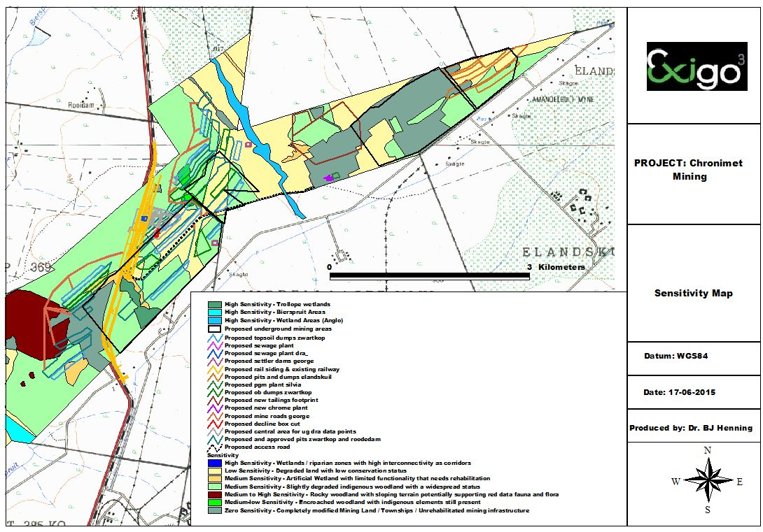

Figure 6. Sensitivity Map for the project area

eCOLOGICAL MANAGEMENT PLAN FOR THE PROPOSED THABA CRONIMET MINE PHASE iii
A management system has been developed to comply with the objectives and principles set out in this document. This system is based on the principle of managing the potential environmental impacts using the best available technology, not entailing excessive cost. In this way, the technology is effective, but does not seriously impair economic stability of the development. Management measures required for the different phases of the mine which relates to biodiversity is presented in Table 17 below.

Table 17. Ecological Management Plan to be implemented as part of the Environmental Management Programme Report for the Thaba Cronimet Mine

Components | Activity | Aspect | Impact | Legal requirements | Objectives | Performance criteria | Action plan | Time frame | Responsible person
Flora and Fauna Planning and Design phase
Pre-mining | Eradication of protected trees through permit application | Flora | Eradication of protected trees | Section 15(1) of the National Forests Act, 1998 | Obtain permits for the eradication of protected trees | Application forms completed as obtained from DAFF regarding specific species, numbers of trees and ecological conditions of the site | Apply and obtain permits from DAFF after liaison with relevant officials and site visit to the area | 2 months | Ecologist / Environmental Assessment Practitioner (EAP)
Construction Phase
Underground Mining (UGM), OC Mining, Support infrastructure, TSF and Plant | Clearing of vegetation | Fauna & Flora | Habitat destruction | NEMA Regulation 543 Section 32  NEMBA Section 56 (1), 57 (1), 57 (2) and 57 (4)  Limpopo Environmental Management Act Schedules 2, 3, 11 and 12 | - Prevent edge effects  - Keep mining development footprint restricted to layout plans  - To limit the habitat loss due to the increase of the mining footprint | Keep mining development footprint restricted to layout plans | - The removal of the isolated indigenous trees and shrubs should only occur on the construction footprint area of the development and not over the larger area. Where possible, vegetation should be retained in between infrastructural elements associated with the project;  - Conduct flora species search and rescue efforts before ground clearing begins in order to reduce negative impacts on species of concern;  - Remove and relocate any plants of botanical or ecological significance as indicated by the ecologist or Environmental Control Officer (ECO);  - Vegetation to be removed as it becomes necessary;  - Construction should preferably take place in winter to reduce disturbance to breeding fauna and flowering flora;  - Remove and relocate any plants of botanical or ecological significance as indicated by the ecologist or Environmental Control Officer (ECO);  - Vegetation to be removed as it becomes necessary – do not clear the entire footprint simultaneously;  - Clearly demarcate the entire development footprint prior to initial site clearance and prevent construction personnel from leaving the demarcated area;  - Monitoring should be implemented during the construction activities to ensure that minimal impact is caused to the flora of the area;  - The ECO should advise the construction team in all relevant matters to ensure minimum destruction and damage to the environment. The ECO should enforce any measures that he/she deem necessary. Regular environmental training should be provided to construction workers to ensure the protection of the habitat, fauna and flora and their sensitivity to conservation;  - Where trenches pose a risk to animal safety, they should be adequately cordoned off to prevent animals falling in and getting trapped and/or injured. This could be prevented by the constant excavating and backfilling of trenches during construction.  - Poisons for the control of problem animals should rather be avoided since the wrong use thereof can have disastrous consequences for the raptors occurring in the area. Poisons for the control of rats, mice or other vermin should only be used after approval from an ecologist. | Continuous |  | Contractor / ECO
Underground Mining (UGM), OC Mining, Support infrastructure, TSF and Plant | Clearing of vegetation | Fauna | Habitat fragmentation | NEMA Regulation 543 Section 32  NEMBA Section 56 (1), 57 (1), 57 (2) and 57 (4)  Limpopo Environmental Management Act Schedules 2, 3, 11 and 12 | - To limit the impact on wildlife habitat  - To limit the loss in carrying capacity  - To prevent negative impact on fauna populations through infrastructure development | Keep mining development footprint restricted to layout plans | - Use existing facilities (e.g., access roads, parking lots, graded areas) to the extent possible to minimize the amount of new disturbance.  - Ensure protection of important resources by establishing protective buffers to exclude unintentional disturbance. All possible efforts must be made to ensure as little disturbance as possible to the sensitive habitats such as ravines and moist grassland pockets during construction.  - During construction, sensitive habitats must be avoided by construction vehicles and equipment, wherever possible, in order to reduce potential impacts. Only necessary damage must be caused and, for example, unnecessary driving around in the veld or bulldozing natural habitat must not take place.  - Construction activities must remain within defined construction areas and the road servitudes. No construction / disturbance will occur outside these areas | Continuous |  | Contractor / ECO
Underground Mining (UGM), OC Mining, Support infrastructure, TSF and Plant | Topsoil & subsoil stripping | Fauna & Flora | Soil erosion and sedimentation | CONSERVATION OF AGRICULTURAL RESOURCES ACT 43 OF 1983  NEMA Regulation 543 Section 32 | - To prevent the loss of soil through the expansion of the WRD  - To prevent the loss of topsoil capability during stockpiling  - To prevent the contamination of soils due to spillages of reagents  - To prevent soil erosion | Management of storm water on site;  Minimize time that soil is left exposed after vegetation is cleared that will cause erosion and sedimentation | - Cover disturbed soils as completely as possible, using vegetation or other materials;  - Minimize the amount of land disturbance and develop and implement stringent erosion and dust control practices.  - Sediment trapping, erosion and storm water control should be addressed by a hydrological engineer in a detailed storm water management plan;  - All aspects related to dust and air quality should be addressed by an air quality specialist in a specialist report;  - Protect sloping areas and drainage channel banks that are susceptible to erosion and ensure that there is no undue soil erosion resultant from activities within and adjacent to the construction camp and Work Areas;  - Repair all erosion damage as soon as possible to allow for sufficient rehabilitation growth;  - Gravel roads must be well drained in order to limit soil erosion; | Continuous |  | Contractor / ECO
Underground Mining (UGM), OC Mining, Support infrastructure, TSF and Plant | Heavy machinery & vehicle movement on site | Fauna & Flora | Spillages | National Environmental Management: Waste Act, 2008 (Act No. 59 of 2008) Section 11(1) | - To prevent contamination of flora due to the spillages of hydrocarbons and reagents used in the process and during transportation of these substances  - To reduce the risk of contamination of soils due to increased fuel deliveries | Active monitoring of potential spillages | - Ensure that mining related waste or spillage and effluent do not affect the sensitive habitat boundaries and associated buffer zones.  - This risk of spillages of reagents and hydrocarbons on the soil during transportation can be reduced with proper maintenance of vehicles. This would include a rigorous and proactive maintenance program  - This risk can be further reduced through an adequate program of training of drivers and crews. This would include defensive driver training, basic vehicle maintenance, and emergency control of spills. In order for the vehicle crews to be adequately able to control any spills at an early stage, the vehicles must be properly equipped with spill containment equipment (booms, sandbags, spades, absorbent pads, etc.). Responsibility for training lies with the transport contractor. Adequate training, maintenance, and equipment of transport crews should be included as a requirement for transport contracts.  - The hydrochloric acid tanks are contained within an epoxy-coated, concrete lined and bermed facility that has been designed to contain 110% of the volume of the tanks in the event of a spill. This eliminates the potential impacts to soils from spills of hydrochloric acid.  - Spills from the tailings thickener will flow by gravity to the mine reclaim water ponds at the southern toe of the existing fines residue deposit. From there they will be pumped back to the processing plant. . The area that would be affected by such a spill has already been impacted by the mining operation.  - All employees will be trained in cleaning up of a spillage. The necessary spill kits containing the correct equipment to clean up spills will be made available at strategic points in the plant area | Continuous |  | Contractor / ECO
Underground Mining (UGM), OC Mining, Support infrastructure, TSF and Plant |  |  | Road mortalities of fauna | NEMBA Section 56 (1), 57 (1), 57 (2) and 57 (4)  NEMA Regulation 543 Section 32 | Prevent fauna mortalities as a result of vehicle movement | Control of vehicle speed  Control of vehicle movement | - More fauna are normally killed the faster vehicles travel. A speed limit should be enforced (speed on site max 40 km/hour; Outside of the site 80 km/h. In Rain max 40 km/h). It can be considered to install speed bumps in sections where the speed limit tends to be disobeyed. (Speed limits will also lessen the probability of road accidents and their negative consequences).  - Travelling at night should be avoided or limited as much as possible. No travelling at night should be allowed without approval by site manager;  - Lights should be positioned 5m from the roads or paved areas. | Continuous |  | Contractor / ECO
Underground Mining (UGM), OC Mining, Support infrastructure, TSF and Plant | Vegetation clearing, topsoil & subsoil stripping, vehicle movement on site | Flora | Potential establishment and spread of declared weeds and alien invader plants | Alien and Invasive Species Regulations (GNR 599 of 2014) as part of the National Environmental Management: Biodiversity Act (10/2004) | To implement an alien invasive eradication programme to manage and control alien species on the mine | Prevent and control of spreading and establishment of alien invasive species on the mining area and larger region | - Control involves killing the alien invasive plants present, killing the seedlings which emerge, and establishing and managing an alternative plant cover to limit re-growth and re-invasion. The control of these species should even begin prior to the construction phase considering that small populations of the AIS occur around the sites;  - Institute strict control over materials brought onto site, which should be inspected for seeds of noxious plants and steps taken to eradicate these before transport to the site. Routinely fumigate or spray all materials with appropriate low-residual herbicides prior to transport to site or in a quarantine area on site. The contractor is responsible for the control of weeds and invader plants within the construction site for the duration of the construction phase;  - Rehabilitate disturbed areas as quickly as possible to reduce the area where invasive species would be at a strong advantage and most easily able to establish;  - Institute a monitoring programme to detect alien invasive species early, before they become established and, in the case of weeds, before the release of seeds;  - Institute an eradication/control programme for early intervention if invasive species are detected, so that their spread to surrounding natural ecosystems can be prevented;  - A detailed plan should be developed for control of noxious weeds and invasive plants that could colonize the area as a result of new surface disturbance activities at the site. The plan should address monitoring, weed identification, the manner in which weeds spread, and methods for treating infestations. | Continuous |  | Contractor / ECO
Underground Mining (UGM), OC Mining, Support infrastructure, TSF and Plant | Vegetation Clearing, Vehicle movement on site | Flora & Fauna | Habitat degradation due to dust | National Environmental Management Air Quality Act 39 of 2004 Section 32 | - To reduce dust emission levels to acceptable norms in terms of aesthetics, health and annoyance  - To implement a dust monitoring programme which will enable the mine to determine the impacts associated with its activities  - To manage the operations in such a way as to ensure that the impact on the air quality is prevented and reduced. | To limit exposure to sensitive receptors resulting from dust and fumes from, mine vehicles and transportation systems and windborne dust from surface working | - Daily dampening of dust areas or other dust suppression methods such as dust-aside or more environmentally friendly methods.  - Re-vegetation of impacted areas is to be conducted on an on-going basis.  - Place dust generating activities where maximum protection can be obtained from natural features.  - Locating dust generating activities where prevailing winds will blow dust away from users.  - Minimize the need to transport and handle materials by placing adequate storage facilities close to processing areas.  - Minimize the re-handling of material which obviously has cost benefits as well.  - Exposed material should be protected from the wind by keeping it within voids or protecting them by topographical features where possible.  - Reduce the drop heights wherever practicable.  - Protect activities from wind by erecting a screen or using a natural barrier.  - All roads on site should be dampened or treated with a binding agent.  - The general vehicle speed should be restricted as there is a direct relationship between the speed and vehicle entrained emissions.  - Monitoring, modelling and emission measurements should be regarded as complementary components in any integrated approach to exposure assessment or determining compliance against air quality criteria. | Continuous |  | Contractor / ECO
OPERATIONAL PHASE
Underground Mining (UGM), OC Mining, Support infrastructure, TSF and Plant | Laydown areas of stockpiles and WRDs | Flora | Habitat destruction | NEMA Regulation 543 Section 32  NEMBA Section 56 (1), 57 (1), 57 (2) and 57 (4)  NEMA Regulation 543 Section 32  Limpopo Environmental Management Act Schedules 2, 3, 11 and 12 | Refer to Construction Phase objectives | Refer to Construction Phase criteria | - Final profile lines of rehabilitated areas must fit in with the character of the topography in the area.  - Concurrent rehabilitation should occur during the operational phase on all exposed areas created by construction as well as roads, stockpiles and WRD. Only indigenous species should be used for rehabilitation. The following programmes should be implemented as part of the operational phase of the mine:  - Concurrent rehabilitation programme  - Alien invasive programme  - Fire management programme  - Educational and training programme on the conservation and ecological systems  - Refer to mitigation measures needed during the operational phase that are similar to the mitigation measures for impacts during the construction phase. | Continuous | Contractor / ECO
 | Laydown areas of stockpiles and WRDs | Fauna | Fragmentation of fauna habitats | NEMA Regulation 543 Section 32  NEMBA Section 56 (1), 57 (1), 57 (2) and 57 (4)  NEMA Regulation 543 Section 32  Limpopo Environmental Management Act Schedules 2, 3, 11 and 12 | Refer to Construction Phase objectives | Refer to Construction Phase criteria | Refer to mitigation measures needed during the operational phase that are similar to the mitigation measures for impacts during the construction phase. | Continuous | Contractor / ECO
 | Laydown areas of WRDs and stockpiles, crushing and stockpiling | Flora | Increased Soil erosion and sedimentation; | CONSERVATION OF AGRICULTURAL RESOURCES ACT 43 OF 1983  NEMA Regulation 543 Section 32 | Refer to Construction Phase objectives | Refer to Construction Phase criteria | - Rehabilitation: revegetate or stabilise all disturbed areas as soon as possible. Indigenous trees can be planted in the buffer zone of the proposed development to enhance the aesthetic value of the site and stabilize soil conditions;  - The vegetative (grass) cover on the soil stockpiles (berms) must be continually monitored in order to maintain a high basal cover. Such maintenance will limit soil erosion by both the mediums of water (runoff) and wind (dust);  - Conservation of topsoil should be prioritized on site and done as follows:  - Topsoil should be handled twice only - once to strip and stockpile, and secondly to replace, level, shape and scarify;  - Stockpile topsoil separately from subsoil;  - Stockpile in an area that is protected from storm water runoff and wind;  - Maintain topsoil stockpiles in a weed free condition;  - Topsoil should not be compacted in any way, nor should any object be placed or stockpiled upon it;  - Stockpile topsoil for the minimum time period possible i.e. strip just before the relevant activity commences and replace as soon as it is completed.  - Refer to mitigation measures needed during the operational phase that are similar to the mitigation measures for impacts during the construction phase. | Continuous | Contractor / ECO
 | Laydown areas of WRDs and stockpiles, materials handling and transportation, crushing and stockpiling | Flora | Spillages of harmful substances to the ecosystem; | National Environmental Management: Waste Act, 2008 (Act No. 59 of 2008) Section 11(1) | Refer to Construction Phase objectives | Refer to Construction Phase criteria | - Vehicle maintenance only done in designated areas – spill trays, sumps to be used and managed according to the correct procedures.  - Vehicles and machines must be maintained properly to ensure that oil spillages are kept to a minimum.  - Fuel and oil storage facilities should be bunded with adequate storm water management measures.  - Operational and Maintenance plan and schedule for management of sewage facilities should be compiled. An emergency plan should be compiled to deal with system failures and should include a down-stream notification procedure  - Routine checks should be done on all mechanical instruments for problems such as leaks, overheating, vibration, noise or any other abnormalities. All equipment should be free of obstruction, be properly aligned and be moving at normal speed. Mechanical maintenance must be according to the manufacturer’s instructions  - Refer to mitigation measures needed during the operational phase that are similar to the mitigation measures for impacts during the construction phase | Continuous | Contractor / ECO
 | Laydown areas of WRDs and stockpiles, materials handling and transportation, crushing and stockpiling | Fauna | Road mortalities of fauna | NEMBA Section 56 (1), 57 (1), 57 (2) and 57 (4)  NEMA Regulation 543 Section 32  NEMA Regulation 543 Section 32 | Refer to Construction Phase objectives | Refer to Construction Phase criteria | - Refer to mitigation measures needed during the operational phase that are similar to the mitigation measures for impacts during the construction phase | Continuous | Contractor / ECO
 | Laydown areas of WRDs and stockpiles, materials handling and transportation, crushing and stockpiling | Flora & Fauna | Habitat degradation due to dust; | National Environmental Management Air Quality Act 39 of 2004 Section 32 | Refer to Construction Phase objectives | Refer to Construction Phase criteria | - Daily dampening of dust areas.  - Re-vegetation of mined areas is to be conducted on an ongoing basis.  - Dust fallout monitoring to be conducted according to the requirements of the legislation.  - Place dust generating activities where maximum protection can be obtained from natural features.  - Locating dust generating activities where prevailing winds will blow dust away from users.  - Minimize the need to transport and handle materials by placing adequate storage facilities close to processing areas.  - Exposed material should be protected from the wind by keeping it within voids or protecting them by topographical features where possible.  - Reduce the drop heights wherever practicable.  - Protect activities from wind by erecting a screen or using a natural barrier.  - Fine spray or fog suppression can also be used in loading bays.  - All roads on site should be dampened or treated with a binding agent.  - The general vehicle speed should be restricted as there is a direct relationship between the speed and vehicle entrained emissions.  - Monitoring, modelling and emission measurements should be regarded as complementary components in any integrated approach to exposure assessment or determining compliance against air quality criteria  - Refer to mitigation measures needed during the operational phase that are similar to the mitigation measures for impacts during the construction phase | Continuous | Contractor / ECO
 | Laydown areas of stockpiles and WRDs | Flora | Potential establishment and spread of declared weeds and alien invader plants | Alien and Invasive Species Regulations (GNR 599 of 2014) as part of the National Environmental Management: Biodiversity Act (10/2004) | Refer to Construction Phase objectives | Refer to Construction Phase criteria | Refer to mitigation measures needed during the operational phase that are similar to the mitigation measures for impacts during the construction phase |  | Ecologist / ECO
DECOMMISSIONING PHASE
Underground Mining (UGM), OC Mining, Support infrastructure, TSF and Plant | Cessation of mining  Demolition of mining infrastructure | Flora | Potential establishment and spread of declared weeds and alien invader plants | Alien and Invasive Species Regulations (GNR 599 of 2014) as part of the National Environmental Management: Biodiversity Act (10/2004) | Refer to Construction Phase objectives | Refer to Construction Phase criteria | To leave all affected areas in a safe condition  Refer to mitigation measures for the construction phase needed during the decommissioning phase that are similar | Continuous | Ecologist / ECO
 | Demolition of mining infrastructure | Fauna & Flora | Habitat degradation due to dust; | National Environmental Management Air Quality Act 39 of 2004 Section 32 | Refer to Construction Phase objectives | Refer to Construction Phase criteria | Refer to mitigation measures for the construction phase needed during the decommissioning phase that are similar | Continuous | Contractor / ECO
 | Demolition of mining infrastructure | Fauna | Road mortalities of fauna | NEMBA Section 56 (1), 57 (1), 57 (2) and 57 (4)  NEMA Regulation 543 Section 32 | Refer to Construction Phase objectives | Refer to Construction Phase criteria | Refer to mitigation measures for the construction phase needed during the decommissioning phase that are similar | Continuous | Contractor / ECO
 | Demolition of mining infrastructure | Fauna & Flora | Spillages of harmful substances to the ecosystem; | National Environmental Management: Waste Act, 2008 (Act No. 59 of 2008) Section 11(1) | Refer to Construction Phase objectives | Refer to Construction Phase criteria | Refer to mitigation measures for the construction phase needed during the decommissioning phase that are similar | Continuous | Contractor / ECO
CLOSURE PHASE
Underground Mining (UGM), OC Mining, Support infrastructure, TSF and Plant | Rehabilitation | Fauna & Flora | Improvement of habitat through revegetation over time | NEMA Regulation 543 Section 32 | - To ensure that the mining areas rehabilitated according to prescriptions  - To shape and prepare the rehabilitation areas to blend in with the surrounding environment.  - To rehabilitate all disturbed areas to a suitable post closure land use  - To manage the social impact of closure on personnel who became redundant due to closure  - To keep all the post closure monitoring in place and to ensure that the necessary reporting is done to the authorities and interested and affected parties | Rehabilitate within development footprint to ensure revegetation and rehabilitation impacts are kept within the mining footprint areas | - Plant vegetation species for rehabilitation that will effectively bind the loose material and which can absorb run-off from the mining areas.  - Rehabilitate all the land where infrastructure has been demolished.  - Monitor the establishment of the vegetation cover on the rehabilitated sites to the point where it is self-sustaining.  - Protect rehabilitation areas until the area is self-sustaining.  - Diversion trenches and storm water measures must be maintained  - Water management facilities will stay operational and maintained and monitored until such a stage is reached where it is no longer necessary.  - The mining areas will be shaped to make it safe.  - All the monitoring and reporting on the management and rehabilitation issues to the authorities will continue till closure of the mine is approved. | Continuous | Ecologist / ECO
 | Rehabilitation | Flora | Potential establishment and spread of declared weeds and alien invader plants | Alien and Invasive Species Regulations (GNR 599 of 2014) as part of the National Environmental Management: Biodiversity Act (10/2004) | Refer to Construction Phase objectives | Refer to Construction Phase criteria | - Monitor and manage invader species and alien species on the rehabilitated land until the natural vegetation can outperform the invaders or aliens. | Continuous | Contractor / ECO
 | Rehabilitation | Fauna & Flora | Habitat degradation due to dust; | National Environmental Management Air Quality Act 39 of 2004 Section 32 | To comply to all the necessary post closure air quality objectives | Refer to Construction Phase criteria | Refer to mitigation measures for the construction phase needed during the closure phase that are relevant | Continuous | Contractor / ECO
 | Rehabilitation | Fauna | Road mortalities of fauna | NEMBA Section 56 (1), 57 (1), 57 (2) and 57 (4)  NEMA Regulation 543 Section 32 | Refer to Construction Phase objectives | Refer to Construction Phase criteria | Refer to mitigation measures for the construction phase needed during the closure phase that are relevant | Continuous | Contractor / ECO
 |  | Fauna & Flora | Spillages of harmful substances to the ecosystem; | National Environmental Management: Waste Act, 2008 (Act No. 59 of 2008) Section 11(1) | Refer to Construction Phase objectives | Refer to Construction Phase criteria | Refer to mitigation measures for the construction phase needed during the closure phase that are relevant | Continuous | Contractor / ECO

MONITORING REQUIREMENTS
The next phase in the management of the mine is to decide on a long-term strategy for monitoring the environmental impacts of the mining operation. This will involve the marking out of permanent plots in the area that can then be measured and recorded on an annual basis. Monitoring provides periodic ‘snapshots’ of the state of the environment. The results of monitoring allow changes in management procedures to be made. In more formal systems, monitoring should include checks on whether prescribed management tasks have been undertaken, as well as on the states of the systems themselves. More formal monitoring is based on records made on indicators, which should be selected by (or at least in collaboration with) those who will actually undertake the monitoring. The monitoring of the proposed mining site should therefore be considered a high priority in this project and the following monitoring procedures should be implemented to ensure sustainability of the mining operation during the lifetime of the mine.
Ecological monitoring is required for the area in which the Thaba Cronimet Mining development is taking place (elsewhere referred to as the site) to determine its ecological status. In the initial terms of reference it was stated that ecological monitoring takes place based on identified ecological indicators as relevant for a specific area. Such indicators may include the following:
- Presence and percentage of pioneer species in the floral community
- Presence/ absence and ratio of exotic versus indigenous species
- Presence and prevalence of alien invader species
- Ratio of bare soil patches and ground cover
- Presence, absence and trends in the occurrence of identified indicator/ sensitive species
Indicators used for ecological evaluation may include, but is not limited to the abovementioned indicators. Subsequently, however, the consultant was asked to incorporate more information on the fauna diversity to the present studies.
Initially it was thought that a mere quantitative description of the site would suffice for monitoring purposes. However, there are components of possible high conservation priority fauna that have not been addressed before, for example the possible occurrence or not of threatened invertebrates. One had to confirm as far as possible whether any high conservation priority species are on the site and if so describe the habitat where these would occur, so that these could be monitored when approved developments occur. Therefore the monitoring was broken down into a twofold approach which is in line with the Biodiversity Act of 2004. Conservation priorities were identified by 1) verifying the presence or not of species and subspecies of particular high conservation priority and by 2) describing biodiversity in a qualitative and quantitative manner for future references. The first step of this description of biodiversity would be species lists that serve as a biodiversity inventory for future references and planning.
The interim report given here focused on recording fauna and flora at the site to provide:
- Confirmation of larger mammal species present at the site with notes on their reproduction and general status in the area.
- Confirmation of bird species present at the site.
- Confirmation of butterfly species present at the site
- Confirmation of scorpion species present at the site.
- Additional plant species to the existing species lists at the site.
- Integration of biodiversity information from all the surveys up to date with the aim at formulating possible impacts and constructing a practical ecological management plan.
- A structure for the final report that would incorporate and summarize the relevant information for an ecological management plan and for partial restoration or rehabilitation.
The monitoring plan will assess, analyse, evaluate, or otherwise substantiate the effects, consequences or results of the mining activities on the terrestrial and aquatic biological and physical elements on the site.

Objectives

The general objective for terrestrial and physical monitoring is to evaluate the success of sustaining biodiversity by measuring specific indicators or biological / physical elements, and to contribute to adaptive management of the natural environment of the area.

Proposed monitoring programme

For the purposes of the monitoring plan indicators should be chosen at the species level and landscape scale. The choice of indicators is based on recognized threats to biodiversity. The following indicators will be used for monitoring biodiversity in the study area:
- Extent and condition of wetlands;
- Habitat transformation;
- Distribution and abundance of selected alien plant species;
- Viability of populations of endangered endemic species;
- Rehabilitation
  - Presence and percentage of pioneer species in the floral community
  - Presence/ absence and ratio of exotic versus indigenous species
  - Ratio of bare soil patches and ground cover
  - Presence, absence and trends in the occurrence of identified indicator/ sensitive species
Details on the monitoring of each indicator are highlighted below. The indicators should be monitored biannually. The year interval has been chosen to reduce the cost of monitoring and also it is a reasonable time interval to assess changes in the above indicators except for the viability of populations of endangered endemic species.

Extent and condition of wetlands and riparian areas

Wetlands and riverine systems are very complex ecosystems and the consequences of particular management prescriptions are often difficult to predict precisely. Monitoring of the wetland is essential for planning and management. The Sand River and its tributaries exhibit some wetland characteristics, although most of this area should be classified as a riparian zone. Given the interest of the local community, environmental institutions and the location close to the town of Polokwane there is an opportunity to develop a comprehensive monitoring program providing management directions and educational benefit. Many guides and programs on wetland monitoring exist. Bio-monitoring form the basis for wetland or river monitoring and encompasses the following:

Biological Monitoring
Biological monitoring techniques have been introduced as part of routine monitoring programmes due to certain shortcomings in standard physical and chemical methods. Because of the difficulty of chemically analysing every potential pollutant in a sample of water, and of interpreting results in terms of the severity of impact, it makes sense to turn to the monitoring of aquatic biota. Results given by biological monitoring are also more cost effective and results can be obtained more rapidly than an extensive chemical analysis.
The main advantage of a biological approach is that it examines organisms whose exposure to water and any pollutants therein is continuous. Thus species present in riverine ecosystems reflect both the present and past history of the water quality at a particular point in the river, allowing detection of disturbances that might otherwise be missed (Eekhout et al., 1996).

Vegetation
Riparian zone enhancement has been designed to establish open water, shallow water, emergent and wet meadow wetland habitat types using planting and natural succession re-vegetation techniques. Some of these habitat types exist at present in the Sand River and its tributaries in the form of dams or small wetlands, although encroachment by invasive plants and weeds has degraded much of the habitat types. The rehabilitation of the riparian vegetation needs to be prioritized as part of the proposed mining development. Ecologists will evaluate plant communities that are representative of various riparian zones or wetland types. Evaluations will be made of the percent vegetation cover, relative frequency of each plant species, and the wetland frequency indicator value.

Wildlife
Riparian zone or wetland rehabilitation and restoration should focus on providing diverse habitat for a variety of wildlife. Feeding, nesting and brood-rearing habitat for waterfowl, wading birds, passerine birds as well as mammals, reptiles and amphibians will be targeted in the wetland rehabilitation.

Habitat transformation
Habitat transformation reduces biodiversity. Mining and invasion by alien plants are the main factors that will transform habitats on site. It is therefore important to monitor the percentage of habitat that is transformed on site during the mining operation.

Vegetation monitoring
The implementation of a vegetation monitoring programme is strongly recommended and will be a direct indicator of habitat transformation. This is the only quantifiable means to evaluate the impact of current and possible future management practices on the vegetation of the study area. This includes evaluating the success of rehabilitation activities. The nature of secondary succession in disturbed areas (previously mined and cultivated) should be evaluated in order to determine whether a favourable succession pathway is occurring towards indigenous vegetation cover.
Plant life will probably resettle, especially after a detailed rehabilitation program on the mining areas. The impact life may, however, be of a long-term and permanent nature. The re-vegetation of the disturbed areas will become an integral part of activities during the closure phase. Monitoring and maintenance of vegetation cover should be done until a self-sustaining plant community is established. Re-establishment of plant cover on disturbed areas should take place as soon as activities have ceased, for example the areas where the buildings and plant area are situated will only be re vegetated once the buildings have been removed during the decommissioning phase. All roads not required for access shall be ripped and planted with endemic vegetation.

Fauna monitoring
The restoration or rehabilitation actions will need the implementation of a faunal monitoring program as a barometer for the mine management to recognize positive changes and trends in the biodiversity of the mining area during and after closure. Fauna monitoring procedures include pit trapping, Elliot-box trapping, spotlighting, mist-netting, bird monitoring, ant monitoring and microhabitat searches and cage trappings (feral animals).The objectives of such a programme may include:
- Assessment of future improvement/deterioration of the faunal biodiversity of the mine lease area (thus a measure of success of environmental management).
- Increase the accuracy of present status determination (actual species present vs. expected species) of the mine lease area with every survey.
- Determination of both temporal and spatial trends in faunal biodiversity on the mine lease area.
- Assist in future management of the mine lease area by providing recommendations and guidelines regarding future activities and rehabilitation.
- Biodiversity management actions during closure should include controlling and monitoring of numbers of alien invasive fauna numbers by eradication, habitat modification, resource limitation and public education. Appropriate control measures for the Common Myna should be developed in consultation with local conservation agency and should form part of the mine’s biodiversity action plan.
- Young nutrient rich growth may entice herbivores to rehabilitated areas. The increased grazing pressure may decrease the rate of rehabilitation. Herbivore-proof fencing may be required around the rehabilitation zones in the early stages to protect seedlings from grazers if grazing pressure is found to significantly affect growth.
- Revegetation programs will include consideration of the possibility of reconstructing fauna habitats. Old salvage logs from cleared areas will be replaced after mining, where possible, to provide habitat for fauna.
- Key fauna species will be identified and targeted for re-colonisation where appropriate. Edible seed bearing plants, perennial grasses and sedges may be seeded or planted to encourage re-colonisation by native fauna.

Distribution and abundance of selected alien plant species
Alien plants (both woody and herbaceous) are a major threat to biodiversity and ecosystem functioning. It is important to map the distribution of selected woody alien species. Remote sensing can be used as described by Rouget et al. (2003). Two elements of this indicator that should be measured are:
- the proportion of the surface area of the proposed study area covered by alien plants; and
- Which plant species are problematic and should be controlled.
It is also important to monitor the recovery of vegetation in areas cleared of alien plants.
The success of the alien invasive control should be monitored by qualified ecologists and the Working for Water group should be contacted for the actual control of the alien species identified.

Viability of populations of endangered endemic species
Emphasis should also be placed on monitoring threatened and near-threatened species and species that have been subject to elevated levels of utilization (e.g. medicinal plants and species utilised for fuelwood). Fine-scale monitoring of populations of endangered endemic species will be required to assess their viability. Size/age class distributions, reproduction, growth and mortality of individuals will need to be recorded. Matrix modelling can be used to assess the viability of the populations.

Occurrence of disturbances (fire)
The occurrence of common disturbances such as fire and episodic disturbances (e.g. floods) should be recorded since these have huge impacts on ecosystems. However, some plant species require fire for persistence. The extent (size of the area affected), timing (date of occurrence) should be recorded. Causes of disturbances such as fire should be recorded.

Responsibility for monitoring and expertise needed
The Mine Group should be responsible for the monitoring programme. Monitoring is a rigorous science requiring appropriate statistical design and analyses (Eberhardt and Thomas,
1991; Nusser et al., 1998; McDonald, 2003). Data cannot be used for making management decisions if the statistical design is faulty. The mine should therefore work together with conservation agencies, non-governmental organizations, private landowners, universities and independent consultants to monitor biodiversity. Expertise is needed for designing sampling strategies and analyzing data.

Data analysis and storage
Data analysis and storage is a key component of any monitoring programme. Data should be analysed as soon as possible after collection. Independent consultants can assist the mine in analyzing the data. The monitoring results should be communicated to the mine in the form of tables and maps. The mine in turn can produce reports on the state of biodiversity for the site every year. The yearly reporting interval should coincide with the annual monitoring surveys for the indicators suggested above. The data can be stored in both digital form and in maps. The Environmental section of the mine should be responsible for data analyses and storage.

Methods
A desktop study will comprise not only of an initial phase, but also it will be used throughout the study to accommodate and integrate all the data that become available during the field observations.
Surveys will be conducted to note key elements of habitats on the site, relevant to the description and conservation of fauna and flora on site. Monitoring differs from survey, the latter often being more of a once only inventory (Goldsmith, 1991). Monitoring is purpose orientated, repeated at regular intervals and often provides the baseline for possible change in the future (Goldsmith, 1991). In the case of this study the purpose of the monitoring is to note the present ecological state and possible future changes, if mining in the area has been approved. Monitoring actions in different seasons of the year often provides diverse but complementary insights much needed for an informative baseline of data. In future some seasons may be excluded from the monitoring where deemed more cost-effective. If open cast mining takes place on site the monitoring will allow for detecting changes and possibly guide rehabilitation actions.
Observations on fauna will be made throughout to add towards an overall picture of the state of biodiversity on the site. The main objective overall is to compile and inventory of biodiversity so that management plans and management of rehabilitation or partial restoration, should the development be approved, can be enhanced.

Habitat characteristics and vegetation
The habitat is investigated by noting habitat structure (rockiness, slope, plant structure/physiognomy) as well as floristic composition. Transects or quadrant counts are applied where appropriate. Voucher specimens of plant species are only taken where the taxonomy is in doubt and where the plant specimens are of significant relevance for invertebrate conservation. Field guides such as those by Van Oudtshoorn (1999), Van Wyk & Malan (1998) and Van Wyk & Van Wyk (1997) are used to confirm the taxonomy of the species. In this case no plant specimens are needed to be collected as voucher specimens or to be send to a herbarium for identification. For the most recent treatise of scientific plant names and broad distributions, Germishuizen, Meyer & Steenkamp (2006) are followed to compile the lists of species.

Mammals
Mammals are noted as sight records by day. For the identification of species and observation of diagnostic characteristics Smithers (1986), Skinner & Chimimba (2005), Cillié, Oberprieler and Joubert (2004) and Apps (2000) are consulted. Sites have been walked, covering as many habitats as possible. Signs of the presence of mammal species, such as calls of animals, animal tracks (spoor), burrows, runways, nests and faeces are recorded. Walker (1996), Stuart & Stuart (2000) and Liebenberg (1990) are consulted for additional information and for the identification of spoor and signs. Habitat characteristics are surveyed to note potential occurrences of mammals. Many mammals can be identified from field sightings but, with a few exceptions bats, rodents and shrews can only be reliably identified in the hand, and even then some species needs examination of skulls, or even chromosomes (Apps, 2000).

Birds
Birds are noted as sight records, mainly with the aid of binoculars (10x30). Nearby bird calls of which the observer is sure of the identity are also recorded. For practical skills of noting diagnostic characteristics, the identification of species and observation techniques Ryan (2001) is followed. For information on identification, biogeography and ecology Barnes (2000), Hockey, Dean & Ryan, P.G. (2005), Cillié, Oberprieler & Joubert (2004), Tarboton & Erasmus (1998) and Chittenden (2007) are consulted. Ringing of birds fell beyond the scope of this survey and is not deemed necessary. Sites have been walked, covering as many habitats as possible. Signs of the presence of bird species such as spoor and nests have additionally been recorded. Habitat characteristics are surveyed to note potential occurrences of birds.

Reptiles
Reptiles are noted as sight records in the field. Binoculars (10x30) can also be used for identifying reptiles of which some are wary. For practical skills of noting diagnostic characteristics, the identification of species and observation techniques, Branch (1998), Marais (2004), Alexander & Marais (2007) and Cillié, Oberprieler and Joubert (2004) are followed. Sites are walked, covering as many habitats as possible. Smaller reptiles are sometimes collected for identification, but this practice is not necessary in the case of this study. Habitat characteristics are surveyed to note potential occurrences of reptiles.

Amphibians
Frogs and toads are noted as sight records in the field or by their calls. For practical skills of noting diagnostic characteristics, the identification of species and observation techniques Carruthers (2001), Du Preez (1996), Conradie, Du Preez, Smith & Weldon (2006) and the recent complete guide by Du Preez & Carruthers (2009) are consulted. CD’s with frog calls by Carruthers (2001) and Du Preez & Carruthers (2009) are used to identify species by their calls when applicable. Sites are walked, covering as many habitats as possible. Smaller frogs are often collected by pitfall traps put out for epigeal invertebrates (on the soil), but this practice falls beyond the scope of this survey. Habitat characteristics are also surveyed to note potential occurrences of amphibians.

LIMITATIONS
For the site visited, it should be emphasized that surveys can by no means result in an exhaustive list of the plants and animals present on the site, because of the time constraint. The onsite survey was conducted during December and January which is an optimal time of the year to find animals such as butterflies, other invertebrates as well as habitat sensitive plant species high conservation priority. In general the weather was not optimal for recording of invertebrates as well as ectothermic (“cold blooded”) vertebrates. The focus of the survey remains sensitive habitats and species of particular conservation priority.
Table 18 indicate the monitoring requirements for the fauna and flora components within the project area.
Table 18. Fauna and Flora Monitoring requirements for the Thaba Cronimet Mine
Component | Relevant activity | Aspects to be monitored | Objective of monitoring | Current monitoring in place | Changes to monitoring programme | Proposed monitoring | Frequency | Any reporting requirements
Construction Phase
Underground Mining (UGM), OC Mining, Support infrastructure, TSF and Plant | Vegetation clearing, vehicle movement & soil stripping | Flora associated with riparian zone / wetlands | Determine potential negative impacts on wetland vegetation & riparian woodland | N/a | N/a | Extent and condition of wetlands / riparian zone | Annual | Ecological Monitoring report
 | Vegetation clearing, vehicle movement & soil stripping | Flora & Fauna | Determine potential edge effects on natural vegetation and fauna populations | N/a | N/a | Habitat transformation of site through fauna and flora monitoring | Annual | Ecological Monitoring report
 | Vegetation clearing, vehicle movement & soil stripping | Flora & Fauna | Indicate presence of AIS to be eradicated | N/a | N/a | Distribution and abundance of selected alien plant species and / or alien fauna | Annual | Ecological Monitoring report
 | Vegetation clearing, vehicle movement & soil stripping | Flora & Fauna | Indicate presence of endemic / protected species on site | N/a | N/a | Viability of populations of endangered endemic species | Annual | Ecological Monitoring report
Operational Phase
Underground Mining (UGM), OC Mining, Support infrastructure, TSF and Plant | Laydown areas of WRDs and stockpiles, materials handling and transportation, crushing and stockpiling, Stockpiling of ore, disposal of tailings, vehicle movement during construction of infrastructure, access roads and bridges | Flora associated with riparian zone / wetlands | Determine potential negative impacts on wetland vegetation & riparian woodland | N/a | N/a | Extent and condition of wetlands / riparian zone | Annual | Ecological Monitoring report
 |  | Flora & Fauna | Determine potential edge effects on natural vegetation and fauna populations | N/a | N/a | Habitat transformation of site through fauna and flora monitoring | Annual | Ecological Monitoring report
 |  | Flora & Fauna | Indicate presence of AIS to be eradicated | N/a | N/a | Distribution and abundance of selected alien plant species and / or alien fauna |  | Ecological Monitoring report
 |  | Flora & Fauna | Indicate presence of endemic / protected species on site | N/a | N/a | Viability of populations of endangered endemic species | Annual | Ecological Monitoring report
Decommissioning Phase
 | Demolition of infrastructure, cessation of mining | Flora & Fauna | Indicate presence of AIS to be eradicated | N/a | N/a | Distribution and abundance of selected alien plant species and / or alien fauna | Annual | Ecological Monitoring report
Closure Phase
Underground Mining (UGM), OC Mining, Support infrastructure, TSF and Plant | Rehabilitation | Flora & Fauna | - Presence and percentage of pioneer species in the floral community  - Presence/ absence and ratio of exotic versus indigenous species  - Ratio of bare soil patches and ground cover  - Presence, absence and trends in the occurrence of identified indicator/ sensitive species | N/a | N/a | Succession of vegetation over time | Annual | Ecological Monitoring report
 | Rehabilitation | Flora & Fauna | Indicate presence of AIS to be eradicated | N/a | N/a | Distribution and abundance of selected alien plant species and / or alien fauna | Annual | Ecological Monitoring report

alternatives
Table 19 provide a description of alternatives for specific ativties in close proximity to sensitive environmental areas:
Table 19. Alternatives for specific mining activities
Alternative | Definition of Alternatives
Activity | Mine road network | Opencast mining
Location | Zwartkop 369 KQ | Zwartkop & Middellaagte
Process | Mine road construction | Construction of openpits in artificial wetlands and vegetation associated with outcrops
Demand | Access to openpit areas needed | Opnepit mining dependant on location of resource
Scheduling | No scheduling alternatives that are more favourable to the environment could be identified
Input | Rerouting | N/a
Routing | Mine roads should access the opencast areas from the south to avoid the sensitive vegetation associated with outcrops | N/a
Site Layout and Design | Refer to routing description | Not possible considering that the mining is dependant on the resource
Scale | Site specific | Site specific
No-go alternative: | Construction of roads across wetlands without IWUL application or in areas with sensitive vegetation and / or ptected species (permits needed) | Opencast mining in natural wetlands and vegetation types without IWUL application or permits for the eradication of protected plants

impact statement and viability of mining project
The proposed mining activities that form part of the Thaba Cronimet Mine will definitely impact on the flora and fauna of the area. The following can be concluded with regards to the impacts:
- Vegetation clearing and topsoil stripping will have the most definite and permanent direct negative impact on the flora and fauna of the area during the construction phase of the mine. The clearance will eradicate all vegetation and displace fauna that will migrate to neighbouring areas;
- The laydown areas of WRDs and stockpiles during the operational phase of the mine will have a direct, significant negative impact on the vegetation and fauna habitats, even though most of the vegetation units are in a degraded state and fragmented;
- The indirect impacts such as soil erosion, fauna mortalities, spillages and establishment of alien invasive species are relevant for all mining phases, although with strict implemented of the mitigation measures and action plans for the various components, the impacts can be minimized;
- Considering the cumulative impacts of the mining phases on the fauna and flora of the area, it can be concluded that the current degraded state of the vegetation and fauna habitats caused by the surrounding and on site mining activities, will cause some negative impacts, although the implementation of a rehabilitation and revegetation plan will allow the vegetation to recover over time and the fauna to return to the area;
- The mining development can be considered as viable as a result of the fragmented state of the vegetation and fauna habitats and the degraded state of the ecosystem caused by nearby villages and other local mining activities.

conclusion
All aspects of the environment, especially living organisms, are vulnerable to disturbance of their habitat. The mining activities will completely modify the natural vegetation and faunal habitats. The importance of rehabilitation and implementation of mitigation processes to prevent negative impacts on the environment during and after the closure phases of the mines should be considered a VERY HIGH priority. Any negative impacts created by such actions and processes will ultimately scar the environment and negatively impact on the ecosystem both on a local and global scale. The proposed site for the mining operation occurs in an already impacted mining area, although some of the natural vegetation features are still intact, though fragmented. The property consists of sensitive drainage features, indigenous woodland and rocky outcrops providing a unique habitat for a variety of plant species to establish as well as perching and breeding areas for larger birds of prey. The riverine woodland, floodplains and smaller drainage channels also provide valuable corridors and feeding and breeding areas for red data and other birds, reptiles and amphibians. Many features of the study area contribute to its ecological sensitivity and it is recommended to be considered during the environmental impact process. Provided that the mitigation measures and recommendations are adhered to as stated in the report, the development of the Thaba Cronimet phase III and associated infrastructure can be supported.

References
ACOCKS, J.P.H. 1988. Veld types of South Africa, 3rd ed. Memoirs of the Botanical Survey of South Africa. 57: 1–146.
BRADY, N. C. & WEIL, R. R. 1996. The Nature and properties of Soils. Prentice Hall, New Jersey.
LOW, A.B. & REBELO, A.G. (eds) 1996. Vegetation of South Africa, Lesotho and Swaziland, p. 39. Dept Environmental Affairs & Tourism, Pretoria.
DWAF. 2003. A practical field procedure for identification and delineation of wetlands and riparian areas. Department of Water Affairs and Forestry, Pretoria.
ENPAT, 2000. Environmental Potential Atlas. Department of Environmental Affairs and Tourism, Pretoria.
KOTZE, D. C., MARNEWECK, G. C., BATCHELOR, A. L., LINDLEY, D. S. & COLLINS, N. B. 2005. Wet-ecoServices: A technique for rapidly assessing ecosystem services supplied by wetlands. South Africa National Biodiversity Institute, Pretoria.
MACVICAR, C. N. 1991. Soil Classification: A Taxonomic system for South Africa. Department of Agriculture, Pretoria.
MCLEESE, R.L. AND WHITESIDE, E.P. 1977. Ecological effects of highway construction upon Michigan woodlots and wetlands: soil relationships. Journal of Environmental Quality. v6 n4, 476-471.
MUCINA, L & RUTHERFORD, M. C. (eds) 2006. The vegetation of South Africa, Lesotho and Swaziland. . Strelitzia 19. South Africa National Biodiversity Institute, Pretoria.
WINTER, C. 1988. A conceptual framework for assessing cumulative impacts on the hydrology of nontidal wetlands. Environmental Management. v12, n5, 605-620.

APPENDIX A – PLANT SPECIES LISTS
Acacia tortilis- Ziziphus mucronata – Peltophorum africanum woodland

Woody species
Acacia caffra
Acacia erubescens
Acacia mellifera
Acacia nilotica
Acacia robusta
Acacia tortilis
Combretum hereroense
Combretum imberbe
Dichrostachys cinerea
Diospyros lycioides
Ehretia rigida
Euclea undulata
Grewia flava
Peltophorum africanum
Rhus lancea
Ximenia americana
Ziziphus mucronata
Grasses
Aristida spp.
Botriochloa insculpta
Cenchrus ciliaris
Cymbopogon plurinoides
Digitaria eriantha
Enneapogon cenchroides
Eragrostis inamoena
Eragrostis lehmanniana
Eragrostis rigidior
Eragrostis superba
Fingerhutia africana
Heteropogon contortus
Hyparrhenia hirta
Hyperthelia dissoluta
Ischaemum fasciculatum
Melinis repens
Panicum maximum
Panicum natalense
Pogonarthria squarrosa
Schmidtia pappophoroides
Setaria incrassatae
Sporobolus fimbriatus
Sporobolus iocladus
Themeda triandra
Urochloa mosambicensis
Herbs/Forbs
Abutilon angulatum
Aptosimum procumbens
Asparagus africanus
Asparagus suaveolens
Berkheya seminivea
Bidens bipinnata
Crabbea angustifolium
Crotalaria lotoides
Cucumis zeyheri
Geigeria burkei
Hermbstaedtia odorata
Indigofera cryptantha
Ipomoea obscura
Ipomoea omnaeyi
Meremmia kentrocaulos
Neurautanenia ficifolius
Nidorella anomala
Pavonia burchellii
Pseudognaphalium luteo-album
Rhynchosia monophylla
Schkuria pinnata
Solanum panduriforme
Tagetes minuta
Vernonia oligocephala
Viscum rotundifolium
Waltheria indica
Zinnia peruviana

Acacia nigrescens woodland

Woody species
Acacia nigrescens
Acacia tortilis
Combretum hereroense
Diospyros lycioides
Euclea undulata
Grewia flava
Ziziphus mucronata
Grasses
Aristida spp.
Cymbopogon plurinoides
Digitaria eriantha
Enneapogon scoparius
Eragrostis bicolor
Eragrostis heteromera
Eragrostis inamoena
Eragrostis superba
Fingerhutia africana
Ischaemum fasciculatum
Panicum maximum
Themeda triandra
Herbs/Forbs
Asparagus suaveolens
Bidens bipinnata
Crabbea angustifolium
Ipomoea obscura
Lantana rugosa
Nidorella anomala
Schkuria pinnata
Solanum panduriforme
Tagetes minuta
Zinnia peruviana

Acacia tortilis – Acacia nilotica woodland

Woody species
Acacia erubescens
Acacia karroo
Acacia mellifera
Acacia nilotica
Acacia robusta
Acacia tenuispina
Acacia tortilis
Combretum imberbe
Dichrostachys cinerea
Diospyros lycioides
Ehretia rigida
Flueggia virosa
Grewia flava
Gymnosporia buxifolia
Ziziphus mucronata
Grasses
Aristida spp.
Brachiaria eruciformes
Cenchrus ciliaris
Cymbopogon plurinoides
Cynodon dactylon
Digitaria eriantha
Enneapogon cenchroides
Enneapogon scoparius
Eragrostis bicolor
Eragrostis heteromera
Eragrostis inamoena
Eragrostis rigidior
Eragrostis trichophora
Fingerhutia africana
Heteropogon contortus
Ischaemum fasciculatum
Panicum maximum
Setaria incrassatae
Setaria verticillata
Herbs/Forbs
Abutilon angulatum
Achyranthes aspera
Asparagus africanus
Asparagus laricinus
Bidens bipinnata
Ceratotheca triloba
Clematis brachiata
Commicarpus pentrandus
Convolvulus sagittatus
Crabbea angustifolia
Cucumis zeyheri
Felicia muricata
Hermbstaedtia odorata
Nidorella anomala
Ocimum americanum
Oldenlandia herbaceae
Solanum panduriforme
Tagetes minuta
Vernonia oligocephala
Vigna vexillata
Zinnia peruviana

Drainage channels & floodplains

Woody species
Acacia karroo
Acacia tenuispina
Acacia tortilis
Dichrostachys cinerea
Grewia flava
Rhus pyroides
Sesbania punicea
Tarchonthus camphoratus
Ziziphus mucronata
Grasses
Aristida spp.
Botriochloa insculpta
Brachiaria eruciformes
Cenchrus ciliaris
Cynodon dactylon
Eragrostis bicolor
Eragrostis inamoena
Ischaemum affrum
Ischaemum fasciculatum
Setaria incrassatae
Setaria sphacelata
Setaria verticillata
Sorghum bicolor
Sorghum versicolor
Herbs/Forbs
Altenanthera pungens
Amaranthus hybridus
Asparagus laricinus
Asparagus setaceus
Bidens bipinnata
Ceratotheca triloba
Clematis brachiata
Conyza albida
Cucumis zeyheri
Cyperus esculentis
Cyperus sexangularis
Flaveria bidentis
Hermbstaedtia linearis
Leonotis ocymifolia
Nidorella anomala
Pearsonia cajanifolia
Persicaria serrulata
Pseudognaphalium luteo-album
Solanum panduriforme
Tagetes minuta
Typha capensis
Xanthium strumarium
Zinnia peruviana

Old fields

Woody species
Acacia mellifera
Acacia nilotica
Acacia tortilis
Dichrostachys cinerea
Grewia bicolor
Melia azedarach
Rhus lancea
Tarchonanthus camphoratus
Ziziphus mucronata
Grasses
Aristida spp.
Botriochloa radicans
Cenchrus ciliaris
Cymbopogon plurinoides
Digitaria eriantha
Enneapogon cenchroides
Eragrostis nindensis
Eragrostis rigidior
Hyperthelia dissoluta
Ischaemum fasciculatum
Panicum coloratum
Panicum maximum
Setaria incrassatae
Setaria nigrirostis
Setaria sphacelata
Trachypogon spicatus
Urochloa mosambicensis
Herbs/Forbs
Altenanthera pungens
Amaranthus hybridus
Argemone Mexicana
Asparagus laricinus
Bidens bipinnata
Ceratotheca triloba
Commicarpus pentrandus
Conyza albida
Crabbea angustifolium
Cucumis zeyheri
Datura stramonium
Flaveria bidentis
Heliotropium steudneri
Hermbstaedtia linearis
Nidorella anomala
Roicinnus communis
Schkuria pinnata
Solanum panduriforme
Tagetes minuta
Vernonia oligocepahala
Vigna vexillata
Waltheria indica
Xanthium strumarium
Zinnia peruviana

Rocky outcrops / ridges

Woody species
Acacia burkei
Acacia caffra
Acacia erubescens
Acacia mellifera
Acacia tortilis
Albizia tanganyicense
Berchemia zeyheri
Bridelia mollis
Combretum apiculatum
Combretum hereroense
Combretum imberbe
Combretum molle
Croton gratissimus
Dichrostachys cinerea
Dombeya rotundifolia
Euclea crispa
Ficus abutifolia
Ficus sonderi
Fluggea virosa
Grewia flava
Grewia flavescens
Grewia monticola
Gymnosporia buxifolia
Maytenus heterophylla
Mundulea sericea
Ochna natalitia
Olea europaea
Pappea capense
Peltophorum africanum
Plectranthus madagascariensis
Pouzolzia mixta
Rhus lancea
Rhus leptodictea
Sclerocarya birrea
Vangueria infausta
Vitex poara
Ximenia americana
Zanthoxylum capense
Ziziphus mucronata
Grasses
Aristida spp.
Botriochloa insculpta
Cymbopogon plurinoides
Digitaria eriantha
Enneapogon pretoriensis
Eragrostis nindensis
Eragrostis rigidior
Fingerhutia africana
Heteropogon contortus
Hyperthelia dissoluta
Loudetia simplex
Melinis repens
Panicum maximum
Pogonartrhia squarrosa
Schizachyrium sanguineum
Setaria lindenbergiana
Sporobolus nitens
Tricholaena monachne
Urochloa mosambicensis
Herbs/Forbs / succulents
Abutilon angulatum
Agave sessilana
Aloe davyana
Aloe maculata
Aloe marlothii
Barleria obtuse
Blepharis saxatalis
Bulbostylis burchellii
Ceratotheca triloba
Chamaechrista mimisoides
Clematis brachiata
Commelina erecta
Cucumis zeyheri
Dicoma anomala
Euryops peduncularis
Evolovulus alsinoides
Felicia muricata
Geigeria burkei
Hermannia spp.
Indigofera daleioides
Lantana rugosa
Opuntia ficus-indica
Opuntia imbricate
Pavonia burchellii
Pellaea calomelanos
Selaginella dregei
Solanum panduriforme
Viscum rotundifolium
Vitex tridentata
Waltheria indica
Xerophyta retinervis

Degraded bushveld

Woody species
Acacia mellifera
Acacia nilotica
Acacia tortilis
Combretum hereroense
Dichrostachys cinerea
Grewia bicolor
Melia azedarach
Rhus lancea
Tarchonanthus camphoratus
Ziziphus mucronata
Grasses
Aristida spp.
Cenchrus ciliaris
Enneapogon cenchroides
Eragrostis nindensis
Eragrostis rigidior
Hyperthelia dissoluta
Panicum maximum
Pennisetum clandestinum
Setaria incrassatae
Setaria sphacelata
Urochloa mosambicensis
Herbs/Forbs
Altenanthera pungens
Amaranthus hybridus
Argemone Mexicana
Asparagus laricinus
Bidens bipinnata
Ceratotheca triloba
Conyza albida
Crabbea angustifolium
Cucumis zeyheri
Datura stramonium
Flaveria bidentis
Hermbstaedtia linearis
Nidorella anomala
Roicinnus communis
Schkuria pinnata
Solanum panduriforme
Tagetes minuta
Vigna vexillata
Waltheria indica
Xanthium strumarium
Zinnia peruviana

APPENDIX B – BIRD SPECIES LIST
English Name | Afrikaans Name | Map Status | General Status
Ostrich | Volstruis | R-C | R-C
Great Crested Grebe | Kuifkopdobbertjie | R-U/C | R(n)-U
Blacknecked Grebe | Swartnekdobbertjie | R-U | R(n)-U
Dabchick | Kleindobbertjie | R-VC | R-C
White Pelican | Witpelikaan | R-U | R-LC/R
Pinkbacked Pelican | Kleinpelikaan | R-U | R-LC/R
Whitebreasted Cormorant | Witborsduiker | R-VC | R-C
Reed Cormorant | Rietduiker | R-VC | R-C
Darter | Slanghalsvoël | R-U/C | R-C
Grey Heron | Bloureier | R-C | R-C
Blackheaded Heron | Swartkopreier | R-VC | R-C
Goliath Heron | Reusereier | R-U/C | R-U
Purple Heron | Rooireier | R-C | R-U
Great White Egret | Grootwitreier | R-C | R-C
Little Egret | Kleinwitreier | R-C | R-C
Yellowbilled Egret | Geelbekwitreier | R-U | R-U
Black Egret | Swartreier | R-U | R-LC/R
Cattle Egret | Veereier | R-VC | R-C
Squacco Heron | Ralreier | R-C | NBM-U
Greenbacked Heron | Groenrugreier | R-U/C | R-U
Blackcrowned Night Heron | Gewone Nagreier | R-U | R-C
Whitebacked Night Heron | Witrugnagreier | R-U | R-R
Little Bittern | Kleinrietreier | R-U | R/NBM-U
Dwarf Bittern | Dwergrietreier | BM-U | BM-R
Hamerkop | Hamerkop | R-VC | R-C
White Stork | Witooievaar | NBM-C | NBM-C
Black Stork | Grootswartooievaar | R-C | R-U/R
Abdim's Stork | Kleinswartooievaar | NBM-U | NBM-C
Marabou Stork | Maraboe | R-U | R-R/LC
Yellowbilled Stork | Nimmersat | NBM-U | NBM/R-LC
Sacred Ibis | Skoorsteenveër | R-VC | R-C
Glossy Ibis | Glansibis | R-C | R-U
Hadeda Ibis | Hadeda | R-VC | R-A
African Spoonbill | Lepelaar | R-U | R(n)-C
Greater Flamingo | Grootflamink | R-U | R(n)-LA
Lesser Flamingo | Kleinflamink | R-C | R(n)-LA
Whitefaced Duck | Nonnetjie-eend | R-VC | R-C
Fulvous Duck | Fluiteend | R-U | R-C
Whitebacked Duck | Witrugeend | R-U | R-U
Egyptian Goose | Kolgans | R-VC | R-A
South African Shelduck | Kopereend | E-U | E-C
Yellowbilled Duck | Geelbekeend | R-U | R-A
African Black Duck | Swarteend | R-C | R-U
Cape Teal | Teeleend | R-U | R-C
Hottentot Teal | Gevlekte Eend | R-U | R-C
Redbilled Teal | Rooibekeend | R-U | R-C
Cape Shoveller | Kaapse Slopeend | E-U | Er-C
Southern Pochard | Bruineend | R-C | R-C
Knobbilled Duck | Knobbeleend | R-C | R-LC
Spurwinged Goose | Wildemakou | R-C | R-VC
Maccoa Duck | Bloubekeend | R-U | R-U
Secretarybird | Sekretarisvoël | R-C | R-U
Cape Vulture | Kransaasvoël | E-C | E-LC
Whitebacked Vulture | Witrugaasvoël | R-U | R-C
Lappetfaced Vulture | Swartaasvoël | R-C | R-U
Black Kite | Swartwou | NBM-U | NBM-LC
Yellowbilled Kite | Geelbekwou | BM-U | BM-C
Blackshouldered Kite | Blouvalk | R-VC | R(n)-C
Cuckoo Hawk | Koekoekvalk | R-U | R-U
Honey Buzzard | Wespedief | NBM-U | NBM-U
Black Eagle | Witkruisarend | R-C | R-U
Tawny Eagle | Roofarend | R-U | R-LC
Steppe Eagle | Steppe-arend | NBM-U | NBM-U
Lesser Spotted Eagle | Gevlekte Arend | NBM-U | NBM-U
Wahlberg's Eagle | Bruinarend | BM-C | BM-C
Booted Eagle | Dwergarend | NBM-U | R/NBM-C
African Hawk Eagle | Grootjagarend | R-C | R-U
Ayres' Eagle | Kleinjagarend | NBM-U | R-R
Martial Eagle | Breëkoparend | R-C | R-U
Brown Snake Eagle | Bruinslangarend | R-C | R-U
Blackbreasted Snake Eagle | Swartborsslangarend | R-C | R-U
African Fish Eagle | Visarend | R-C | R-C
Steppe Buzzard | Bruinjakkalsvoël | NBM-C | NBM-C
Jackal Buzzard | Rooiborsjakkalsvoël | E-U | E-C
Lizard Buzzard | Akkedisvalk | R-C | R-C
Ovambo Sparrowhawk | Ovambosperwer | R-U | R-U
Little Sparrowhawk | Kleinsperwer | R-U | R-C
Black Sparrowhawk | Swartsperwer | R-U | R-C
Little Banded Goshawk | Gebande Sperwer | R-U | R-C
Gabar Goshawk | Witkruissperwer | R-C | R-C
Pale Chanting Goshawk | Bleeksingvalk | E-U | Er-C
Eurasian Marsh Harrier | Europese Vleivalk | NBM-U | NBM-R
African Marsh Harrier | Afrikaanse Vleivalk | R-U | R-C
Montagu's Harrier | Blouvleivalk | NBM-U | NBM-R
Pallid Harrier | Witborsvleivalk | NBM-U | NBM-R
Gymnogene | Kaalwangvalk | R-C | R-C
Osprey | Visvalk | NBM-U | NBM-U
Peregrine Falcon | Swerfvalk | NBM-U | R/NBM-R
Lanner Falcon | Edelvalk | R-U/C | R-C
Northern Hobby Falcon | Europese Boomvalk | NBM-C | NBM-U
Western Redfooted Kestrel | Westelike Rooipootvalk | NBM-U | NBM-R
Eastern Redfooted Kestrel | Oostelike Rooipootvalk | NBM-U | NBM-C
Rock Kestrel | Kransvalk | R-U | R-C
Greater Kestrel | Grootrooivalk | R-U | R-C
Lesser Kestrel | Kleinrooivalk | NBM-U | NBM-VC
Coqui Francolin | Swempie | R-C | R-C
Crested Francolin | Bospatrys | R-VC | R-VC
Shelley's Francolin | Laeveldpatrys | R-C | R-C
Natal Francolin | Natalse Fisant | E-VC | Er-C
Swainson's Francolin | Bosveldfisant | E-VC | Er-C
Common Quail | Afrikaanse Kwartel | R-U | R/BM/NBM-C
Harlequin Quail | Bontkwartel | BM-U | R/BM-C
Helmeted Guineafowl | Gewone Tarentaal | R-VC | R-VC
Kurrichane Buttonquail | Bosveldkwarteltjie | R-U | R(n)-U/LC
Blue Crane | Bloukraanvoël | E-U | E-U
African Rail | Grootriethaan | R-C | R/BM-C
African Crake | Afrikaanse Riethaan | BM-U | BM-U
Black Crake | Swartriethaan | R-C | R-C
Spotted Crake | Gevlekte Riethaan | Rare | R-U
Baillon's Crake | Kleinriethaan | R-U | R-C
Redchested Flufftail | Rooiborsvleikuiken | R-U | R-C
Purple Gallinule | Grootkoningriethaan | R-U | R-C
Common Moorhen | Grootwaterhoender | R-U/C | R-C
Redknobbed Coot | Bleshoender | R-C | R-A
African Finfoot | Watertrapper | R-U | R-U
Kori Bustard | Gompou | R-VC | R-R
Stanley's Bustard | Veldpou | R-C | R-U
Whitebellied Korhaan | Witpenskorhaan | E-U | E-U
Redcrested Korhaan | Boskorhaan | E-VC | Es-C
Whitewinged Korhaan | Witvlerkkorhaan | E-VC | E-VC
African Jacana | Grootlangtoon | R-U | R-VC
Old World Painted Snipe | Goudsnip | R-C | R-U
Ringed Plover | Ringnekstrandkiewiet | NBM-U | NBM-C
Kittlitz's Plover | Geelborsstrandkiewiet | R-C | R-C
Threebanded Plover | Driebandstrandkiewiet | R-VC | R-C
Caspian Plover | Asiatiese Strandkiewiet | NBM-U | NBM-U
Grey Plover | Grysstrandkiewiet | NBM-U | NBM-C
Crowned Plover | Kroonkiewiet | R-VC | R-C
Blacksmith Plover | Bontkiewiet | R-VC | R-VC
Wattled Plover | Lelkiewiet | R-VC | R/BM-LC
Ruddy Turnstone | Steenloper | NBM-U | NBM-C
Common Sandpiper | Gewone Ruiter | NBM-C | NBM-C
Green Sandpiper | Witgatruiter | NBM-U | NBM-R
Wood Sandpiper | Bosruiter | NBM-C | NBM-C
Marsh Sandpiper | Moerasruiter | NBM-C | NBM-C
Greenshank | Groenpootruiter | NBM-C | NBM-C
Curlew Sandpiper | Krombekstrandloper | NBM-C | NBM-VC
Little Stint | Kleinstrandloper | NBM-C | NBM-C
Sanderling | Drietoonstrandloper | NBM-U | NBM-C
Ruff | Kemphaan | NBM-U | NBM-C
Ethiopian Snipe | Afrikaanse Snip | R-U | R-LC
Whimbrel | Kleinwulp | NBM-U | NBM-C
Pied Avocet | Bontelsie | R-U | R-LC
Blackwinged Stilt | Rooipootelsie | R-U | R-C
Spotted Dikkop | Gewone Dikkop | R-C | R-C
Water Dikkop | Waterdikkop | R-C | R-C
Temminck's Courser | Trekdrawwertjie | R-C | R-U
Bronzewinged Courser | Bronsvlerkdrawwertjie | NBM-U | R/BM-U
Blackwinged Pratincole | Swartvlerksprinkaanvoël | NBM-C | NBM-LA
Greyheaded Gull | Gryskopmeeu | R-U | R-VC
Whiskered Tern | Witbaardsterretjie | BM-U | R(n)-LC
Whitewinged Tern | Witvlerksterretjie | NBM-U | NBM-A
Burchell's Sandgrouse | Gevlekte Sandpatrys | E-C | E-C
Yellowthroated Sandgrouse | Geelkeelsandpatrys | R-U | R-LC
Doublebanded Sandgrouse | Dubbelbandsandpatrys | E-C | Er-C
Feral Pigeon | Tuinduif | R-C | R-A
Rock Pigeon | Kransduif | R-VC | R-C
Rameron Pigeon | Geelbekbosduif | R-U | R-LC
Redeyed Dove | Grootringduif | R-VC | R-C
Cape Turtle Dove | Gewone Tortelduif | R-A | R-VC
Laughing Dove | Rooiborsduifie | R-A | R-VC
Namaqua Dove | Namakwaduifie | R-VC | R-VC
Greenspotted Dove | Groenvlekduifie | R-A | R-C
African Green Pigeon | Papegaaiduif | R-U | R-C
Meyer's Parrot | Bosveldpapegaai | R-C | R-C
Grey Lourie | Kwêvoël | R-A | R-C
Eurasian Cuckoo | Europese Koekoek | NBM-U | NBM-U
African Cuckoo | Afrikaanse Koekoek | BM-U | BM-U
Redchested Cuckoo | Piet-my-vrou | BM-C | BM-C
Black Cuckoo | Swartkoekoek | BM-U | BM-C
Great Spotted Cuckoo | Gevlekte Koekoek | BM-U | NBM-U
Striped Cuckoo | Gestreepte Nuwejaarsvoël | BM-U | BM-U
Jacobin Cuckoo | Bontnuwejaarsvoël | BM-C | BM-C
Klaas's Cuckoo | Meitjie | BM-U | R/BM-C
Diederik Cuckoo | Diederikkie | BM-C | BM-VC
Burchell's Coucal | Gewone Vleiloerie | R-VC | R-C
Barn Owl | Nonnetjie-uil | R-C | R-C
Grass Owl | Grasuil | R-U | R-U
Marsh Owl | Vlei-uil | R-U | R-C
African Scops Owl | Skopsuil | R-C | R-C
Whitefaced Owl | Witwanguil | R-C | R-C
Pearlspotted Owl | Witkoluil | R-VC | R-C
Cape Eagle Owl | Kaapse Ooruil | R-U | R-U
Spotted Eagle Owl | Gevlekte Ooruil | R-C | R-C
Giant Eagle Owl | Reuse-ooruil | R-U | R-U
Eurasian Nightjar | Europese Naguil | NBM-U | R-U
Fierynecked Nightjar | Afrikaanse Naguil | R-C | R/BM-C
Rufouscheeked Nightjar | Rooiwangnaguil | BM-C | BM-C
Freckled Nightjar | Donkernaguil | R-VC | R-C
Eurasian Swift | Europese Windswael | NBM-U | NBM-C
Black Swift | Swartwindswael | BM-U | R-C
Whiterumped Swift | Witkruiswindswael | BM-C | BM-VC
Horus Swift | Horuswindswael | BM-U | BM-LC
Little Swift | Kleinwindswael | R-VC | R/BM-VC
Alpine Swift | Witpenswindswael | BM-C | BM-C
Palm Swift | Palmwindswael | R-C | R-C
Speckled Mousebird | Gevlekte Muisvoël | R-C | R-C
Whitebacked Mousebird | Witkruismuisvoël | E-C | E-C
Redfaced Mousebird | Rooiwangmuisvoël | R-VC | R-C
Pied Kingfisher | Bontvisvanger | R-C | R-C
Giant Kingfisher | Reusevisvanger | R-U | R-U
Halfcollared Kingfisher | Blouvisvanger | R-U | R-U
Malachite Kingfisher | Kuifkopvisvanger | R-U | R-C
Pygmy Kingfisher | Dwergvisvanger | BM-C | BM-LC
Woodland Kingfisher | Bosveldvisvanger | BM-U/C | BM-C
Brownhooded Kingfisher | Bruinkopvisvanger | R-VC | R-C
Greyhooded Kingfisher | Gryskopvisvanger | BM-U | BM-U
Striped Kingfisher | Gestreepte Visvanger | R-VC | R-C
Eurasian Bee-eater | Europese Byvreter | NBM-VC | NBM/BM-C
Bluecheeked Bee-eater | Blouwangbyvreter | NBM-C | NBM-LC
Carmine Bee-eater | Rooiborsbyvreter | NBM-U | NBM-LC
Whitefronted Bee-eater | Rooikeelbyvreter | R-C | R-C
Little Bee-eater | Kleinbyvreter | R-VC | R-C
Swallowtailed Bee-eater | Swaelstertbyvreter | R-U | R-LC
Eurasian Roller | Europese Troupant | NBM-C | NBM-C
Lilacbreasted Roller | Gewone Troupant | R-A | R/LM-C
Purple Roller | Groottroupant | R-C/VC | R-U
African Hoopoe | Hoephoep | R-VC | R(n)-C
Redbilled Woodhoopoe | Rooibekkakelaar | R-VC | R-C
Scimitarbilled Woodhoopoe | Swartbekkakelaar | R-VC | R-C
Grey Hornbill | Grysneushoringvoël | R-VC | R-C
Redbilled Hornbill | Rooibekneushoringvoël | R-VC | R-C
Southern Yellowbilled Hornbill | Geelbekneushoringvoël | E-VC | Er-C
Blackcollared Barbet | Rooikophoutkapper | R-VC | R-C
Pied Barbet | Bonthoutkapper | E-U | Er-C
Yellowfronted Tinker Barbet | Geelblestinker | R-VC | R-C
Crested Barbet | Kuifkophoutkapper | R-VC | R-C
Greater Honeyguide | Grootheuningwyser | R-C | R-U
Lesser Honeyguide | Kleinheuningwyser | R-U | R-LC
Sharpbilled Honeyguide | Skerpbekheuningvoël | R-U | R-U
Bennett's Woodpecker | Bennettse Speg | R-U | R-U
Goldentailed Woodpecker | Goudstertspeg | R-C | R-C
Cardinal Woodpecker | Kardinaalspeg | R-C | R-C
Bearded Woodpecker | Baardspeg | R-C | R-C
Monotonous Lark | Bosveldlewerik | E-U | Er-C
Rufousnaped Lark | Rooineklewerik | R-VC | R-C
Flappet Lark | Laeveldklappertjie | R-U | R-LC
Fawncoloured Lark | Vaalbruinlewerik | R-U | R-C
Sabota Lark | Sabotalewerik | E-VC | Er-C
Dusky Lark | Donkerlewerik | NBM-U | NBM-U
Redcapped Lark | Rooikoplewerik | R-U | R(n)-C
Pinkbilled Lark | Pienkbeklewerik | E-U | Er-C
Chestnutbacked Finchlark | Rooiruglewerik | R-C | R(n)-C
Eurasian Swallow | Europese Swael | NBM-VC | NBM-A
Whitethroated Swallow | Witkeelswael | BM-C | BM-C
Pearlbreasted Swallow | Pêrelborsswael | R-U | R/BM-C
Redbreasted Swallow | Rooiborsswael | BM-C | BM-C
Greater Striped Swallow | Grootstreepswael | BM-VC | BM-C
Lesser Striped Swallow | Kleinstreepswael | BM-VC | R/BM-C
South African Cliff Swallow | Familieswael | NBM-U | Ebm-LC
Rock Martin | Kransswael | R-C | R-C
House Martin | Huisswael | NBM-U | NBM-LC
Sand Martin | Europese Oewerswael | NBM-U | NBM-C
Brownthroated Martin | Afrikaanse Oewerswael | R-U/C | R-C
Banded Martin | Gebande Oewerswael | BM-U | BM-U
Black Cuckooshrike | Swartkatakoeroe | R-C | R-U
Forktailed Drongo | Mikstertbyvanger | R-A | R-C
Eurasian Golden Oriole | Europese Wielewaal | NBM-U | NBM-U
Blackheaded Oriole | Swartkopwielewaal | R-VC | R-C
Black Crow | Swartkraai | R-U/VC | R-C
Pied Crow | Witborskraai | R-C/A | R-A
Ashy Tit | Akasiagrysmees | E-C | Er-U
Southern Black Tit | Gewone Swartmees | E-VC | Er-C
Cape Penduline Tit | Kaapse Kapokvoël | E-U | Er-C
Grey Penduline Tit | Gryskapokvoël | R-U | R-C
Arrowmarked Babbler | Pylvlekkatlagter | R-VC | R-VC
Pied Babbler | Witkatlagter | E-VC | E-C
Redeyed Bulbul | Rooioogtiptol | E-VC | Er-VC
Blackeyed Bulbul | Swartoogtiptol | R-A | R-VC
Kurrichane Thrush | Rooibeklyster | R-VC | R-C
Karoo Thrush | Geelbeklyster | E-VC | E-C
Groundscraper Thrush | Gevlekte Lyster | R-VC | R-C
Cape Rockthrush | Kaapse Kliplyster | E-C | E-C
Shorttoed Rockthrush | Korttoonkliplyster | E-U | Er-U
Mountain Chat | Bergwagter | E-C | Er-C
Capped Wheatear | Hoëveldskaapwagter | R-U | R/BM-C
Buffstreaked Chat | Bergklipwagter | E-C | E-C
Familiar Chat | Gewone Spekvreter | R-C | R-C
Mocking Chat | Dassievoël | R-C | R-C
Anteating Chat | Swartpiek | E-U | E-C
Stonechat | Gewone Bontrokkie | R-U | R-VC
Cape Robin | Gewone Janfrederik | R-VC | R-C
Whitethroated Robin | Witkeeljanfrederik | E-C | E-C
Whitebrowed Robin | Gestreepte Wipstert | R-VC | R-C
Kalahari Robin | Kalahariwipstert | E-VC | Er-C
Garden Warbler | Tuinsanger | NBM-U | NBM-C
Whitethroat | Witkeelsanger | NBM-U | NBM-U
Titbabbler | Bosveldtjeriktik | E-VC | Er-C
Icterine Warbler | Spotsanger | NBM-U | NBM-C
Olivetree Warbler | Olyfboomsanger | NBM-U | NBM-U
Great Reed Warbler | Grootrietsanger | NBM-U | NBM-C
African Marsh Warbler | Kleinrietsanger | BM-U/C | BM-C
Eurasian Marsh Warbler | Europese Rietsanger | NBM-U | NBM-C
Eurasian Sedge Warbler | Europese Vleisanger | NBM-U | NBM-C
Cape Reed Warbler | Kaapse Rietsanger | R-C | R-C
African Sedge Warbler | Kaapse Vleisanger | R-C | R-C
Willow Warbler | Hofsanger | NBM-C | NBM-VC
Barthroated Apalis | Bandkeelkleinjantjie | R-U | R-C
Longbilled Crombec | Bosveldstompstert | R-VC | R-C
Yellowbellied Eremomela | Geelpensbossanger | R-C | R-U
Burntnecked Eremomela | Bruinkeelbossanger | R-C | R-C
Greybacked BleatingWarbler | Grysrugkwêkwêvoël | R-VC | R-C
Desert Barred Warbler | Gebande Sanger | E-U | Er-C
Fantailed Cisticola | Landeryklopkloppie | R-C | R-VC
Desert Cisticola | Woestynklopkloppie | R-C | R-C
Ayres' Cisticola | Kleinste Klopkloppie | R-U | R-C
Tinkling Cisticola | Rooitinktinkie | R-U | R-U
Rattling Cisticola | Bosveldtinktinkie | R-VC | R-C
Levaillant's Cisticola | Vleitinktinkie | R-U | R-C
Lazy Cisticola | Luitinktinkie | R-U | R-C
Neddicky | Neddikkie | R-C | R-C
Tawnyflanked Prinia | Bruinsylangstertjie | R-VC | R-C
Blackchested Prinia | Swartbandlangstertjie | E-VC | Er-C
Spotted Flycatcher | Europese Vlieëvanger | NBM-C | NBM-C
Fantailed Flycatcher | Waaierstertvlieëvanger | R-U | R-U
Black Flycatcher | Swartvlieëvanger | R-C | R-C
Marico Flycatcher | Maricovlieëvanger | E-VC | Er-C
Pallid Flycatcher | Muiskleurvlieëvanger | R-U/C | R-C
Fiscal Flycatcher | Fiskaalvlieëvanger | E-VC | E-C
Chinspot Batis | Witliesbosbontrokkie | R-VC | R-C
Fairy Flycatcher | Feevlieëvanger | NBM-C | E-C
Paradise Flycatcher | Paradysvlieëvanger | BM-VC | BM-C
African Pied Wagtail | Bontkwikkie | R-U | R-C
Cape Wagtail | Gewone Kwikkie | R-U | R-C
Yellow Wagtail | Geelkwikkie | NBM-C | NBM-U
Grassveld Pipit | Gewone Koester | R-VC | R-C
Longbilled Pipit | Nicholsonse Koester | R-U | R-C
Plainbacked Pipit | Donkerkoester | R-U | R-C
Buffy Pipit | Vaalkoester | R-U | R-U
Striped Pipit | Gestreepte Koester | R-U | R-LC
Tree Pipit | Boomkoester | NBM-U | NBM-U
Bushveld Pipit | Bosveldkoester | R-U | R-LC
Orangethroated Longclaw | Oranjekeelkalkoentjie | E-VC | E-C
Lesser Grey Shrike | Gryslaksman | NBM-C | NBM-C
Fiscal Shrike | Fiskaallaksman | R-A | R-C
Redbacked Shrike | Rooiruglaksman | NBM-VC | NBM-C
Longtailed Shrike | Langstertlaksman | R-VC | R-C
Southern Boubou | Suidelike Waterfiskaal | E-VC | E-C
Crimsonbreasted Shrike | Rooiborslaksman | E-VC | Er-C
Puffback | Sneeubal | R-A | R-C
Brubru | Bontroklaksman | R-VC | R-C
Threestreaked Tchagra | Rooivlerktjagra | R-VC | R-C
Blackcrowned Tchagra | Swartkroontjagra | R-VC | R-C
Orangebreasted Bush Shrike | Oranjeborsboslaksman | R-U/VC | R-C
Greyheaded Bush Shrike | Spookvoël | R-VC | R-C
White Helmetshrike | Withelmlaksman | R-VC | R-C
Whitecrowned Shrike | Kremetartlaksman | E-VC | Er-C
Wattled Starling | Lelspreeu | R-VC | R(n)-LA
Plumcoloured Starling | Witborsspreeu | BM-VC | BM-U
Burchell's Starling | Grootglansspreeu | E-VC | Er-C
Glossy Starling | Kleinglansspreeu | E-VC | Er-C
Redwinged Starling | Rooivlerkspreeu | R-VC | R-VC
Redbilled Oxpecker | Rooibekrenostervoël | R-VC | R-C
Gurney's Sugarbird | Rooiborssuikervoël | E-U | E-LC
Malachite Sunbird | Jangroentjie | R-U | R-C
Marico Sunbird | Maricosuikerbekkie | R-VC | R-C
Whitebellied Sunbird | Witpenssuikerbekkie | R-VC | R-C
Black Sunbird | Swartsuikerbekkie | R-VC | R-C
Cape White-eye | Kaapse Glasogie | E-VC | E-VC
Redbilled Buffalo Weaver | Buffelwewer | R-VC | R-LC
Whitebrowed Sparrowweaver | Koringvoël | R-U | R-VC
House Sparrow | Huismossie | R-VC | R-VC
Great Sparrow | Grootmossie | R-C | R-U
Cape Sparrow | Gewone Mossie | E-C | Er-VC
Southern Greyheaded Sparrow | Gryskopmossie | E-VC | Er-C
Yellowthroated Sparrow | Geelvlekmossie | R-C | R-U
Scalyfeathered Finch | Baardmannetjie | E-VC | Er-C
Spottedbacked Weaver | Bontrugwewer | R-VC | R-VC
Cape Weaver | Kaapse Wewer | E-U | E-C
Masked Weaver | Swartkeelgeelvink | R-VC | R-C
Lesser Masked Weaver | Kleingeelvink | R-U | R-LC
Redheaded Weaver | Rooikopwewer | R-U | R-C
Cuckoofinch | Koekoekvink | BM-U | R/BM-U
Redbilled Quelea | Rooibekkwelea | R-VC | R(n)-LA
Red Bishop | Rooivink | R-VC | R-C
Golden Bishop | Goudgeelvink | R-U | R(n)-LC
Whitewinged Widow | Witvlerkflap | R-C | R(n)-LC
Redcollared Widow | Rooikeelflap | R-U/C | R(n)-LC
Longtailed Widow | Langstertflap | R-VC | R(n)-C
Melba Finch | Gewone Melba | R-VC | R-C
Bluebilled Firefinch | Kaapse Vuurvinkie | R-U | R-C
Jameson's Firefinch | Jamesonse Vuurvinkie | R-C | R-C
Redbilled Firefinch | Rooibekvuurvinkie | R-C | R-C
Blue Waxbill | Gewone Blousysie | R-A | R-C
Violeteared Waxbill | Koningblousysie | E-VC | Er-LC
Common Waxbill | Rooibeksysie | R-VC | R-C
Blackcheeked Waxbill | Swartwangsysie | R-C | R-LC
Quail Finch | Gewone Kwartelvinkie | R-C | R-C
Orangebreasted Waxbill | Rooiassie | R-U/C | R-LC
Cutthroat Finch | Bandkeelvink | R-C | R(n)-U
Redheaded Finch | Rooikopvink | E-U | Er-VC
Bronze Mannikin | Gewone Fret | R-VC | R-VC
Pintailed Whydah | Koningrooibekkie | R-VC | R(n)-C
Shafttailed Whydah | Pylstertrooibekkie | E-VC | Er-C
Paradise Whydah | Gewone Paradysvink | R-VC | R-C
Black Widowfinch | Gewone Blouvinkie | R-U | R(n)-LC
Purple Widowfinch | Witpootblouvinkie | R-U | R-U
Steelblue Widowfinch | Staalblouvinkie | R-C | R(n)-C
Yelloweyed Canary | Geeloogkanarie | R-VC | R-C
Blackthroated Canary | Bergkanarie | R-VC | R-C
Streakyheaded Canary | Streepkopkanarie | R-U/C | R-C
Goldenbreasted Bunting | Rooirugstreepkoppie | R-VC | R-U
Cape Bunting | Rooivlerkstreepkoppie | R-U | R-C
Rock Bunting | Klipstreepkoppie | R-VC | R(n)-LC
Larklike Bunting | Vaalstreepkoppie | E-U | Er-VC

APPENDIX C – MAMMAL SPECIES LIST (Friedmann & Daly, 2004)

Scientific name | Vernacular name | Probability of occurrence | Conservation status
Acomys spinosissimus | Spiny Mouse | Moderate | Least Concern
Aepyceros melampus | Impala | Confirmed | Least Concern
Alcelaphus buselaphus | Red Hartebeest | Confirmed | Least Concern
Atelerix frontalis | South African Hedgehog | Low - moderate | Near threatened
Canis mesomelas | Black-backed Jackal | High | Least Concern
Caracal caracal | Caracal | Low - moderate | Least Concern
Cercopithecus aethiops pygerythrus | Vervet Monkey | High | Least Concern
Civettictis civetta | African Civet | Low - moderate | Least Concern
Connochaetes taurinus taurinus | Blue Wildebeest | Confirmed | Least Concern
Crocidura cyanea | Reddish-grey Musk Shrew | Moderate-High | Data deficient
Crocidura hirta | Lesser Red Musk Shrew | High | Data deficient
Cryptomys hottentotus | Common Mole-rat | High | Least Concern
Damaliscus pygargus phillipsi | Blesbuck | Confirmed | Least Concern
Elephantulus brachyrhynchus | Short-snouted Elephant-shrew | Moderate - High | Data deficient
Equus burchellii | Plains Zebra | Confirmed | Least Concern
Felis silvestris | African Wild Cat | High | Least Concern
Galago moholi | Lesser Bushbaby | High | Least Concern
Galerella sanguinea | Slender Mongoose | High | Least Concern
Genetta genetta | Small-spotted Genet | High | Least Concern
Genetta tigrina | Large-spotted Genet | High | Least Concern
Graphiurus murinus | Woodland Dormouse | High | Least Concern
Helogale parvula | Dwarf Mongoose | Low - moderate | Least Concern
Hyaena brunnea | Brown Hyaena | Low | Near threatened
Hystrix africaeaustralis | Porcupine | Confirmed | Least Concern
Ictonyx striatus | Striped Polecat | Low - moderate | Least Concern
Kobus ellipsiprymnus ellipsiprymnus | Waterbuck | Confirmed | Least Concern
Lemniscomys rosalia | Single-striped Mouse | High | Least Concern
Lepus saxatilis | Scrub Hare | High | Least Concern
Manis temminckii | Pangolin | Low | Vulnerable
Mastomys coucha | Multimammate Mouse | High | Least Concern
Mellivora capensis | Honey Badger | Low | Near threatened
Mungos mungo | Banded Mongoose | Moderate | Least Concern
Neoromicia capensis | Cape Serotine Bat | High | Least Concern
Nycteris thebaica | Egyptian Slit-faced Bat | Low - moderate | Least Concern
Orycteropus afer | Aardvark | Moderate | Least Concern
Panthera pardus | Leopard | Moderate | Least Concern
Papio ursinus | Chacma Baboon | High | Least Concern
Paraxerus cepapi | Tree Squirrel | High | Least Concern
Pedetes capensis | Springhare | Low | Least Concern
Phacochoerus africanus | Warthog | Confirmed | Least Concern
Pipistrellus hesperidus | African Pipistrelle | Moderate - High | Least Concern
Pipistrellus rusticus | Rusty Bat | Moderate | Near threatened
Poecilogale albinucha | African Weasel | Low | Data deficient
Proteles cristatus | Aardwolf | Low | Least Concern
Raphicerus campestris | Steenbuck | High | Least Concern
Rhabdomys pumilio | Striped Mouse | Low - moderate | Least Concern
Saccostomus campestris | Pouched Mouse | High | Least Concern
Scotophilus dinganii | Yellow House Bat | High | Least Concern
Sylvicapra grimmia | Common Duiker | High | Least Concern
Tadarida aegyptiaca | Egyptian Free-tailed Bat | High | Least Concern
Taphozous mauritianus | Mauritian Tomb Bat | Moderate-High | Least Concern
Tatera leucogaster | Bushveld Gerbil | Moderate | Data deficient
Taurotragus oryx | Eland | Confirmed | Least Concern
Thallomys paedulcus | Tree Rat | High | Least Concern
Tragelaphus angasii | Nyala | Confirmed | Least Concern
Tragelaphus strepsiceros | Kudu | Confirmed | Least Concern

appendix e. herpetofauna species list for project area

Genus | Species | Subspecies | Common name | Red list category
Acanthocercus | atricollis | atricollis | Southern Tree Agama | Least Concern (SARCA 2014)
Monopeltis | infuscata |  | Dusky Worm Lizard | Least Concern (SARCA 2014)
Amblyodipsas | polylepis | polylepis | Common Purple-glossed Snake | Least Concern (SARCA 2014)
Python | natalensis |  | Southern African Python | Least Concern (SARCA 2014)
Chamaeleo | dilepis | dilepis | Common Flap-neck Chameleon | Least Concern (SARCA 2014)
Boaedon | capensis |  | Brown House Snake | Least Concern (SARCA 2014)
Crotaphopeltis | hotamboeia |  | Red-lipped Snake | Least Concern (SARCA 2014)
Dasypeltis | scabra |  | Rhombic Egg-eater | Least Concern (SARCA 2014)
Dispholidus | typus | typus | Boomslang | Least Concern (SARCA 2014)
Gonionotophis | nyassae |  | Black File Snake | Least Concern (SARCA 2014)
Lycophidion | capense | capense | Cape Wolf Snake | Least Concern (SARCA 2014)
Philothamnus | hoplogaster |  | South Eastern Green Snake | Least Concern (SARCA 2014)
Philothamnus | semivariegatus |  | Spotted Bush Snake | Least Concern (SARCA 2014)
Psammophis | angolensis |  | Dwarf Sand Snake | Least Concern (SARCA 2014)
Pseudaspis | cana |  | Mole Snake | Least Concern (SARCA 2014)
Telescopus | semiannulatus | semiannulatus | Eastern Tiger Snake | Least Concern (SARCA 2014)
Thelotornis | capensis | capensis | Southern Twig Snake | Least Concern (SARCA 2014)
Cordylus | vittifer |  | Common Girdled Lizard | Least Concern (SARCA 2014)
Pseudocordylus | transvaalensis |  | Northern Crag Lizard | Near Threatened (SARCA 2014)
Dendroaspis | polylepis |  | Black Mamba | Least Concern (SARCA 2014)
Elapsoidea | boulengeri |  | Boulenger's Garter Snake | Least Concern (SARCA 2014)
Naja | annulifera |  | Snouted Cobra | Least Concern (SARCA 2014)
Naja | mossambica |  | Mozambique Spitting Cobra | Least Concern (SARCA 2014)
Chondrodactylus | turneri |  | Turner's Gecko | Least Concern (SARCA 2014)
Hemidactylus | mabouia |  | Common Tropical House Gecko | Least Concern (SARCA 2014)
Homopholis | wahlbergii |  | Wahlberg's Velvet Gecko | Least Concern (SARCA 2014)
Lygodactylus | capensis | capensis | Common Dwarf Gecko | Least Concern (SARCA 2014)
Pachydactylus | affinis |  | Transvaal Gecko | Least Concern (SARCA 2014)
Gerrhosaurus | flavigularis |  | Yellow-throated Plated Lizard | Least Concern (SARCA 2014)
Matobosaurus | validus |  | Common Giant Plated Lizard | Least Concern (SARCA 2014)
Nucras | holubi |  | Holub's Sandveld Lizard | Least Concern (SARCA 2014)
Leptotyphlops | scutifrons | scutifrons | Peters' Thread Snake | Not listed
Mochlus | sundevallii | sundevallii | Sundevall's Writhing Skink | Least Concern (SARCA 2014)
Trachylepis | capensis |  | Cape Skink | Least Concern (SARCA 2014)
Trachylepis | punctatissima |  | Speckled Rock Skink | Least Concern (SARCA 2014)
Trachylepis | varia |  | Variable Skink | Least Concern (SARCA 2014)
Kinixys | lobatsiana |  | Lobatse Hinged Tortoise | Least Concern (SARCA 2014)
Kinixys | spekii |  | Speke's Hinged Tortoise | Least Concern (SARCA 2014)
Stigmochelys | pardalis |  | Leopard Tortoise | Least Concern (SARCA 2014)
Varanus | albigularis | albigularis | Rock Monitor | Least Concern (SARCA 2014)
Bitis | arietans | arietans | Puff Adder | Least Concern (SARCA 2014)
AMPHIBIANS
Breviceps | adspersus |  | Bushveld Rain Frog | Least Concern
Amietophrynus | garmani |  | Olive Toad | Least Concern
Schismaderma | carens |  | Red Toad | Least Concern
Kassina | senegalensis |  | Bubbling Kassina | Least Concern
Phrynomantis | bifasciatus |  | Banded Rubber Frog | Least Concern
Phrynobatrachus | natalensis |  | Snoring Puddle Frog | Least Concern
Ptychadena | anchietae |  | Plain Grass Frog | Least Concern
Ptychadena | mossambica |  | Broadbanded Grass Frog | Least Concern
Cacosternum | boettgeri |  | Common Caco | Least Concern
Pyxicephalus | edulis |  | African Bull Frog | Least Concern
Tomopterna | cryptotis |  | Tremelo Sand Frog | Least Concern
Chiromantis | xerampelina |  | Southern Foam Nest Frog | Least Concern

PHOTOGRAPHIC GUIDE

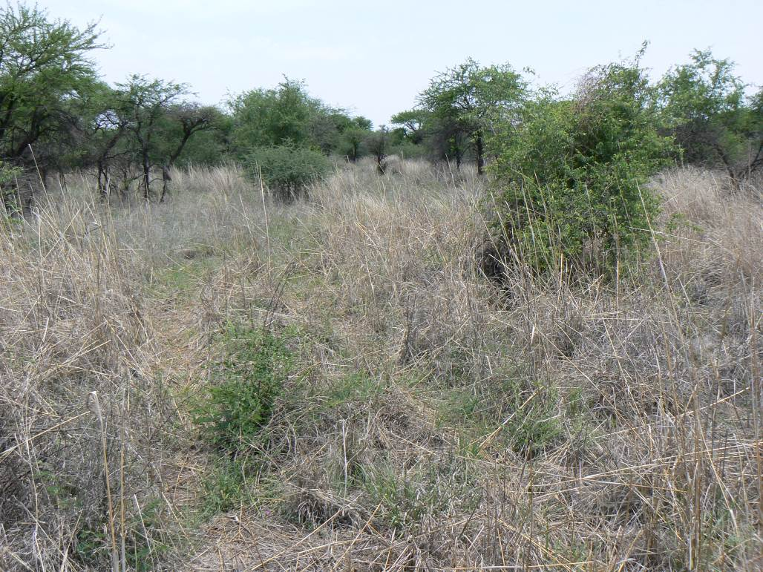
Acacia tortilis – Ziziphus mucronata – Peltophorum africanum woodland

Acacia tortilis – Acacia nilotica woodland (open variation)

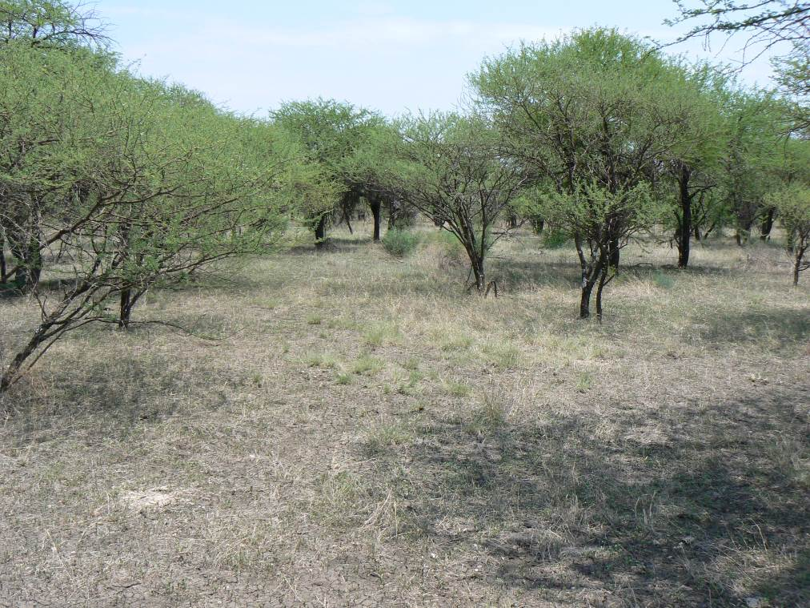

Unchannelled valley bottom– Closed grassland
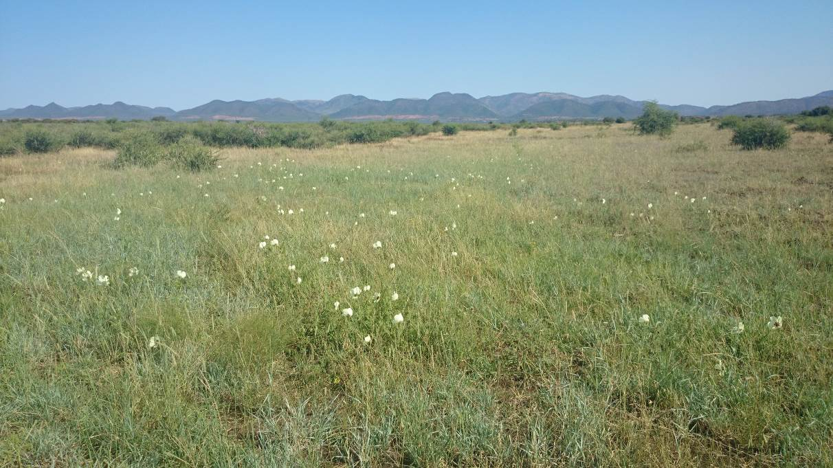
Channelled valley bottom
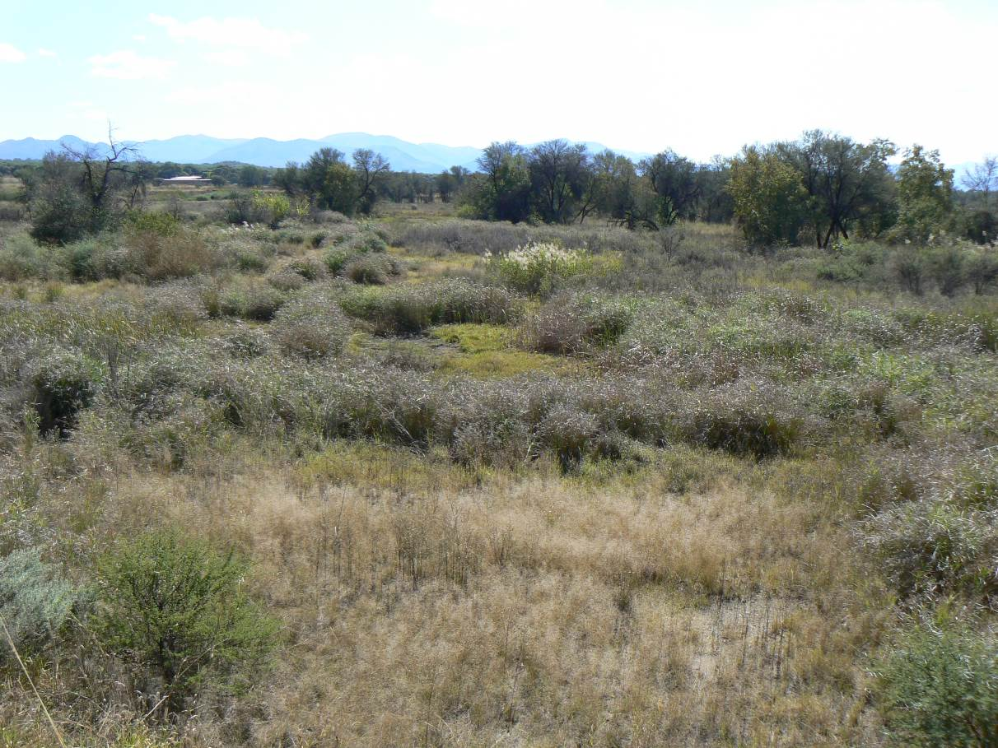
Drainage channel & ripartian woodland - Bier Spruit
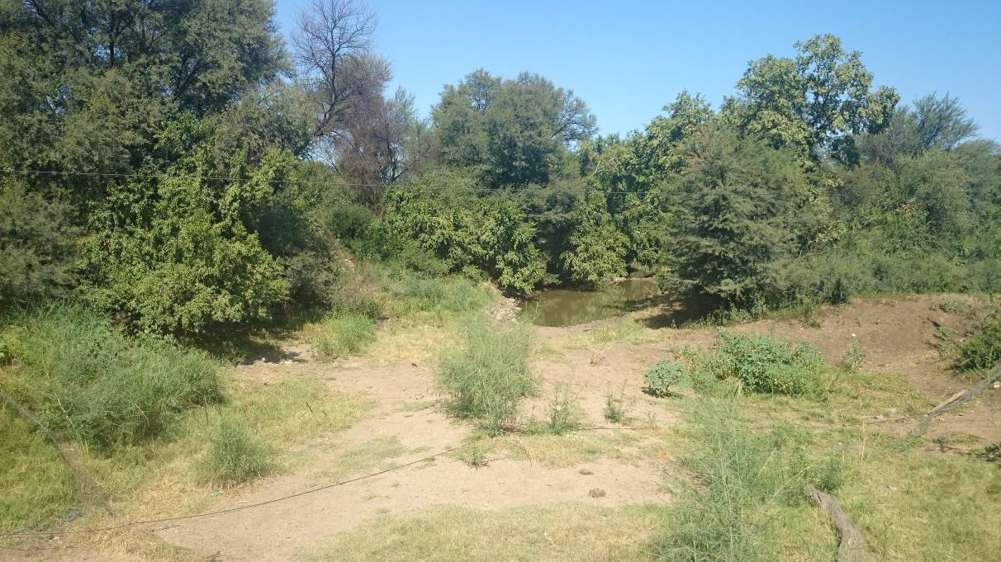
Primary Old Fields
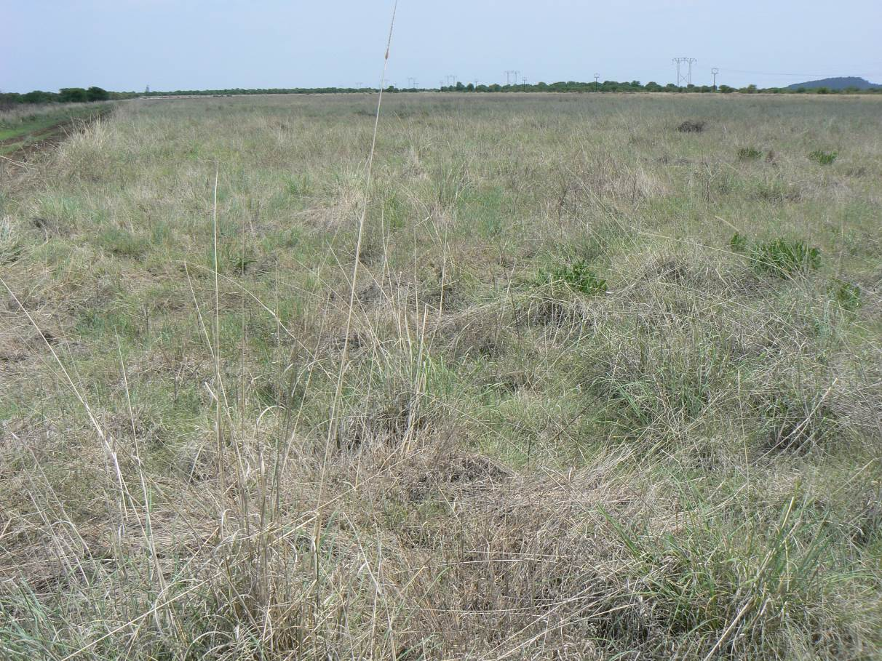

Secondary Old fields

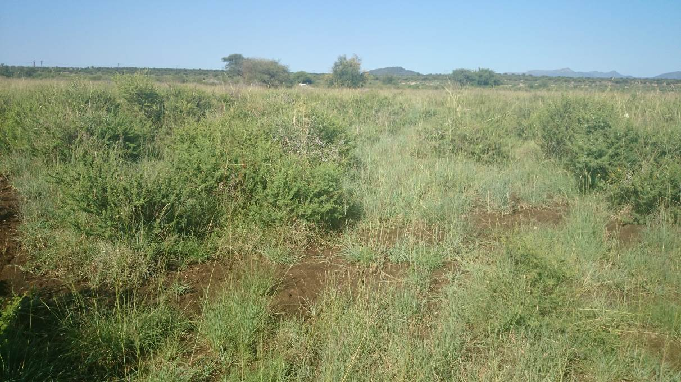
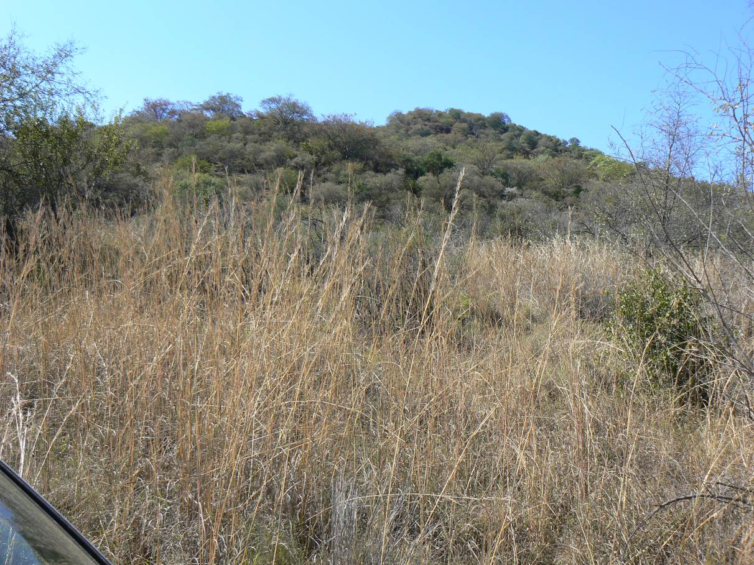
Rocky outcrops

Knobthorn thickets
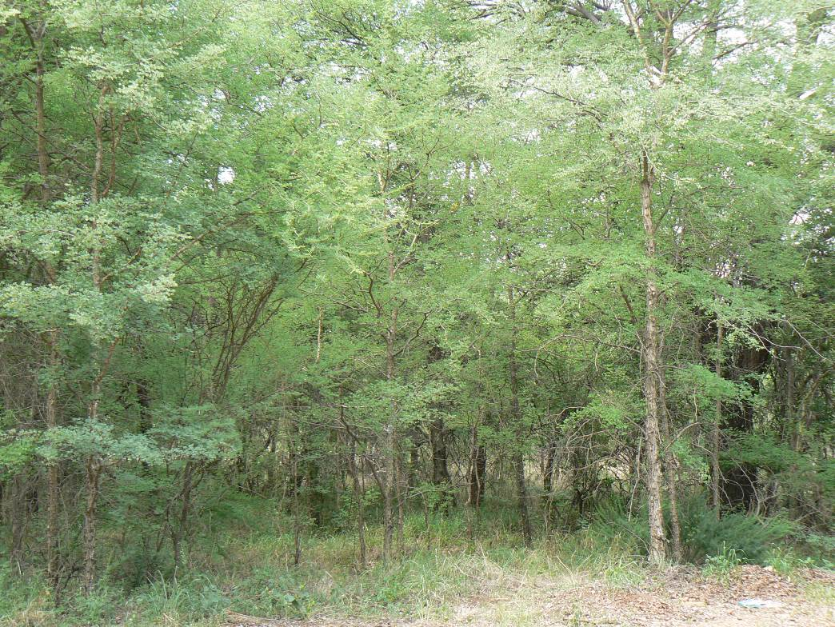

Degraded bushveld
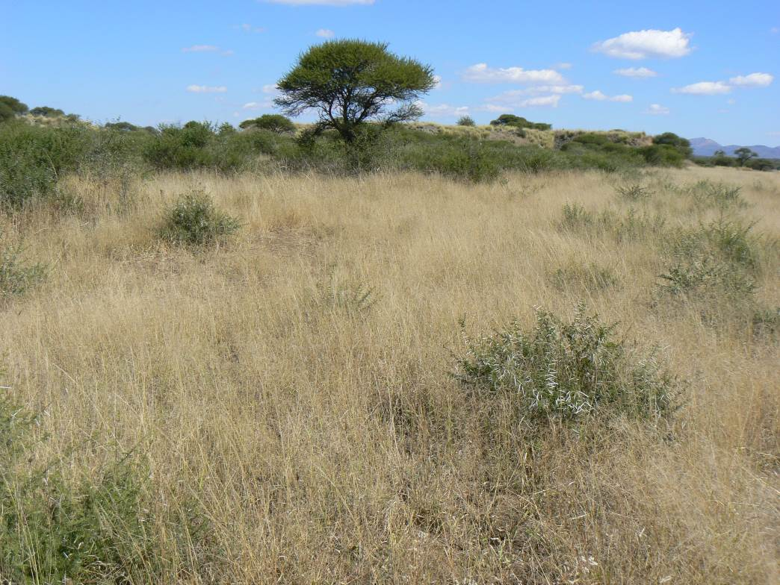

Seepage zones
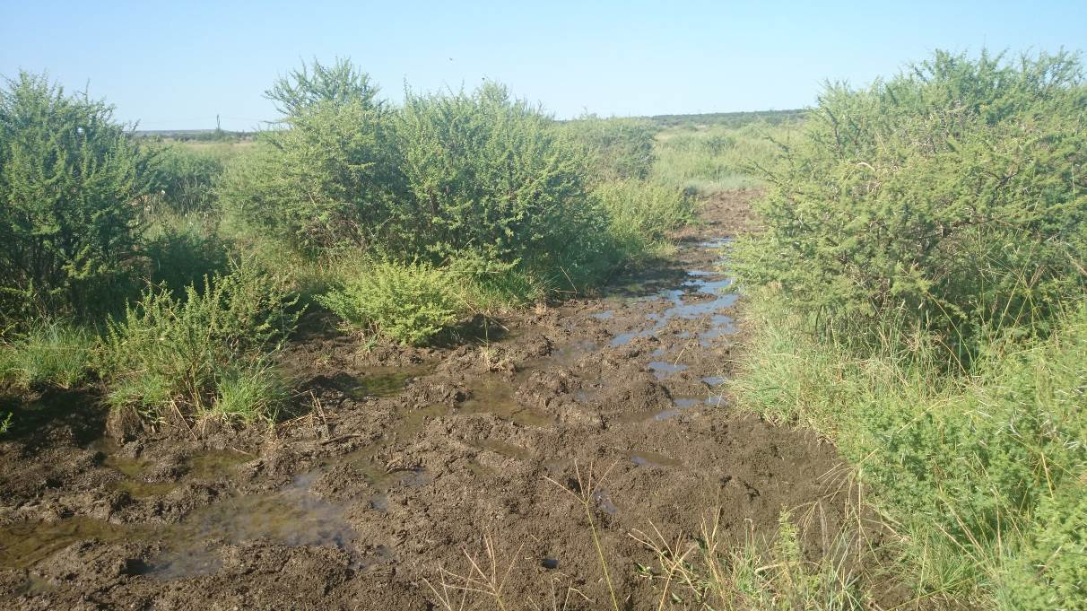
Dam in Bier Spruit

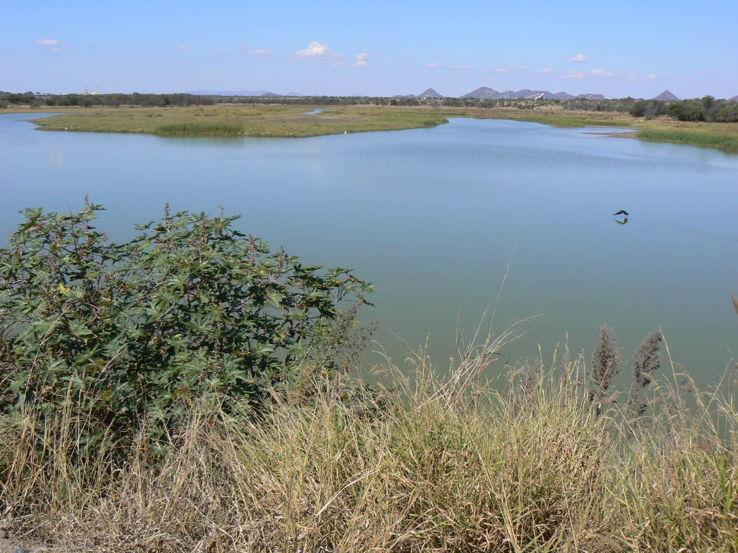

Connectivity (habitat connectivity) - Allowing for the conservation or maintenance of continuous or connected habitats, so as to preserve movements and exchanges associated with the habitat.

